
CAN - Cognitive assistant for networks
User manual for desktop application

Version 4.0
July 11, 2019
Avanseus HOLDINGS pte. LTD.

Disclaimer
THE SPECIFICATION AND INFORMATION REGARDING THIS USER MANUAL ARE SUBJECT TO CHANGE WITHOUT NOTICE. ALL STATEMENTS, INFORMATION AND RECOMMENDATION IN THIS MANUAL ARE BELIEVED TO BE ACCURATE BUT ARE PRESENTED WITHOUT WARRANTY OF ANY KIND, EXPRESS OR IMPLIED. USER MUST TAKE FULL RESPONSIBILITY FOR THEIR APPLICATION OF ANY CONFIGURATIONS.
IN NO EVENT SHALL AVANSEUS OR ITS SUPPLIERS BE LIABLE FOR ANY INDIRECT, SPECIAL, CONSEQUENTIAL OR INCIDENTAL DAMAGES INCLUDING, WITHOUT LIMITATION, LOST PROFITS OR LOSS OR DAMAGE TO DATA ARISING OUT OF USER OR INABILITY TO USE THIS MANUAL, EVEN IF AVANSEUS OR ITS SUPPLIERS HAVE BEEN ADVISED OF THE POSSIBILITY OF SUCH DAMAGES.
NO PART OF THIS USER MANUAL SHOULD BE DUPLICATED OR CIRCULATED OR USED FOR PROFIT WITHOUT PRIOIR WRITTEN APPROVAL FROM AVANSEUS TECHNOLOGIES LTD.

Preface
On the advent of CAN 4.0 release, we are pleased to share you the detailed user manual. This user manual provides you the detailed information on the various configuration aspects accessible for regular users, administrators and developers working on CAN 4.0. It may also be noted that some configurations may not be applicable to you depending on the type of integration you have chosen for.
This user manual is intended for ISP/Telecom Network NOC engineers or managers who manages the telecom network, their administrators and developers who possess technical knowledge and are familiar with the concepts of telecom networks. They would understand how to configure the different features and extract the best results out of this application.
For warranty, service or support information, kindly reach us at:
Avanseus Technologies Pvt. Ltd.
N1 Block, 11th Floor, Manyata Tech Park, Thanisandra, Bengaluru, Karnataka 560045
Email: can.care@avanseus.com

Revision History

Version | Date | Change Description | Prepared by | Updated By | Approved by
V 1.0 | August, 2016 | Draft release |  | Sheenginee | Chiranjib
V 2.0 | November, 2016 | Updates |  | Sheenginee | Chiranjib
V 3.0 | January, 2017 | Updates |  | Sheenginee | Chiranjib
V 4.0 | July, 2019 | Updates | Sandeep Singh | Naveen | Chiranjib

Table of Contents
1. DASHBOARD APPLICATION SCREEN 5
Login Page 5
2. EXECUTIVE DASHBOARD HOME 7
3. PREDICTIVE FAULT ANALYSIS 11
Map View 11
Tabular View and Graphical Representation (Chart view) 15
Prediction Action Tracking 17
Report Download 19
4. ROOT CAUSE ANALYSIS 22
5. CROSS DOMAIN CORRELATION 43
6. FAULT ANALYSIS 54
Work Order Status 57
7. TECHNICIAN WORK PLAN 58
8. INVENTORY 60
9. ANNOUNCEMENT 63
10. USER MANAGEMENT 64
Manage roles 65
Manage users 65
View logs 66
11. SETTINGS 67
Rule Configuration for Announcement Exclusion 67
Technician Availability 68
Mailing List 69
Equipment Component Configuration 70
12. MONITORING 71
Data Collection Audit 71
Notification Handler 72
13. ADAPTATION 74
Parser (Input Mapper) 75
Pre - Processor 79
Post – Processor 80
File Collection 81
SFTP and FTP 82
GITHUB 83
Steps for Cloning GITHUB 83
EMAIL 84
Prediction Assignment Policy 85
Filter Configuration 87
Post Prediction Process 90
Report Configuration 90
Page Configuration 90
Excel Report Configuration 93
Resource Configuration 96
Advanced Configuration 98
SFTP Data 98
User Management 98
Archive Data 98
Matching Configuration 98
Advance Prediction 98
Visual Preferences 100
Algorithm Configuration 100
Cross-Domain Correlation 101
General Configuration 102
RoE 102
Sheet Configuration 109
Linking 112

DASHBOARD APPLICATION SCREEN

Login Page
Executives can log on to the CAN desktop application using the single sign-in screen.
- In the Username box, enter your user name.
- In the Password box, enter the password.
- To access the dashboard application, click the ‘Login' button.

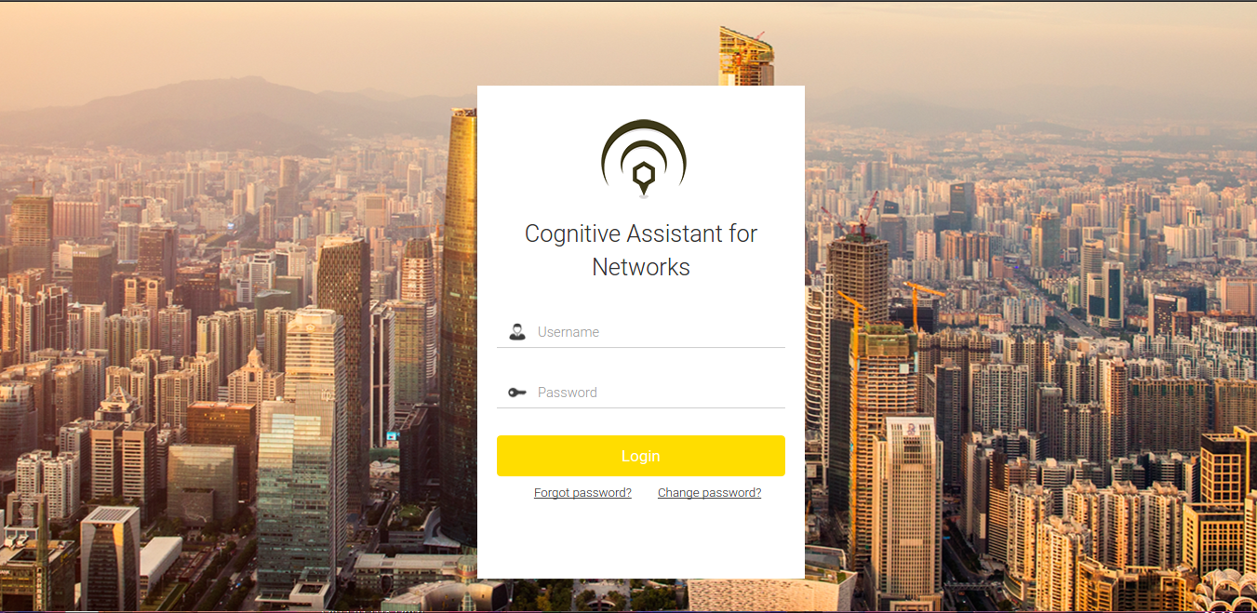
Figure 1.1 - Login Screen

Note: Currently CAN desktop application supports English (default), Russian, Spanish and Japanese.

If you forgot the password, click ‘Forgot password’ to reset the password. You will receive a link to change the password on your registered email id.

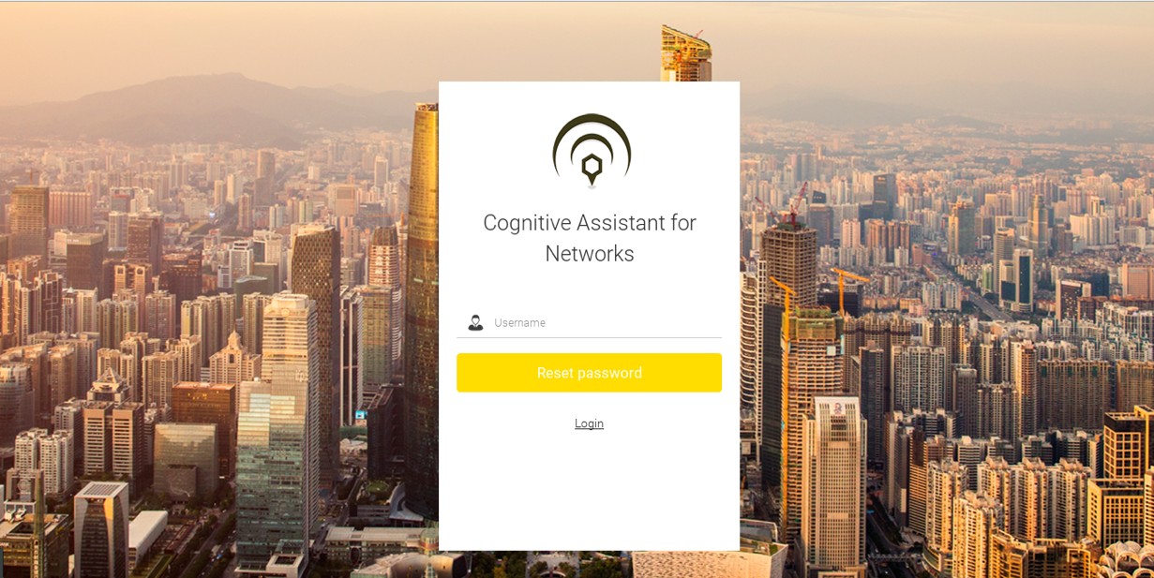
Figure 1.2 - Forgot Password Screen
To modify existing password, click on “Change Password” and in the ‘New password’ box, type your new password.
In the ‘Confirm new password’ box, again type your new password.
Click ‘Modify Password’.


Figure 1.3 - Modify Password screen

EXECUTIVE DASHBOARD HOME
Executive dashboard home serves as a starting point for the application.
The executive dashboard has three different sections:
- User
- Administrator
- Developer
The User section provides access to Predictive Fault Analysis, Root Cause Prediction, Fault Analysis, Inventory Planning, Cross Domain Correlation, Technician Work Plan and Announcement.
The Administrator section provides access to User Management, Monitoring and Settings.
The Developer section provides view to Adaptation.
By default, the home screen displays the Top faults of the current month.

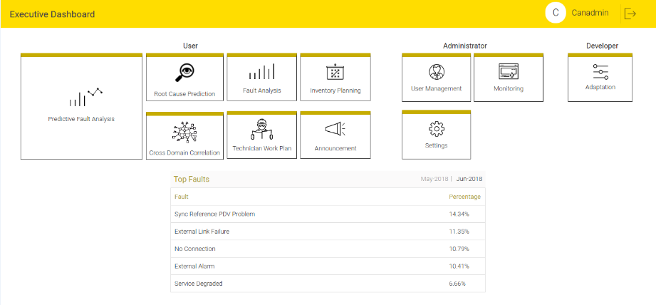
Figure 2.1 - Executive Dashboard Home

To view the Top Faults of the previous month and current month, click the previous month (May 2018 on the screen) or current month (June 2018 on the screen).

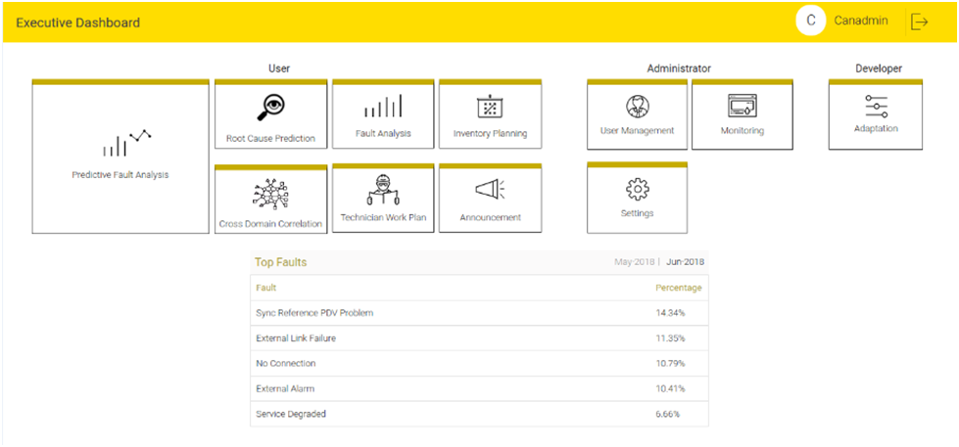
Figure 2.2 - Top Faults
If your deployment uses cause category, then you will also see top Infra and Non-Infra faults. To view the Top Infra and Top Non-infra faults of the previous month, click ‘previous month’ on the screen.

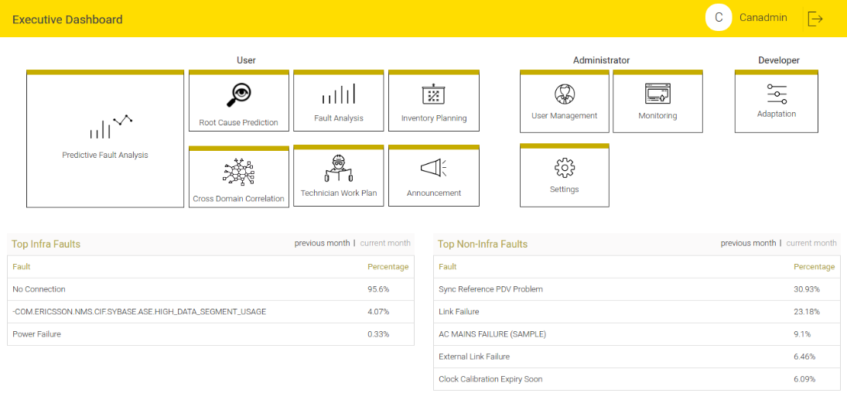
Figure 2.3 - Top Infra and Top Non-infra Faults of Previous Month

To view the Top Infra and Top Non-infra faults of the current month, click ‘current month’ on the screen.

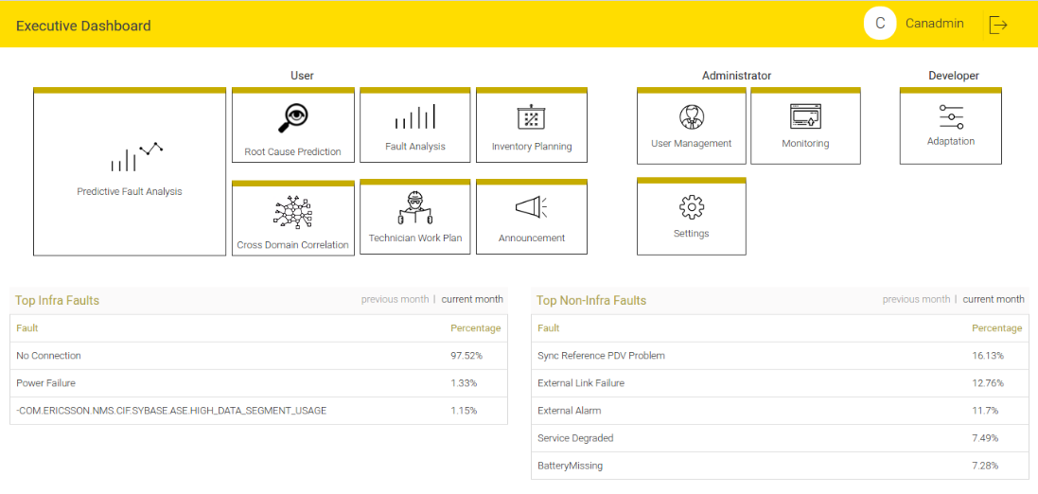
Figure 2.4 - Top Infra and Top Non-infra Faults Current Month

Alternately, user can also see previous month’s Top Infra faults and current month’s Top Non-infra faults together:

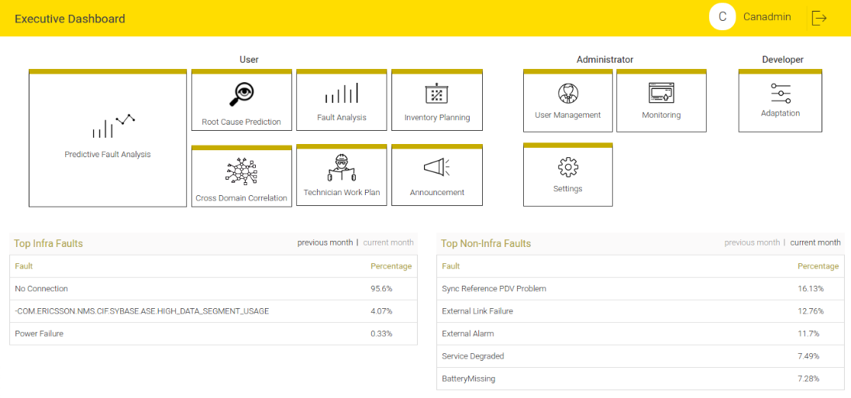
Figure 2.5 - Previous month’s Top Infra and Current month’s Top Non-Infra Faults

User can also see current month’s Top Infra faults and previous month’s Top Non-infra faults together:

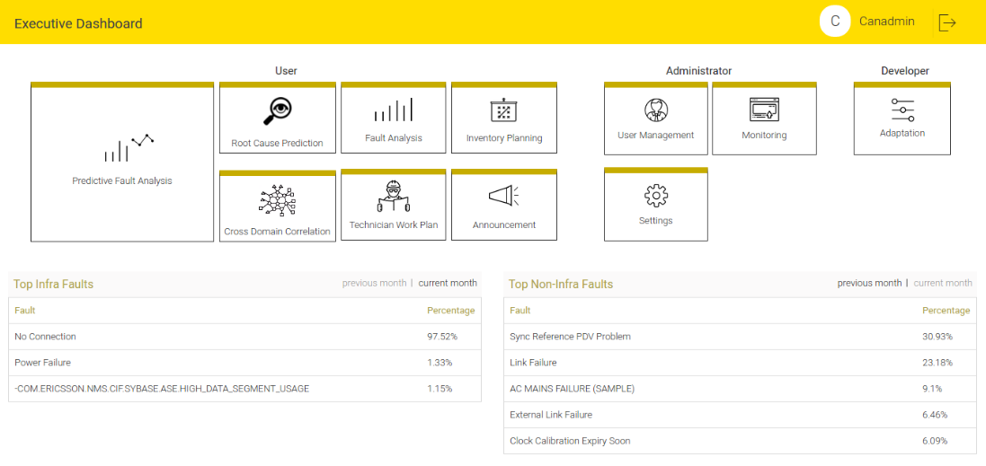
Figure 2.6 - Current month’s Top Infra and Previous month’s Top Non-Infra Faults

PREDICTIVE FAULT ANALYSIS
Predictive Fault Analysis allows the executives to view the predicted faults nation wise, region wise and city wise and so on.
Predictive Fault Analysis has two representations:
Map View
Tabular View
To select the Map or Tabular view, click the map icon or tabular icon respectively (the default view depends on the selection made in the Visual Preferences option on Advanced Configuration tab).

Map View
- The markers on the map represents the predicted faults. The marker will be placed on the latitude and longitude where the equipment on which fault is predicted to occur is located.
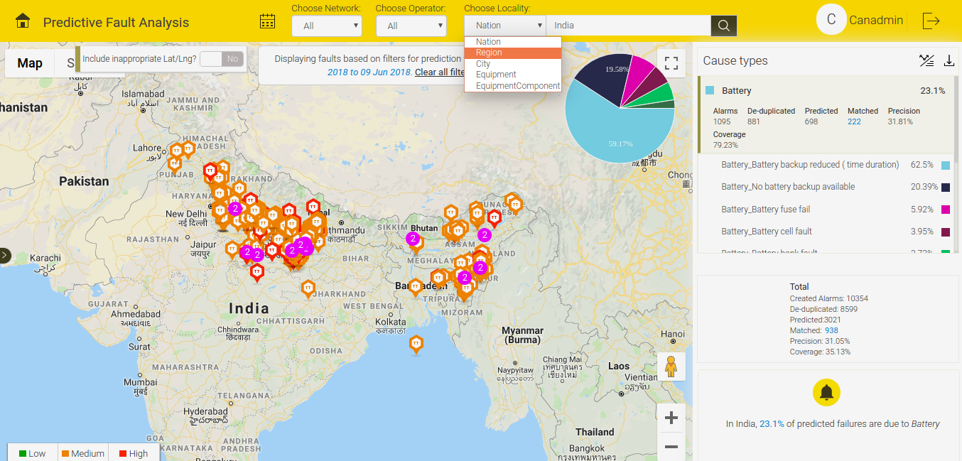
Figure 3.1 - Location Based Filtering

- Predicted faults are classified based on their priority and are represented below:
Red - High priority predicted faults
Yellow - Medium priority predicted faults
Green - Low priority predicted faults
- User can select the location based filter options from the drop-down menu. Drop-down menu has options: Nation, Region, City, Equipment Component, Equipment in the header. Choose a location in the text box from the auto-complete list.

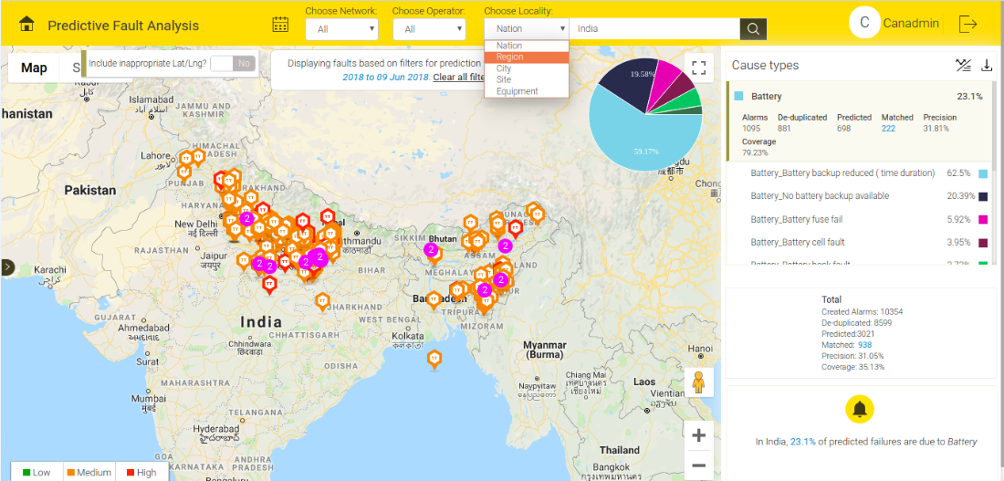
Figure 3.2 - Location Based Filtering

- User can apply the sub-filter to narrow down the search along with the selection of fault priority in the bottom. To apply the sub filter, click the sub filter icon .
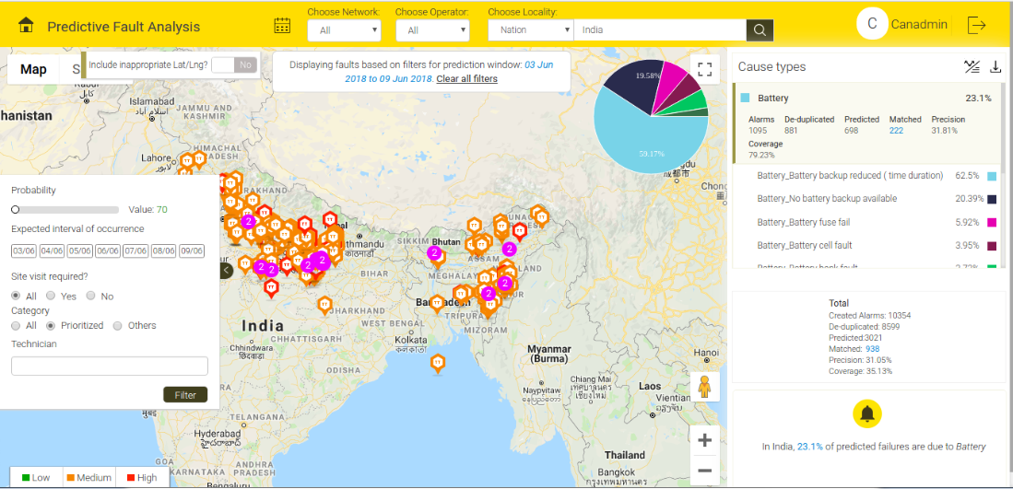
Figure 3.3 - Sub-filter

- Sub-filters include filtration on the fields like Probability, Prediction day, Category, etc.
- User can view the top causes for the predicted faults and the percentage of its occurrence on the right section of the screen. When user choose a particular cause, faults will be filtered with respect to that cause on the map.

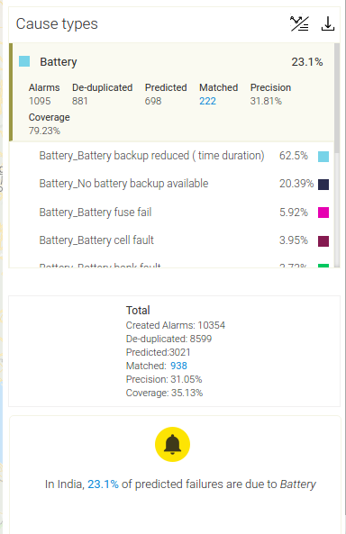
Figure 3.4 - Cause Types

- To filter the predicted faults based on the prediction week, click the Calendar button.

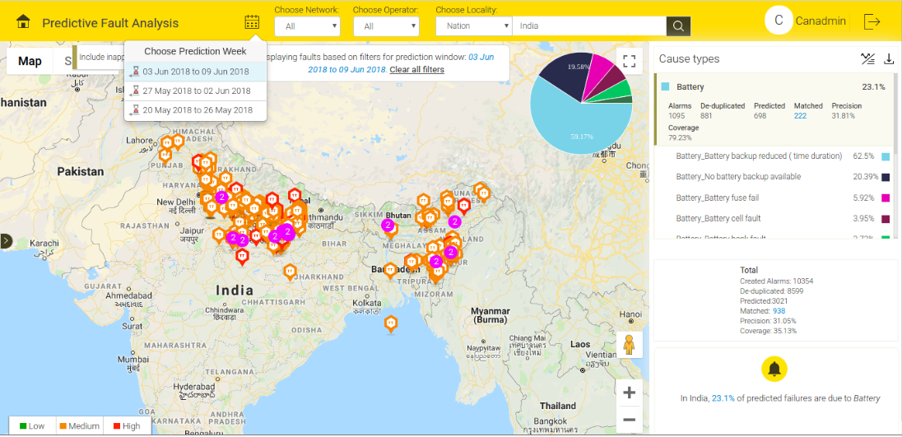
Figure 3.5 - Prediction Week
- If multiple predictions occur at the same latitude and longitude, purple circle represents a cluster and the circle displays the number of predictions occurred in that cluster (it will display minimum 2 predictions and up to 10 and anything higher than 10 will be marked as 10+). Click the circle, the screen will display a slot. User can select the equipment. The screen will display the fault details of the selected equipment.

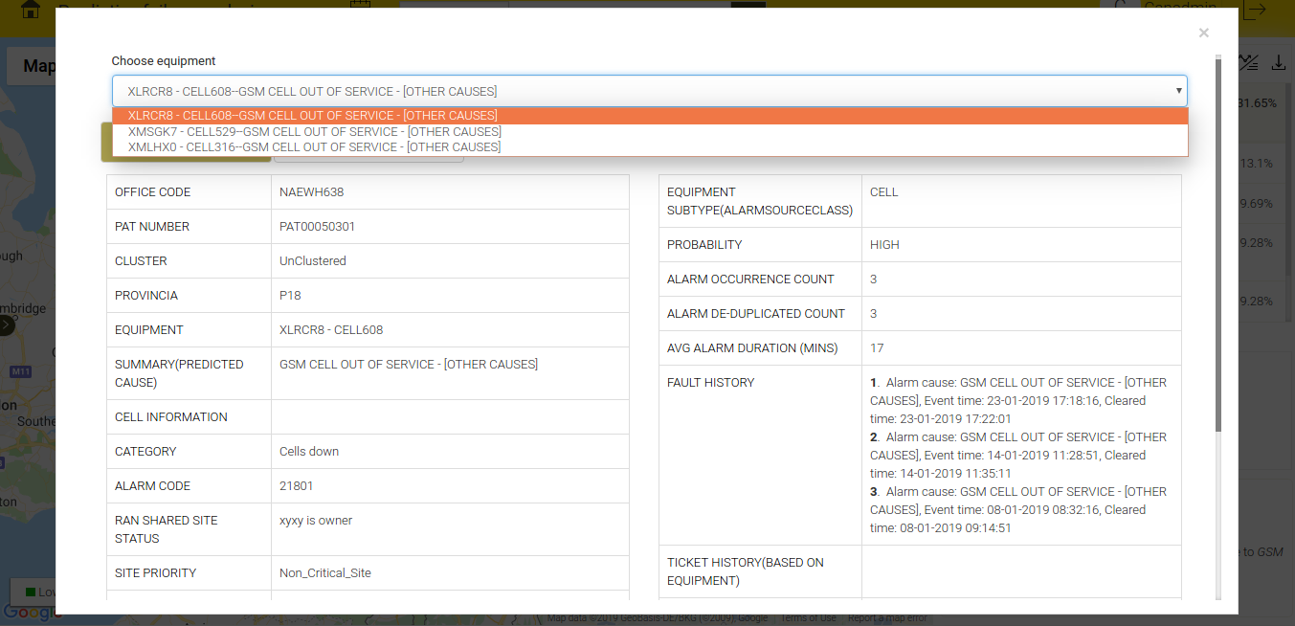
Figure 3.6 - Clustered Equipment

Map shows the Pie-chart. It graphically represents the way causes are spread.

- The bottom section on the right hand side of the screen displays a message indicating the top causes for the searched location.

Figure 3.7 - Cause Types

Tabular View and Graphical Representation (Chart view)
- To view the chart view, click the chart icon and to view the tabular view, click the tabular icon .
- Executives can view all the details of a predicted fault on the screen. The screen includes the following fields:
Equipment
Cause
Prediction Day
Priority
Probability
Slot 1 (7days) match
Slot 2 (7days) match

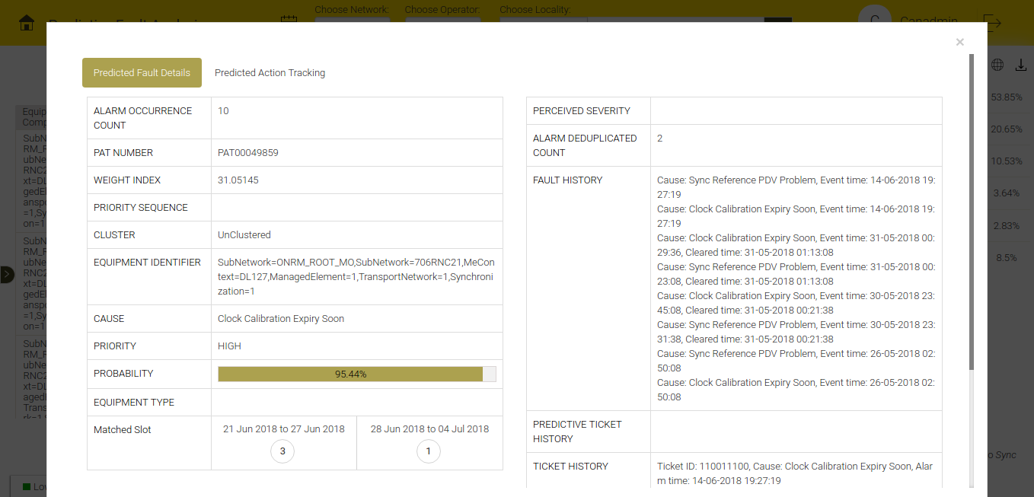
Figure 3.8 - Predicted Fault Details

- Points 3, 4, 5, 6, 7 of map view is applicable for tabular representation as well.
- To view the predicted fault details, click the details label 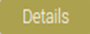 on the priority column tab.

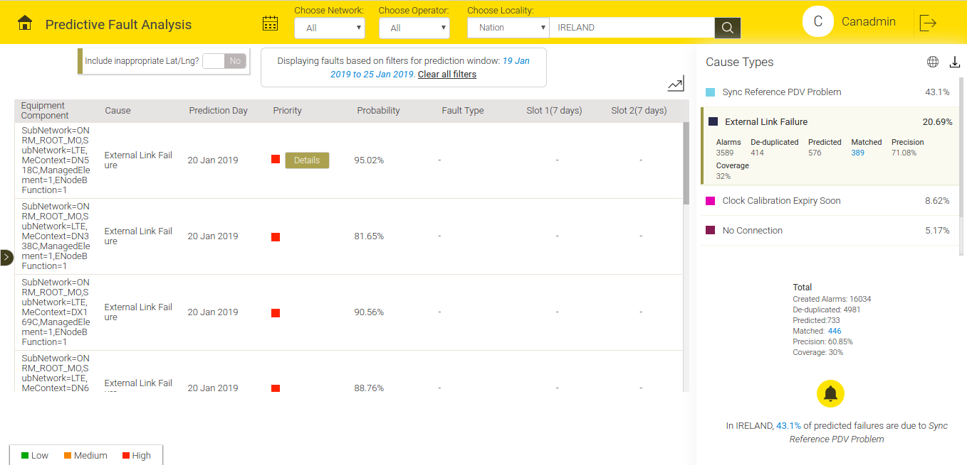
Figure 3.9 - Predictive Failure Analysis (Tabular View)

- Chart view displays the statistics related to Cause Category, Priority, Cause and Zone.

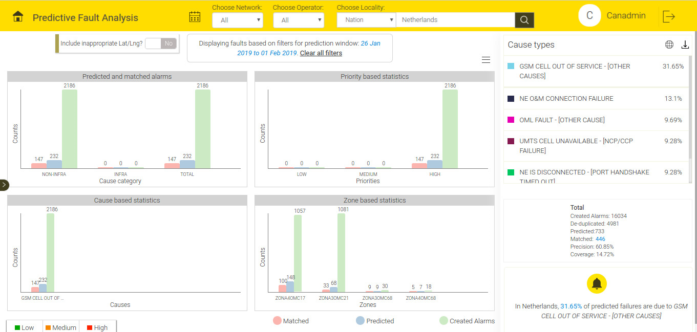
Figure 3.10 - Predictive Failure Analysis (Chart View)

Prediction Action Tracking
The Recommended Technician section displays the details of the technicians based on his experience to solve the ticket on that equipment. The screen recommends the technician based on the availability and the rating of the technician. The rating of the technician is based on technician's previous records .

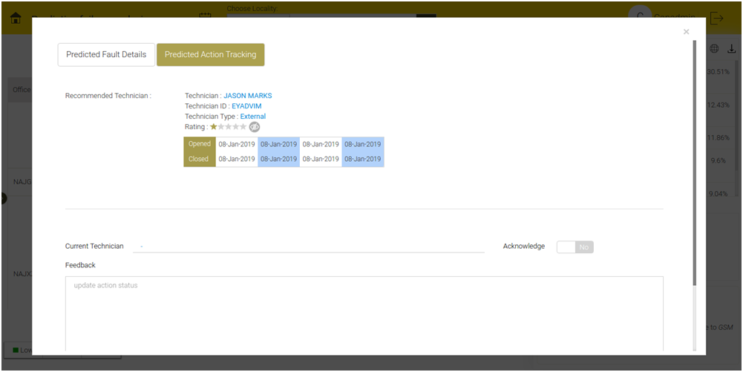
Figure 3.11 - Predictive Action Tracking - Recommended Technician

If Recommended Technician section displays no technician, it means that no technician is available or none of the technicians solved the ticket/prediction in that equipment earlier.

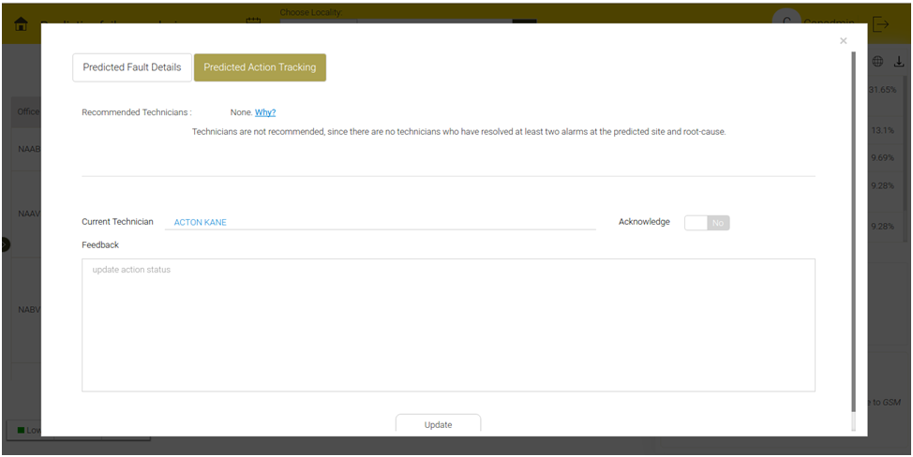
Figure 3.12 - Predictive Action Tracking - Recommended Technician

User can assign the technician for the ticket/prediction in case the screen displays no recommended technician. User or the technician can acknowledge the ticket. To acknowledge, click Yes on the 'Acknowledge' toggle button.

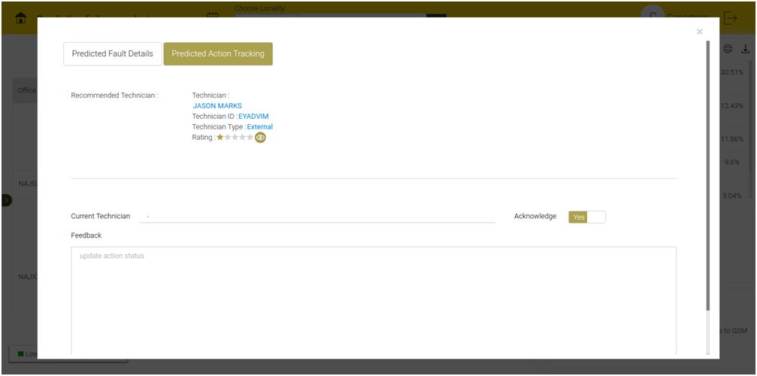
Figure 3.13 - Predictive Action Tracking - Acknowledge

User can acknowledge the prediction and can also provide feedback. To acknowledge, select Yes/No on the 'Acknowledge' toggle button. To provide / update feedback, write feedback in the Feedback section.

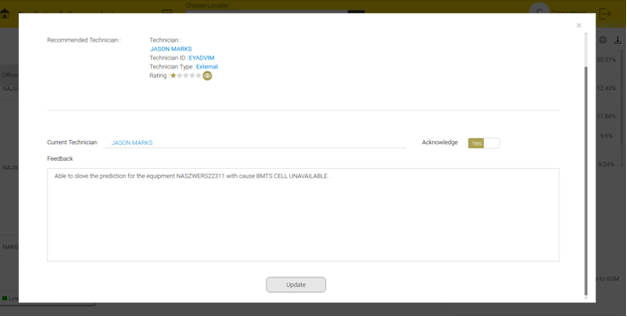
Figure 3.14 - Predictive Action Tracking - Feedback

Report Download
To download the Predicted Fault Report, click the Download icon.
Predicted fault report are of 3 types: Filtered Report, Daily Report and Matching Report.

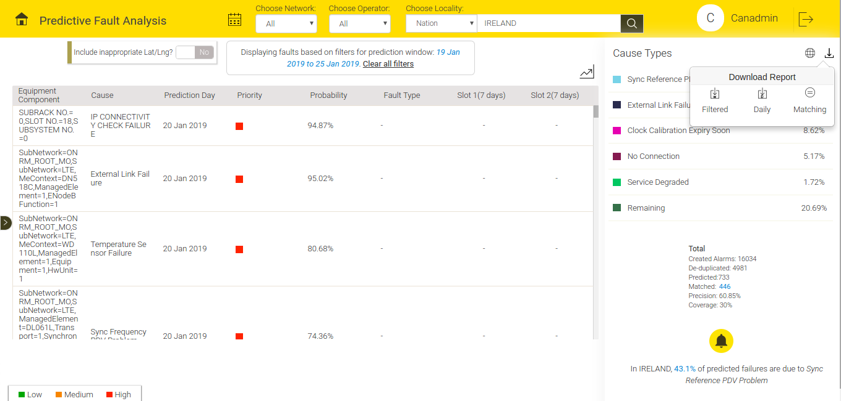
Figure 3.15 - Download Report

User can select filter(s) and view the Filtered Report based on the filters applied.
To view Daily Report, choose the time frame. Download the prediction report for the selected timeframe. Timeframe will begin from current day to 15 days prior with an interval of 1 day. If the prediction report is not available for the given timeframe, the screen will display a popup message "Report is not available for the search criteria".

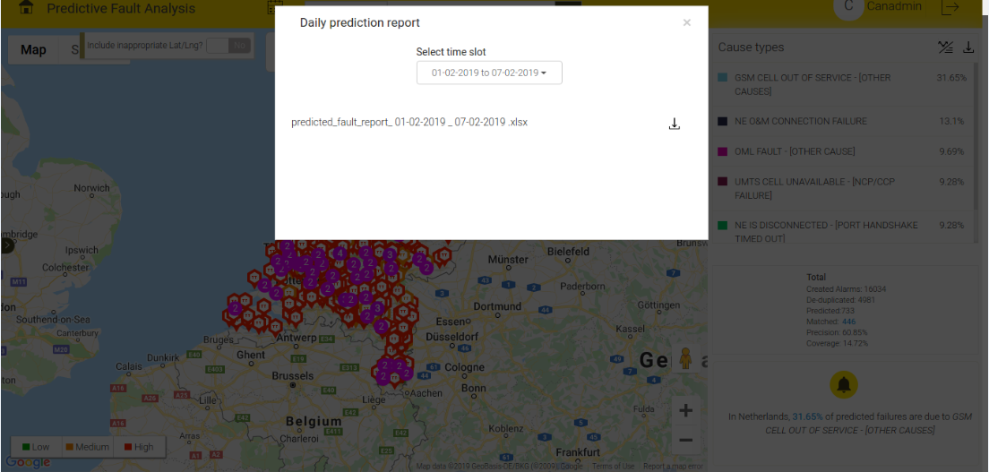
Figure 3.16 - Daily Report

User can download the Matching Report for the selected predicted week.
See the following figure for sample prediction report.

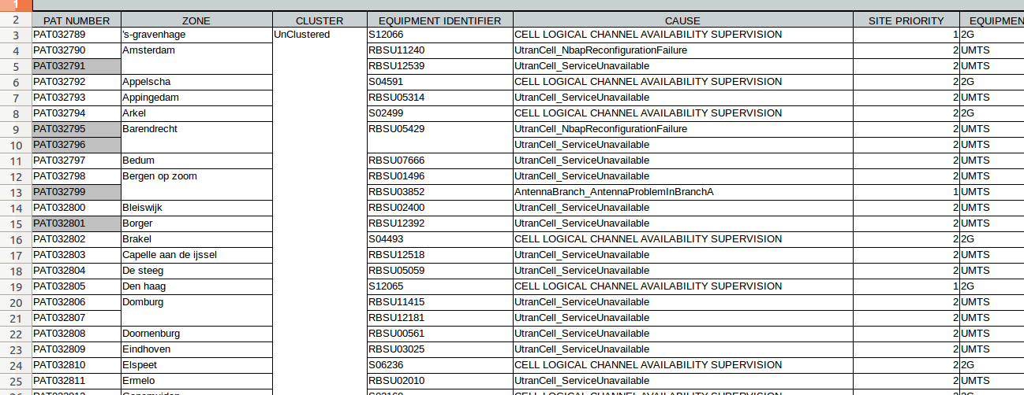
Figure 3.17 - Downloaded Report

ROOT CAUSE ANALYSIS
Root Cause Prediction pinpoints the causes of predicted faults.
The “Operationalisation flow” displays the following information:
At the beginning, root causes for predicted faults are provided based on technical analysis i.e. based on knowledge of the equipments and alarms.
As we proceed with more and more field actions, root causes are learnt based on the feedback received from the field.
With time, technical causes are replaced by field learnt root causes that are more accurate.
Within 6 months of field actions, we expect 80% of field learnt root causes.

To minimize the Operationalisation flow, click the minimize button .
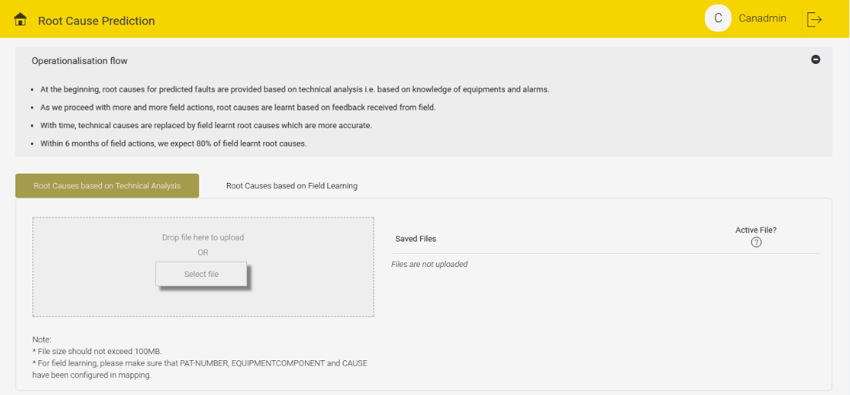
Figure 4.1 - Minimize Button

To maximize the Operationalisation Flow, click the maximize button .
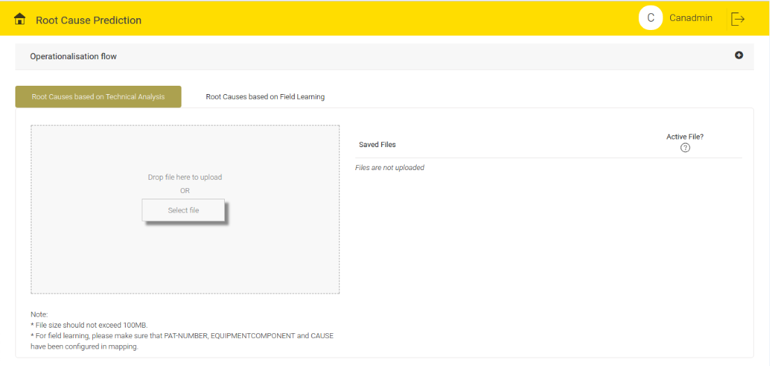
Figure 4.2 - Maximize Button
Root Cause Prediction Tab has two options:
- Root Causes Based on Technical Analysis
- Root Causes Based on Field Learning.

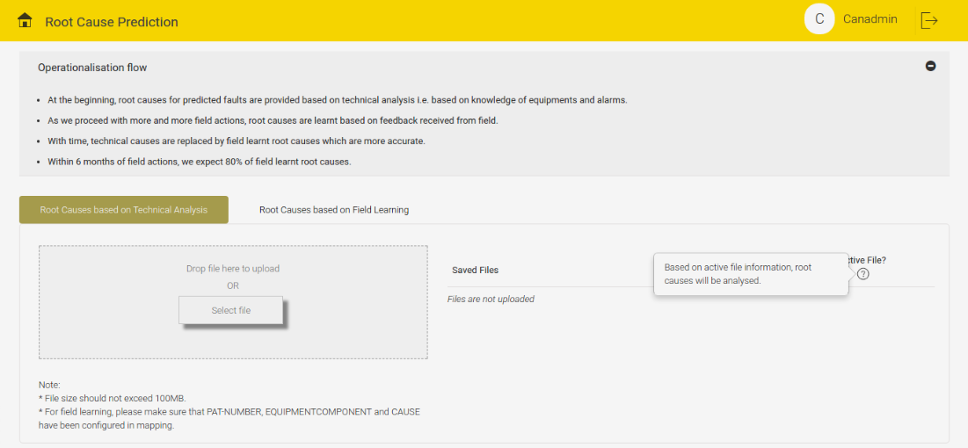
Figure 4.3 - Root Causes Based on Technical Analysis Tab

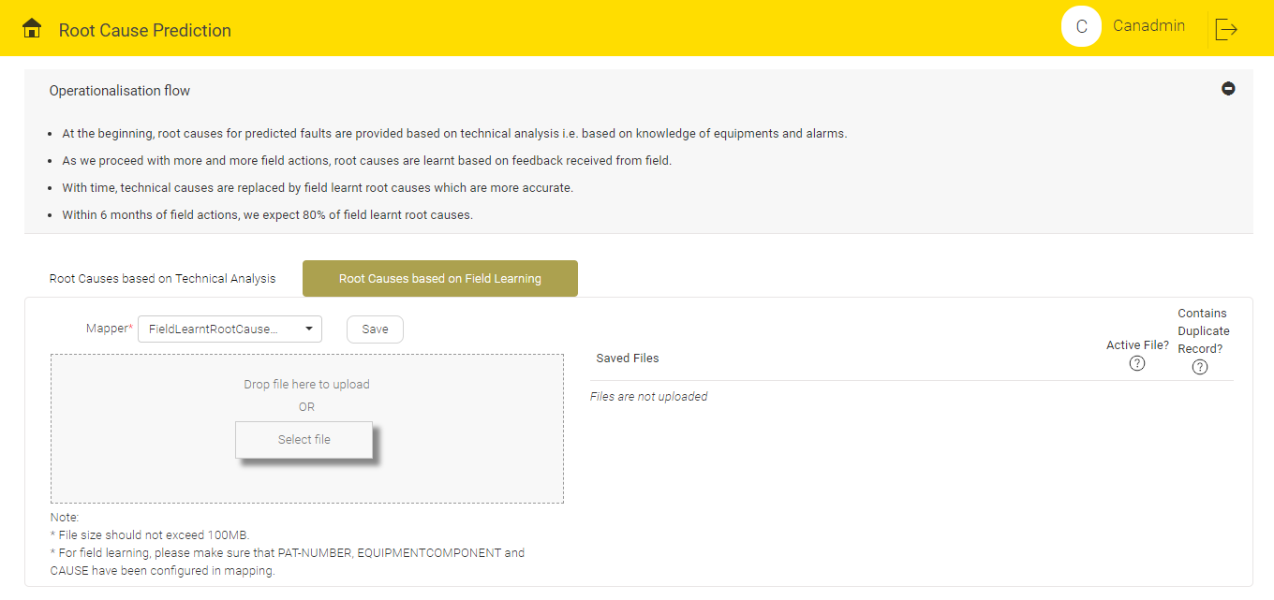
Figure 4.4 - Root Causes Based on Technical Analysis Tab

If the user clicks “Root Causes based on Technical Analysis” tab, the screen displays the following features:
- User can upload any type of files. The maximum file size should not exceed 100 MB.
- User can analyse the technical root causes based on the active file information.
- By default, the latest uploaded file (if parsed successfully) will be active.

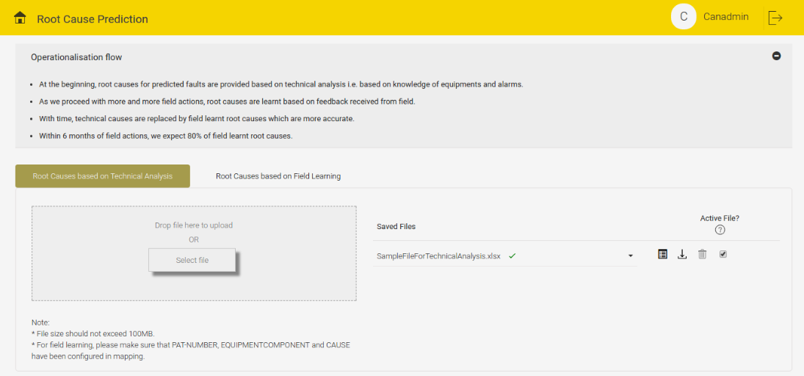
Figure 4.5 - Latest Upload File is Active

- If already one active file is present at the time of new file upload, the new file becomes active and the existing file becomes inactive.

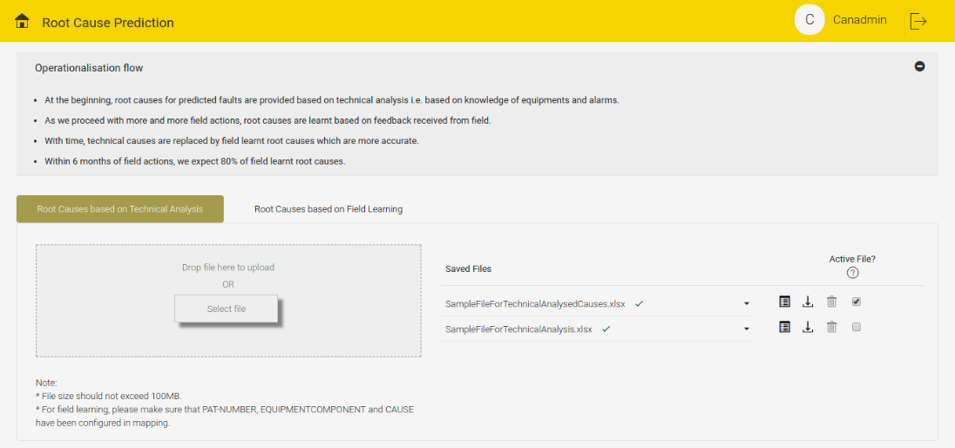
Figure 4.6 - Active against Multiple Files Scenario

Click the Detailed info button to view the Detailed Information of the particular parsed file. The Detailed Information displays the following details on the screen:
- CAUSE
- FAULT HISTORY
- POSSIBLE REASON
- REMARKS

- Verify CAUSE name and FAULT HISTORY with pre-configured alarm causes and see if POSSIBLE REASON is available or not. If verified, the Remarks column shows green tick, otherwise the Remark column shows red cross with corresponding remarks.

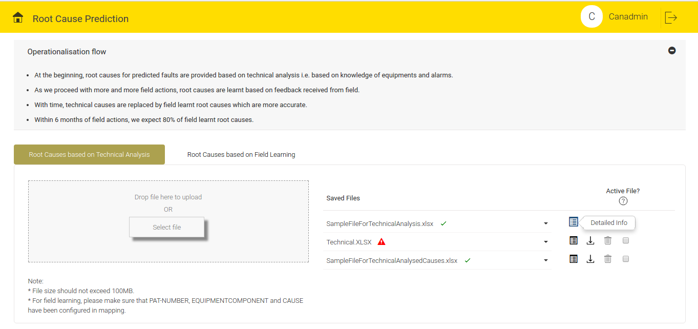
Figure 4.7 - Details Button

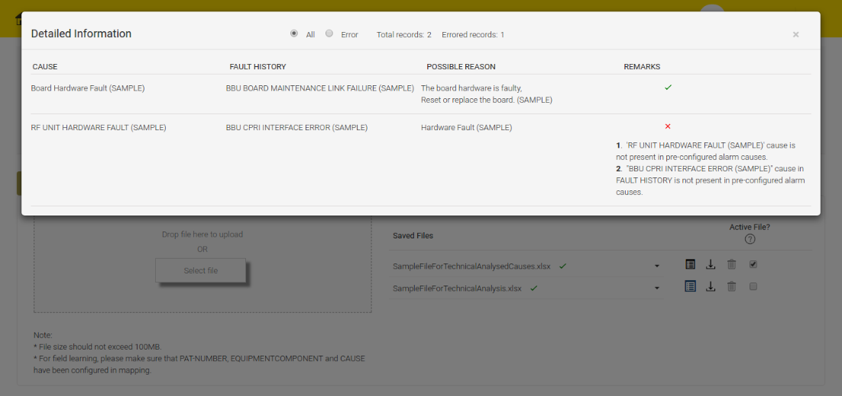
Figure 4.8 - File Details with Remarks

- On the 'Detailed Information' pop-up, the screen displays the count of total records and errored records. An errored record represents red cross with corresponding remarks in Remarks column. By default, the screen displays all the effective records. When user selects the 'Error' radio button , user can see only the errored records on the screen.

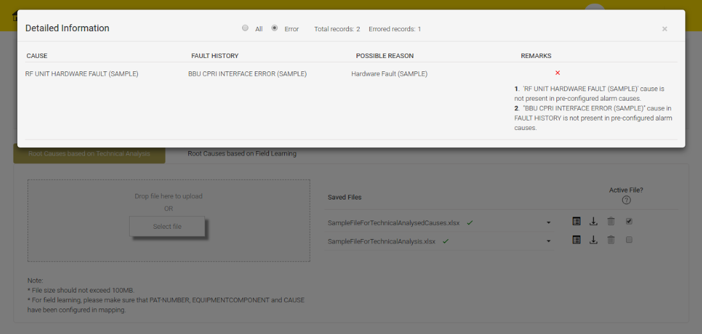
Figure 4.9 - Error Radio Button Selection and Errored Record Sample

When the user clicks the Active File check box and if the selected file is already active, a message '''SampleFileForTechnicalAnalysisCauses.xlsx' is already active for Technical Analysis. This file will remain active until you make another file active' will appear on the screen.

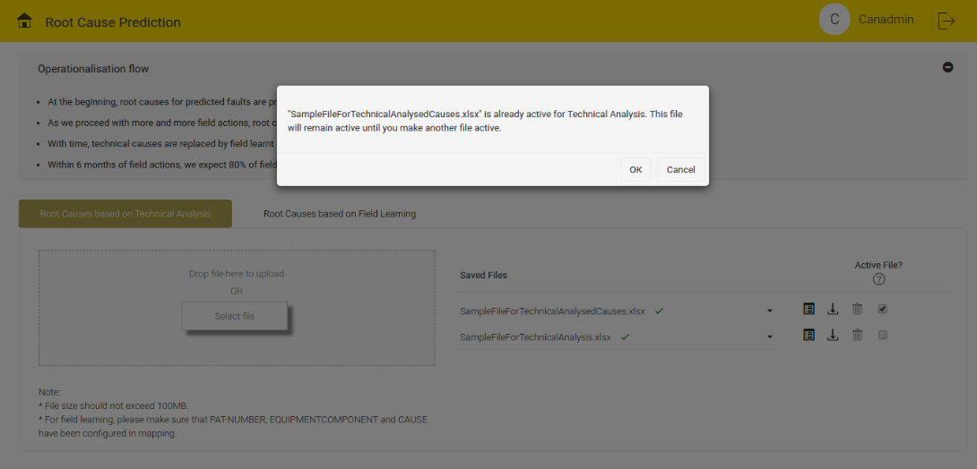
Figure 4.10 - Only File Active
If the file is not active and contains discarded records, the pop-up displays the details of discarded records while we activate the file.. At a time, only one file can remain active.

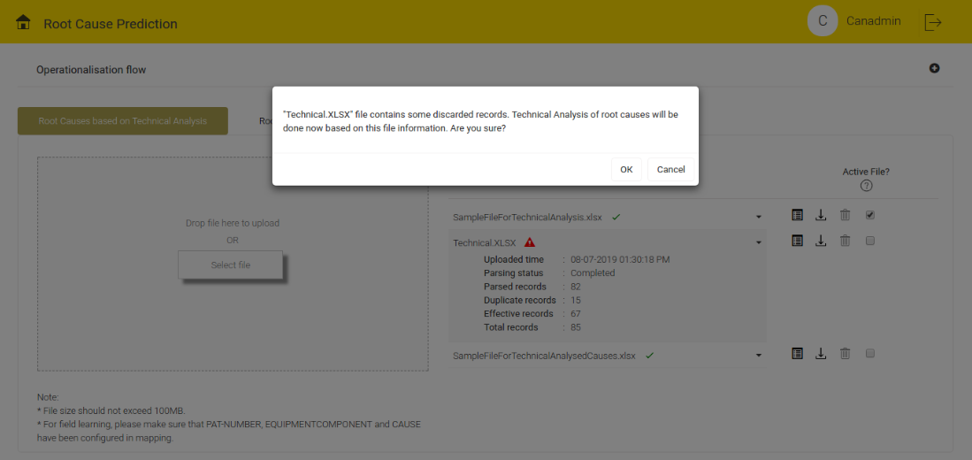
Figure 4.11 - Discarded Record Check

When user clicks the “Root Causes Based on Field Learning” tab, the screen displays the following features:
- User can upload any type of files based on the saved mapper configured in the parser screen. From the Mapper drop-down menu, user can select the Mapper name and upload the file only after the mapper is saved.

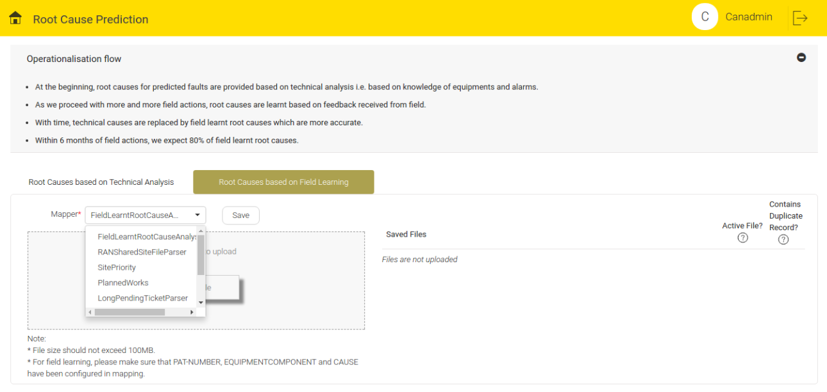
Figure 4.12 - Drop-down Menu to Select Mapper Name
If selected Mapper is not saved and user try to upload the file, a message “Before uploading file, please save the mapper” will appear as error message on the screen.

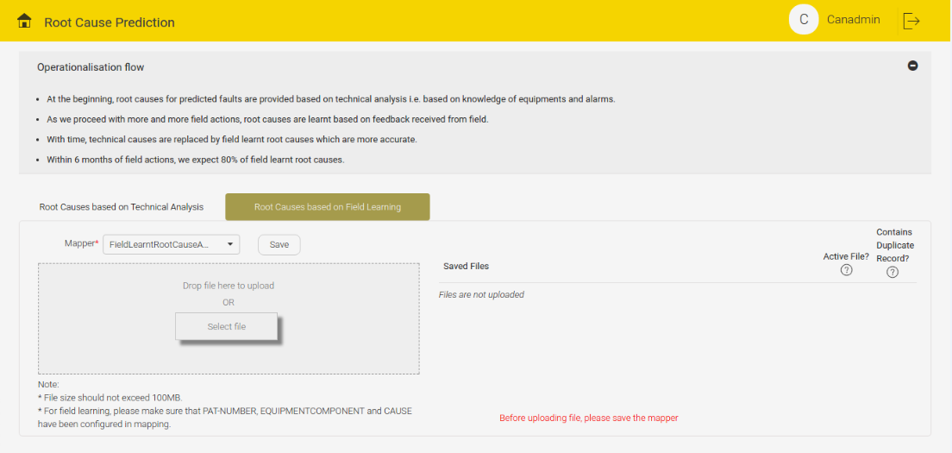
Figure 4.13 - Error Message when Parser is Not Saved

NOTE:
File size should not exceed 100 MB
Make sure that PAT-NUMBER and EQUIPMENTCOMPONENT and CAUSE are configured in the parser mapping.

By default, the latest uploaded file will be active. If already one active file is present at the time of new file upload, the new file becomes active and the existing file becomes inactive (same as Technical Analysis). For Field Learning, active file represents at least one record of that particular file is active. By default, all the records of the active file is active and based on the active records, the system will analyse the field learnt root causes.

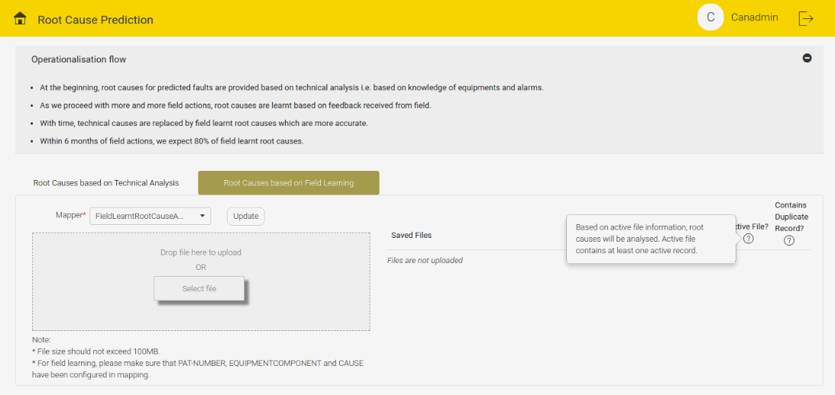
Figure 4.14 - Active file Contains at least One Active Record

Click the Details Info tab to view the Detailed Information of the records from the parsed file. The screen displays the following informations:
Mandatory Information
- ACTIVE RECORD
- PAT-NUMBER
- EQUIPMENT_COMPONENT
- CAUSE
- REMARKS
Optional Information
- OFFICECODE
- PREDICTIVE TT RESPONSIBLE GROUP
- TICKET REMARKS

NOTE: The screen displays the mandatory information. The screen might or might not display Optional information as per the user's requirement/mapping.
Verify CAUSE name and EQUIPMENT_COMPONENT name with pre-configured alarm causes and equipmentComponents respectively. See the combination of PAT-NUMBER and EQUIPMENT_COMPONENT is available or not among the predictions. If verified, the Remarks column shows green tick, otherwise the Remark column shows red cross and corresponding remarks.

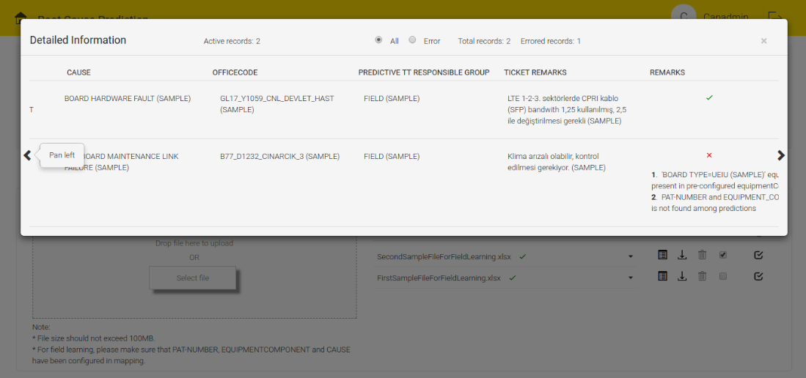
Figure 4.15 - Remarks for Field Learning

On the 'Detailed Information' pop-up, the screen displays the count of total records and errored records. An errored record represents the red cross with the corresponding remarks in the Remarks column. By default, the pop-up on the screen displays all the effective records.

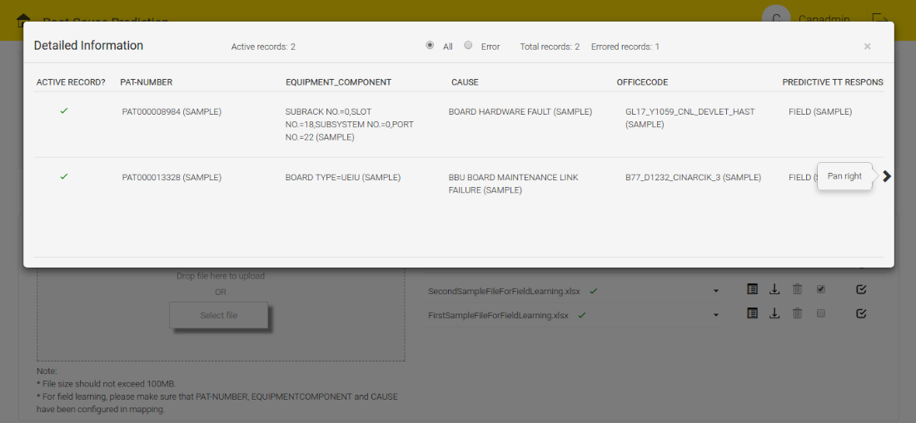
Figure 4.16 - Active Records Count, Total Records and Errored Records Count

To view only Error record, user can select the 'Error' radio button. User can view the count of active records corresponding to that file. If the record is active, the Remarks column shows green tick, otherwise the Remarks column shows red cross with corresponding remarks.

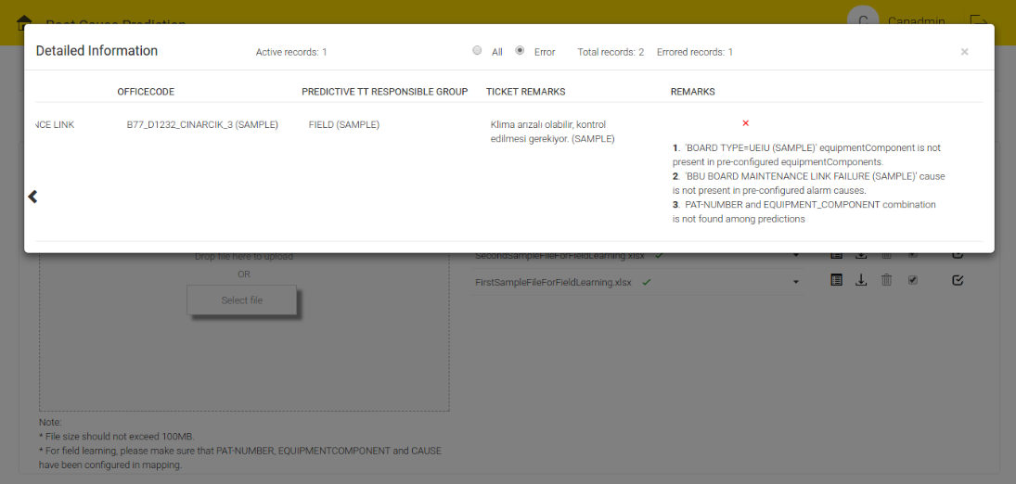
Figure 4.17 - Error Radio Button

To view the whole information, use the pan-right and pan-left tab.

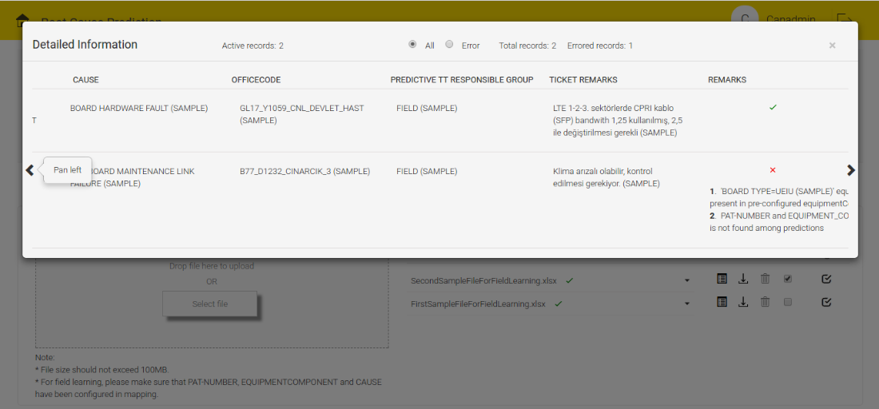
Figure 4.18 - Pan Left and Pan Right to Visualize all

If a file contains duplicate records based on PAT-NUMBER, EQUIPMENT_COMPONENT and CAUSE combination, system would accept the first record and reject others.
For each PAT-NUMBER, EQUIPMENT_COMPONENT and CAUSE combination, if multiple records are there across multiple files, then only the selected record will be active. By default all the records of the active file will be active.
Note: “Duplicate Records Verification” check box will appear only when duplicates are present across multiple files. The checkboxes will appear under “Contains Duplicate Record?”.

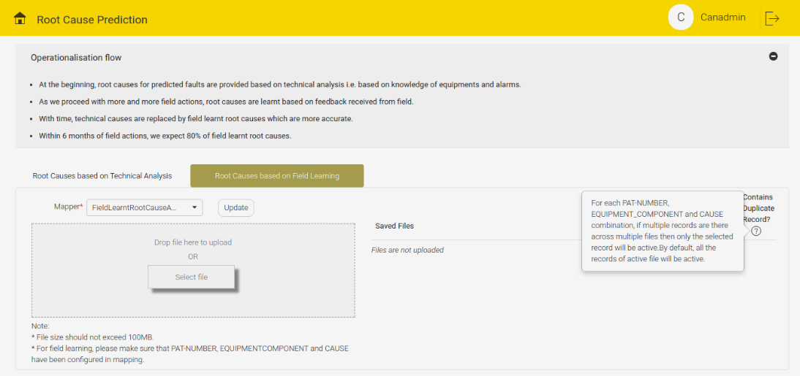
Figure 4.19 - Contains Duplicate Record Queryimage Info

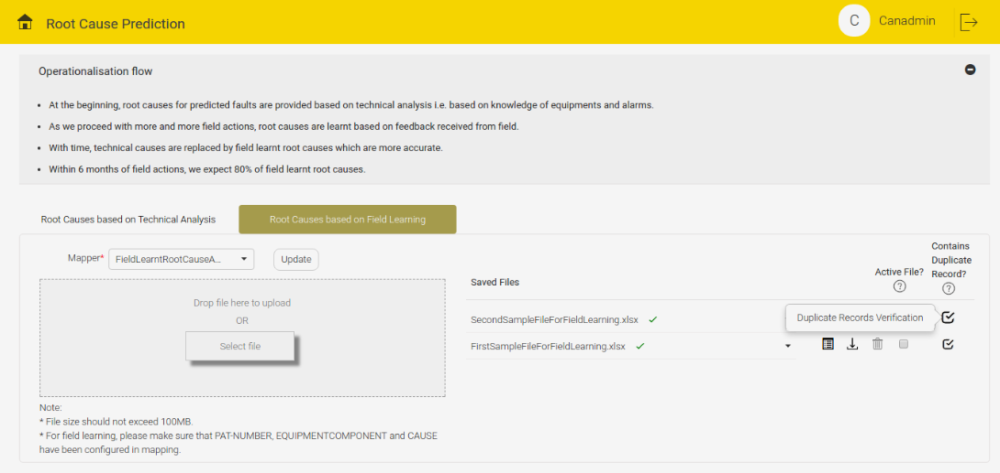
Figure 4.20 - Duplicate Record Verification Section

To view the Duplicate Records Information, Click the “Duplicate Records Verification” checkbox. The Duplicate Records Information displays the following information:
- PAT-NUMBER
- EQUIPMENT_COMPONENT
- CAUSE
The pop up on the screen displays the total No. of duplicate records.

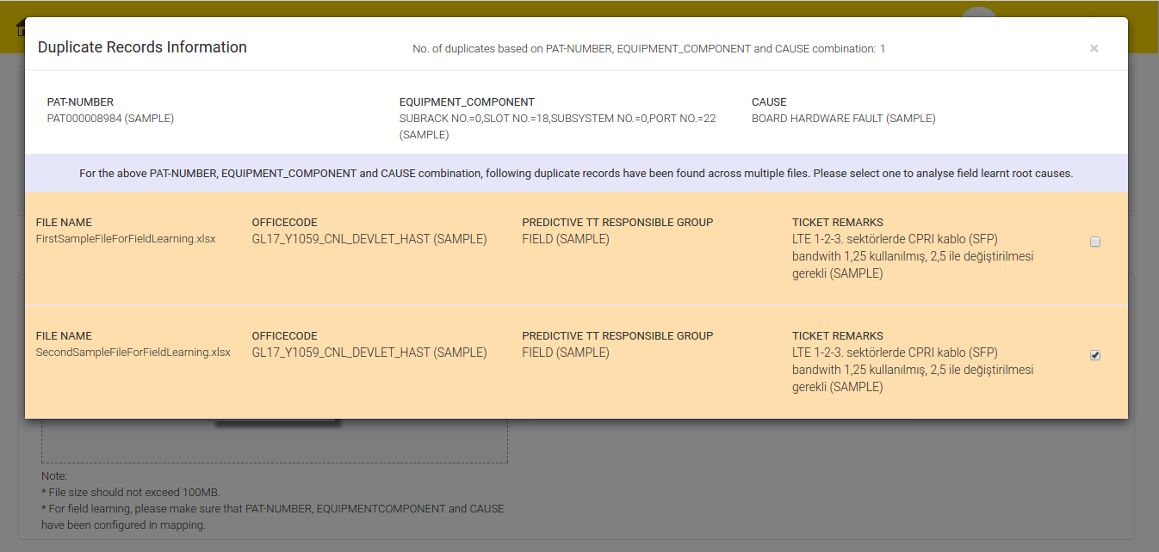
Figure 4.21 - No. of Duplicate Records Count and Duplicate Verification

By default Active Records checkboxes are selected. If required user can select the other file information also. But at a time, user can select only one record among the duplicate records. Once user selects the record, that particular record becomes active.

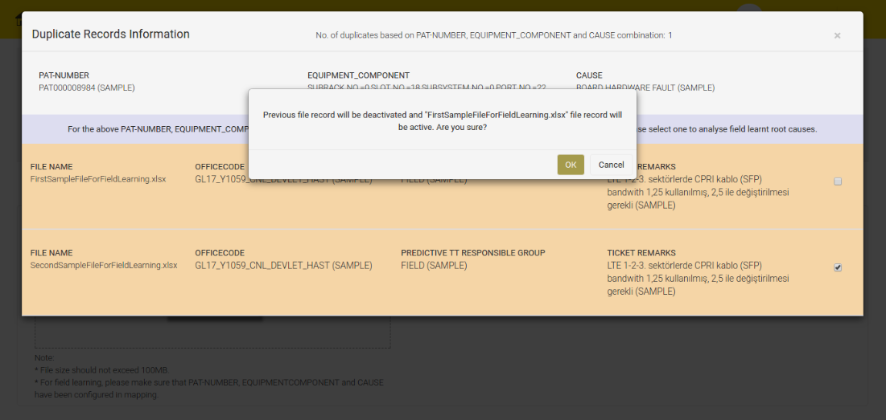
Figure 4.22 - Select the Other File Record

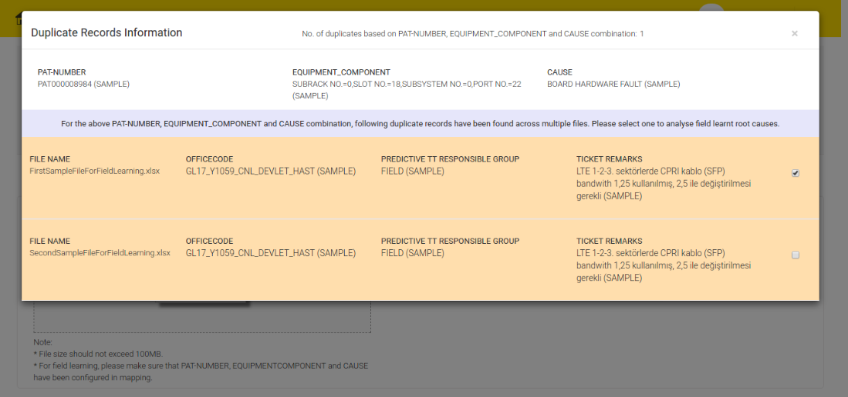
Figure 4.23 - Duplicate Record Verification
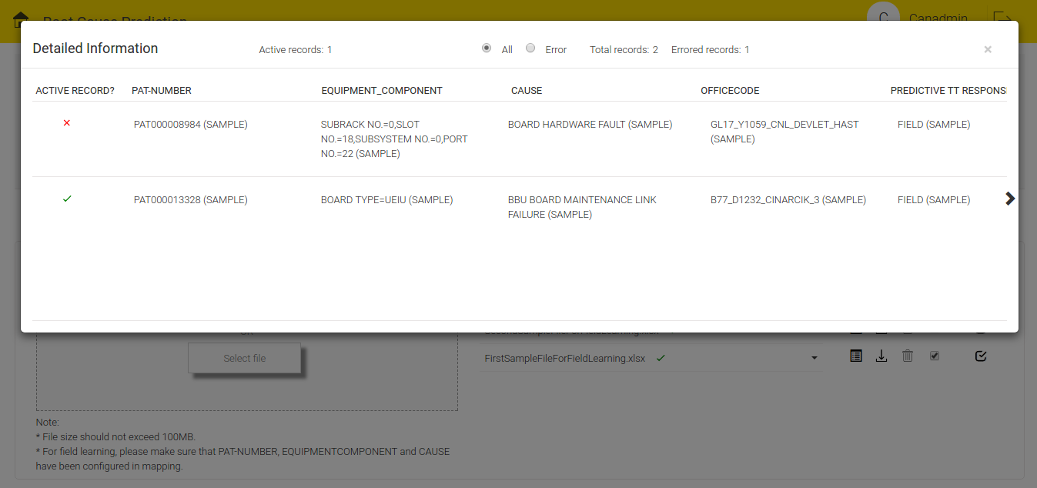
Figure 4.24 - One Record Active

Click the Active File check box to select a file. If that file is the only active file, a message " 'SampleFileForFieldLearntRCA-1.xlsx is already active for Field Learning. This is the only active file. Please make atleast one record active for another file to deactivate this. Click OK to make all the records active otherwise Click Cancel" will appear on the screen.

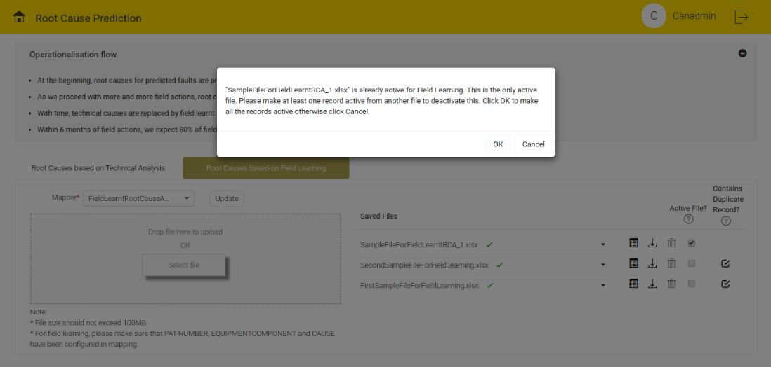
Figure 4.25 - Already Active File

If duplicate records are not available across multiple files and user click to active the deactive file, a message "Field Learning of root causes will be done now based on the "SampleFileForFieldLearntRCA-1.xlsx" information and all the records of this file will be active. Click OK to deactive all the records of other files and make this file active" will appear on the screen.

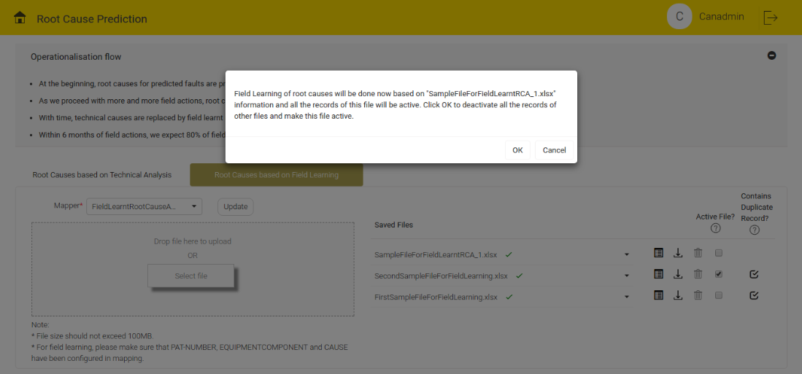
Figure 4.26 - No Duplicate Record Active

If multiple files have duplicate records and user tries to activate one file among multiple files, a message "Field Learning of root causes will be done now based on "SecondSampleFileForFieldLearning.xlsx" file information. Since this file contains duplicate records, please verify those first and then proceed" will pop-up on the screen.

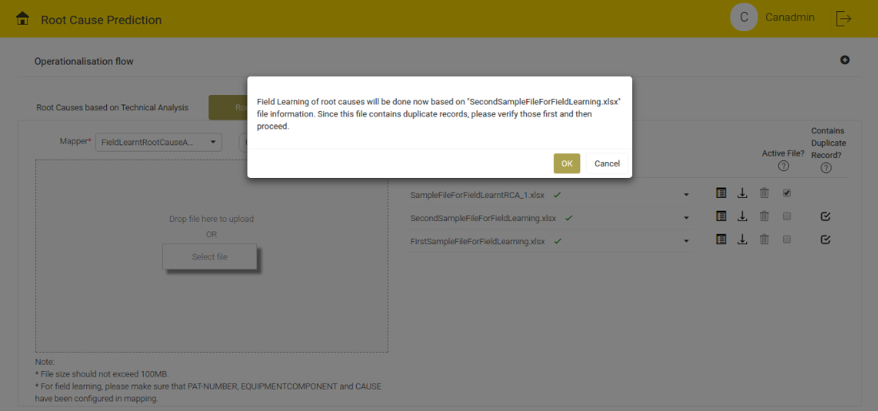
Figure 4.27 - File contains Duplicate Records
If all the duplicates are not verified and user tries to activate the file, a message "Field Learning of root causes will be done now based on "SecondSampleFileForFieldLearning.xlsx" information and all the records of this will be active. Please verify all the dublicates of this file. Click Cancel to deactivate all the record; to continue with the same, click OK will appear on the screen.

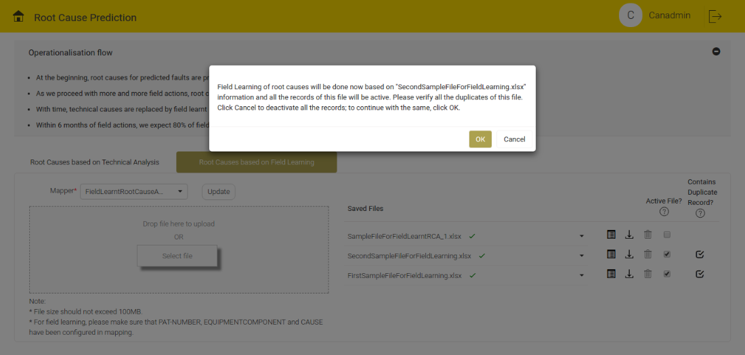
Figure 4.28 - All Duplicates are Not Verified

After all the duplicate verification, click the Active File check box, if the file is already active, then click the 'OK' button to activate all the records.
Click the 'Cancel' button, to retain the previous active record(s).

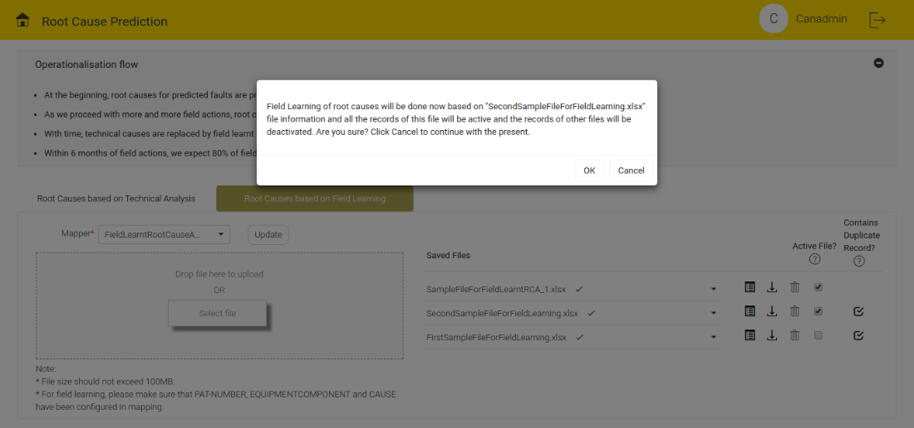
Figure 4.29 - Duplicate Records across Multiple Files

At a time, multiple files can be active. Active file contains at least one active record if there are duplicates among them.

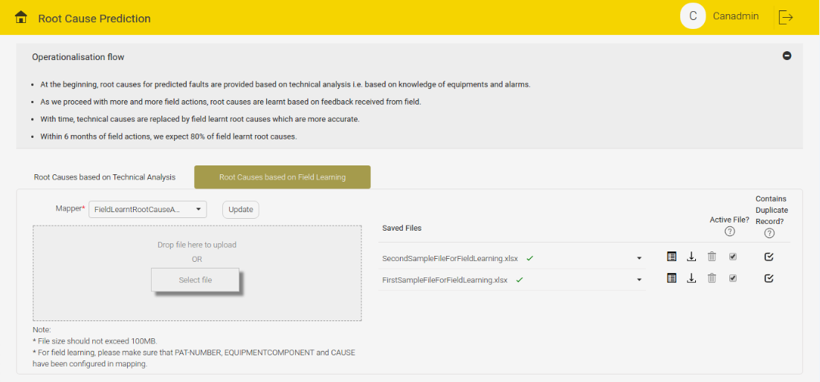
Figure 4.30 - Multiple Files Active at a Time

The following features are common for the above two tabs:
For each file being uploaded, status icon is showed. Banned icon denotes “All records rejection”, which means there is no parsed record.

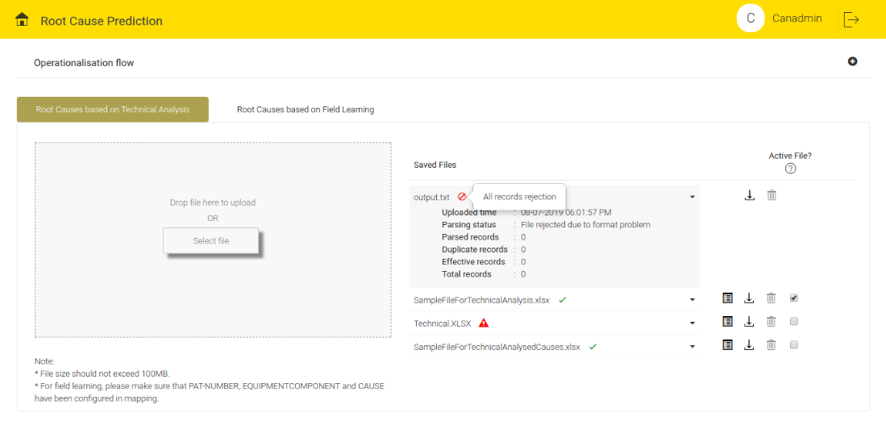
Figure 4.31 - All Records Rejection Details

Alert icon denotes “Completed with partial error” that means effective records count is not equal to total records count for that particular file.

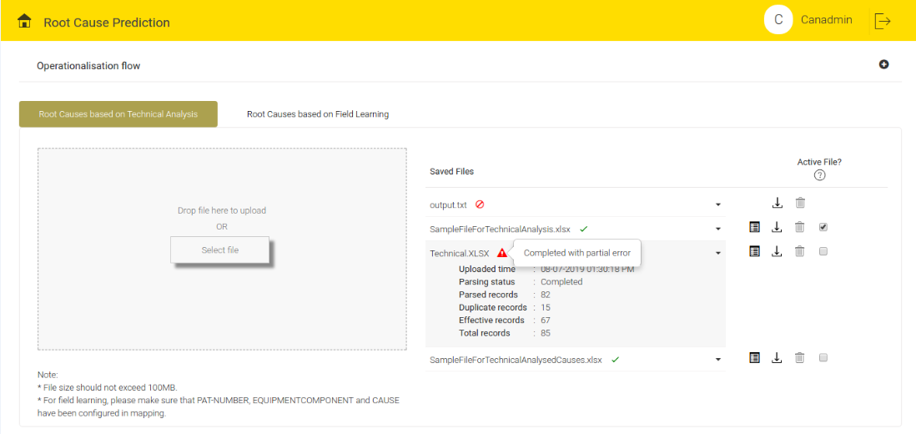
Figure 4.32 - Completed with Partial Error Details

Green tick denotes 'Completed' that means all the records of the file have been parsed successfully and all of them are effective records.

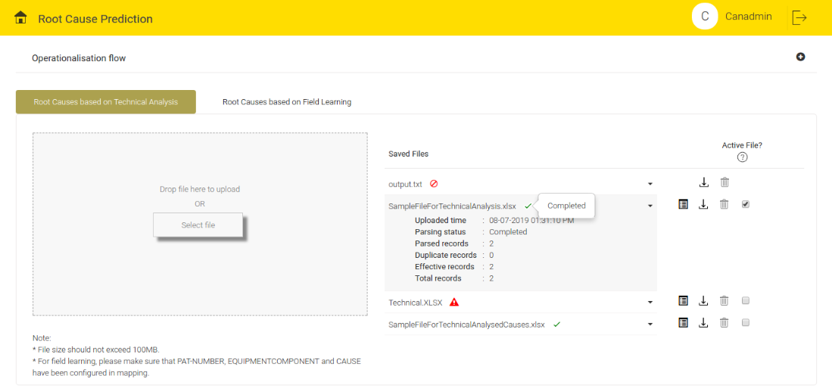
Figure 4.33 - Complete Information

Click the File name or drop-down icon to view the the parsed details of each file. User can see the following details: Uploaded time, Parsed status, Parsed records, Duplicate records, Effective records and Total records.

To download the required file, click download icon.

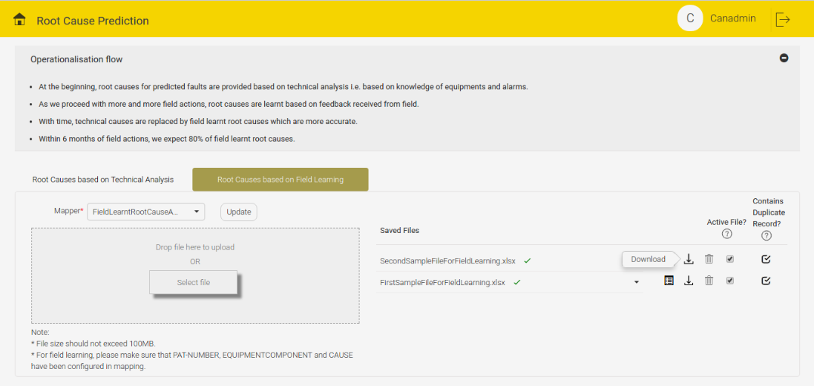
Figure 4.34 - Download Option

To delete the file, click the delete icon.

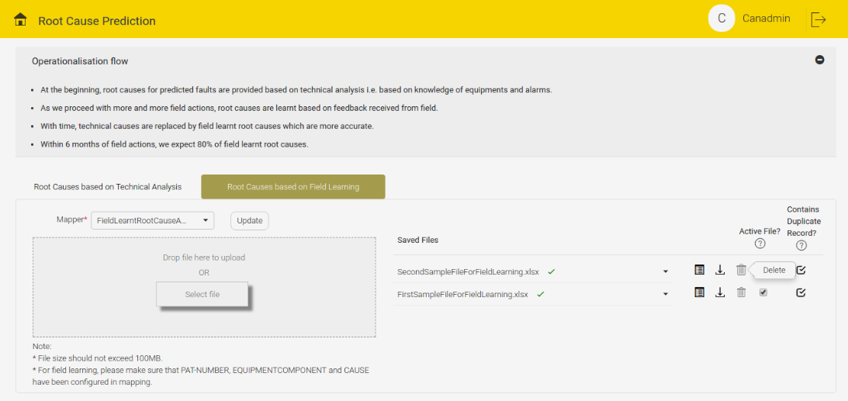
Figure 4.35 - Delete Option

NOTE:
- For technical analysis if user deletes the active file, the first file containing detailed information icon will automatically become active.
- For field learning if user deletes the active file and if no other file is active, the first file containing detailed information icon will automatically become active.

CROSS DOMAIN CORRELATION
This screen displays the Cross Domain Correlation details. It depends on the Alarm data.
If there is no data, the screen displays "No cluster data found". See the below figure for reference:

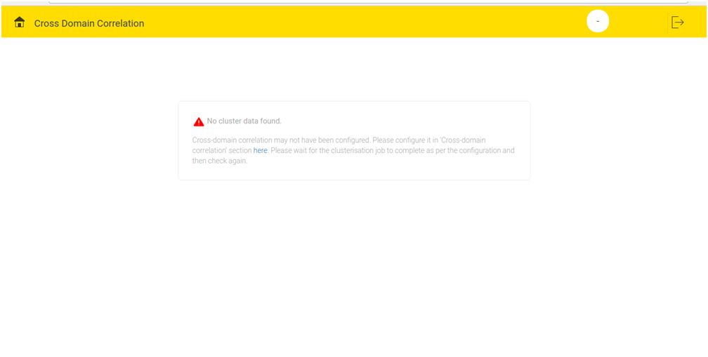
Figure 5.1 - Cross Domain Correlation Screen with No data

When adequate data is available, the page displays all the correlated faults according to their zone. If No. of zones is less than equal to three, then the screen displays all the zones. If zone details are not provided, all clusters/correlated faults are listed under single zone by default.

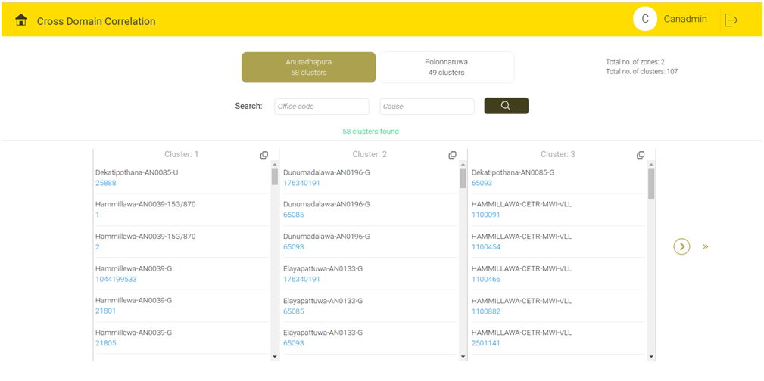
Figure 5.2- Cross Domain Correlation

In case of more than three zones, the screen displays three zones. To navigate to the fourth and the subsequent zones, use the link “Choose another zone”.
When user clicks 'choose another zone', user can see two views.
- Block view
- Bar chart view

Block View:
In block view, zones are arranged alphabetically as individual blocks.
Click the particular zone, to make the particular zone active.

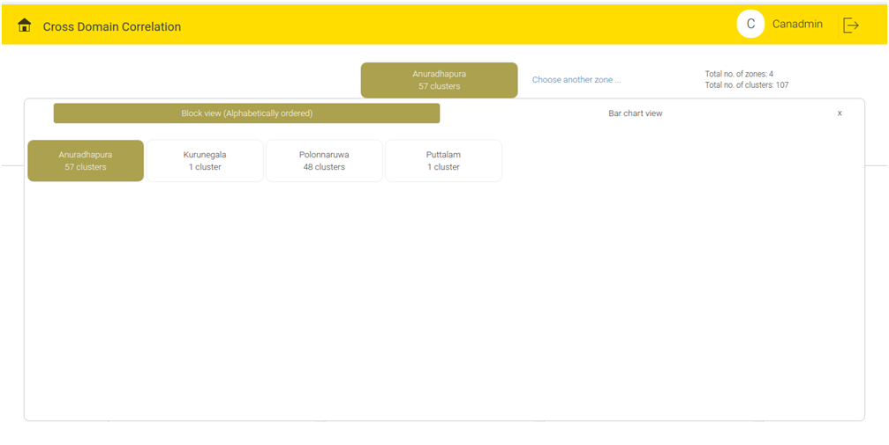
Figure 5.3 - Zone Details Block View
Bar chart view:
In Bar chart view, the screen displays one horizontal bar chart. In the bar chart, the zones are arranged as per the No. of clusters present for that zone.
Click the particular zone, to make the particular zone active.

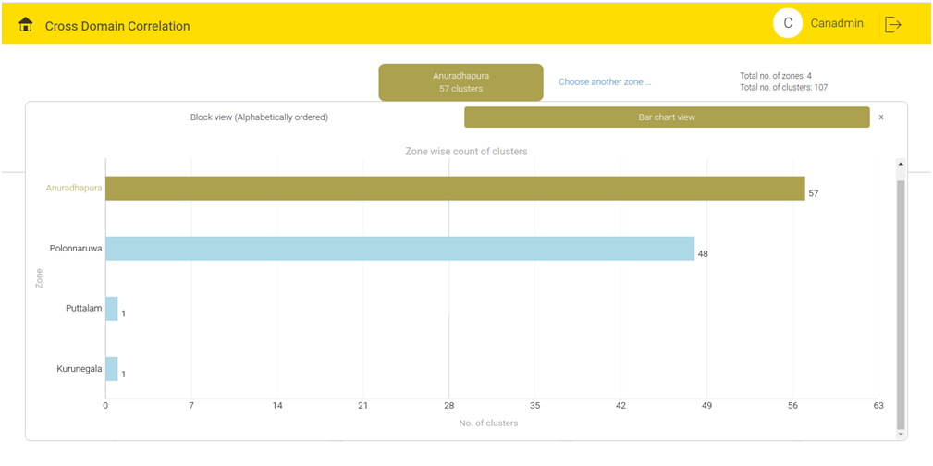
Figure 5.4 - Zone Details Bar Chart View
User can see total No. of zones and total No. of clusters (i.e. Sum of No. of clusters for each zone) at top right corner.

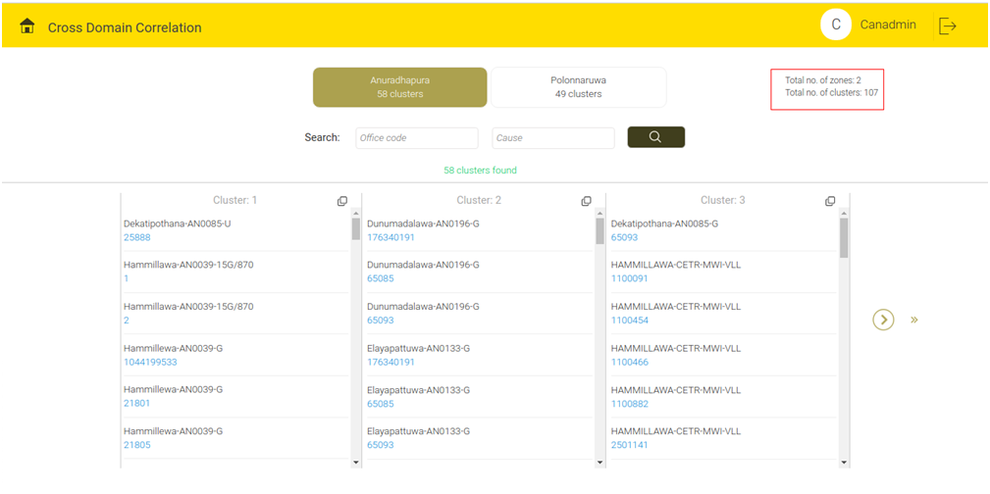
Figure 5.5 - No. of Zones and Clusters

Note: Correlation details will appear for the active zone.

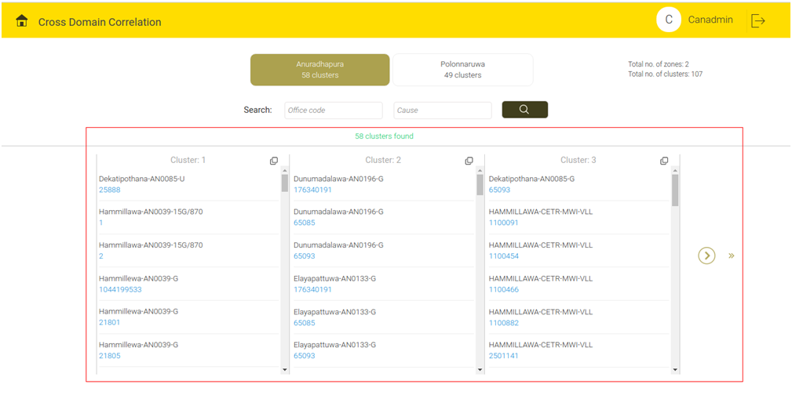
Figure 5.6 - Cluster Details for Active Zone

To see the next cluster, click the single arrow.
To skip the next ten cluster ids, click the double arrow.

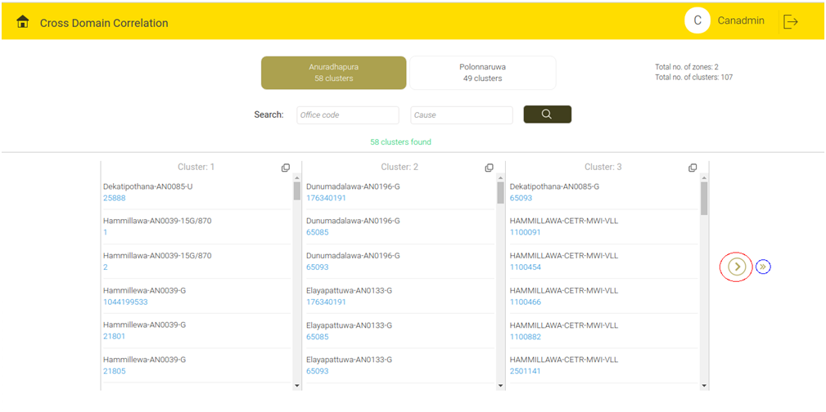
Figure 5.7 - Go to Next Cluster

To search a combination based on office code and cause, use the search button and the input boxes.

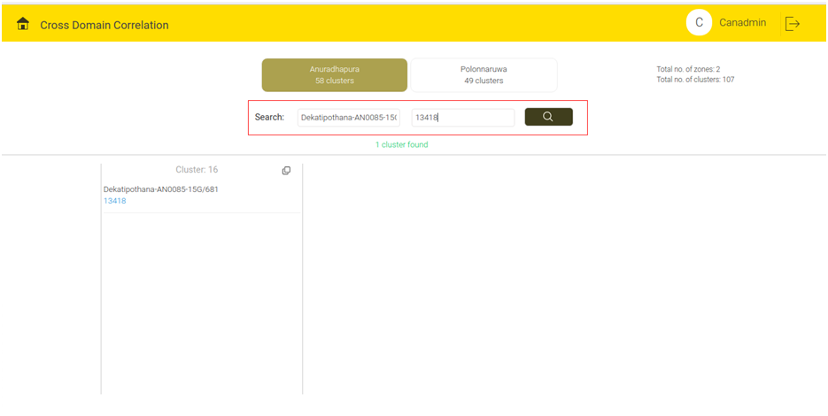
Figure 5.8 - Search Query

To view the details of a cluster, click the more button.

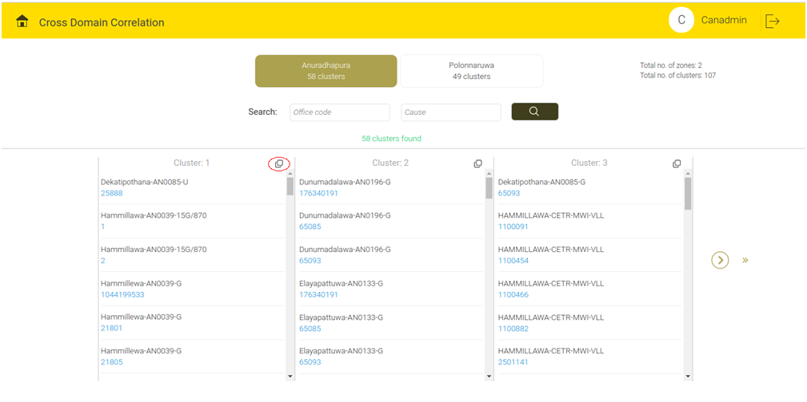
Figure 5.9 - More Option Button

The screen displays one dialog box containing the particular cluster details.
Three kind of views are there.
- Block view
- Bit pattern view
- Map view

Block view:
This view displays all the combinations of Office Code and cause separated by ‘-’ in Block view.

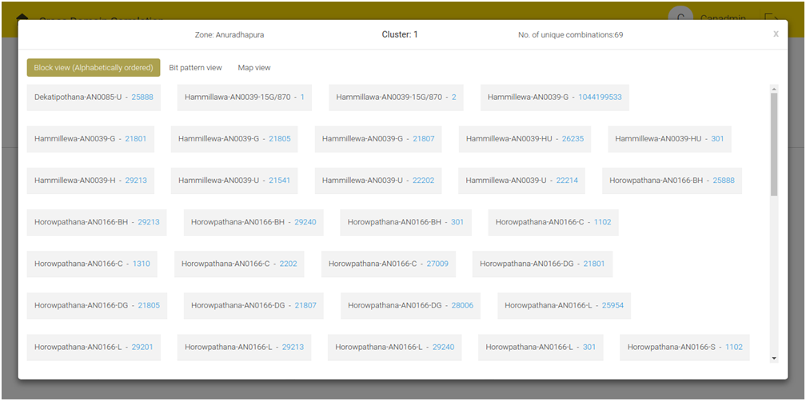
Figure 5.10 - Block View

Bit pattern view:
This view displays all the combinations and the corresponding bit pattern for that combination.
To scroll the pattern side wise, click the buttons. The slider will decide the speed of the scroll.

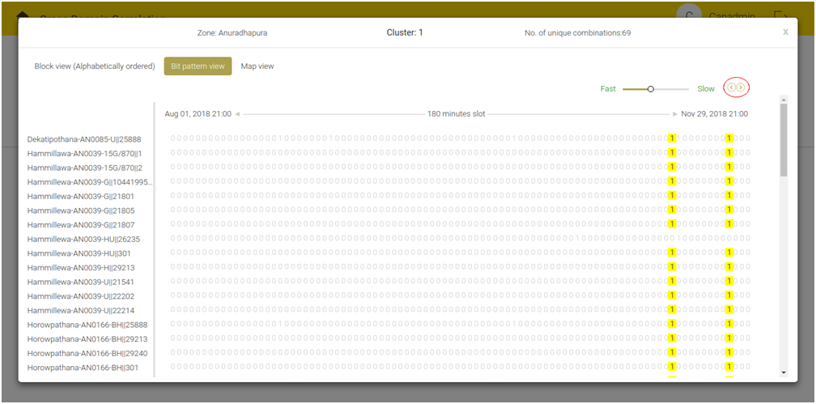
Figure 5.11 - Bit Pattern View
The screen displays the Start date, end date and correlation duration pattern.

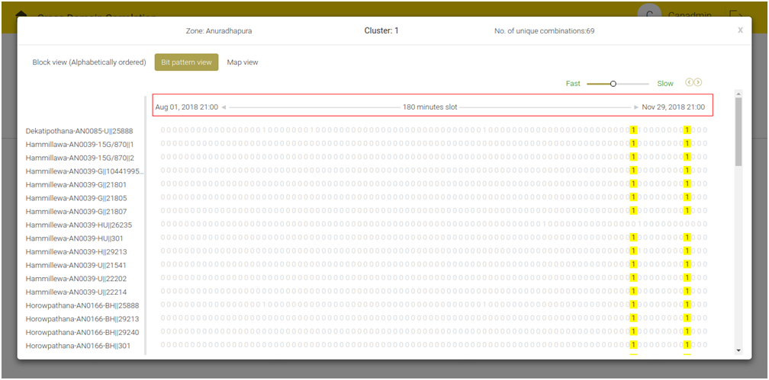
Figure 5.12 - Bit Pattern View

Resize option is there to see the full combination.

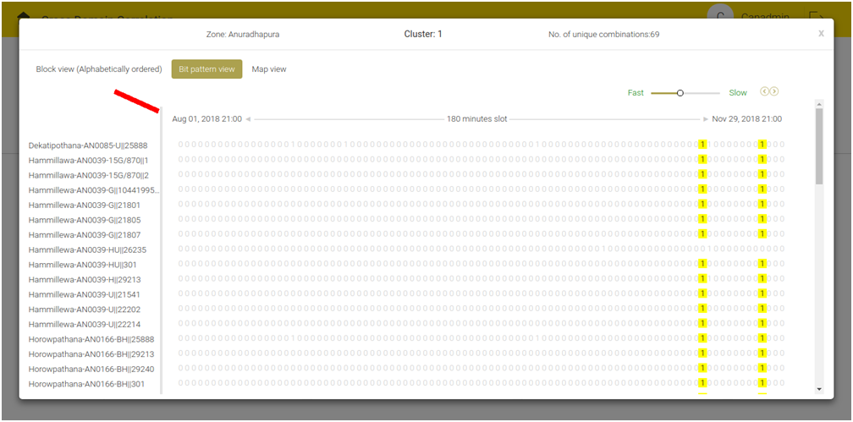
Figure 5.13 - Resize Option
Note: This screen will display only the filtered cluster. If user hovers on the highlighted 1, date and time corresponding to that 1 will be displayed.

Map view:
This view displays the place where the office code and cause are present on a map.
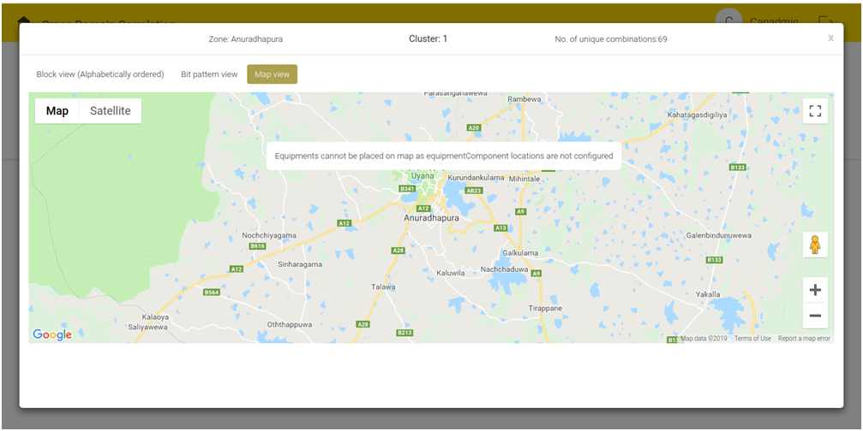
Figure 5.14 - Map View

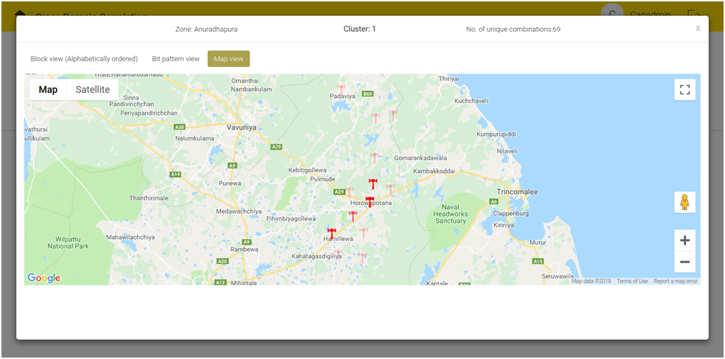
Figure 5.15 - Map View with Pointer

If place details are not present, the screen displays only map but not the pointer.

Figure 5.16 - Map View without Pointer

To see the details of the particular point, click the pointers.
The pop-up on the screen displays the Corresponding office code, cause, equipment component and place details.

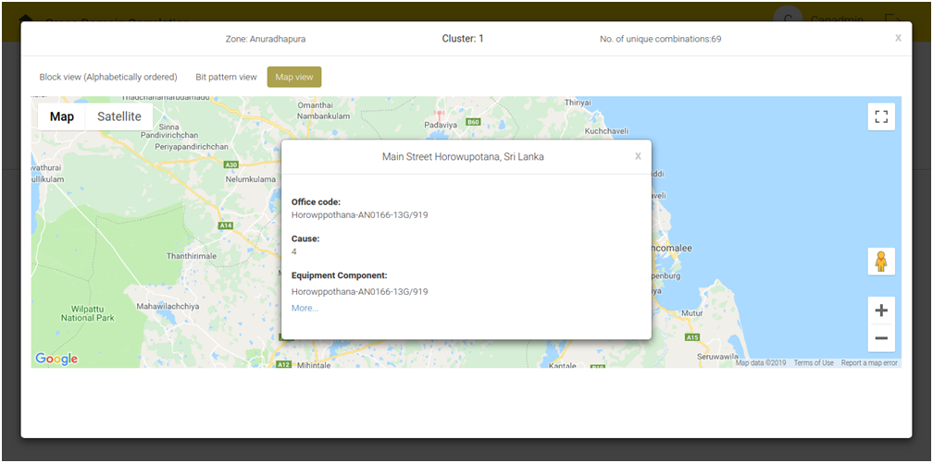
Figure 5.17 - Map View with Details

Click the 'more link' to display the entire list of equipment components attached to the specific pointer.
Click the link to see all the equipment components corresponding to that office code.

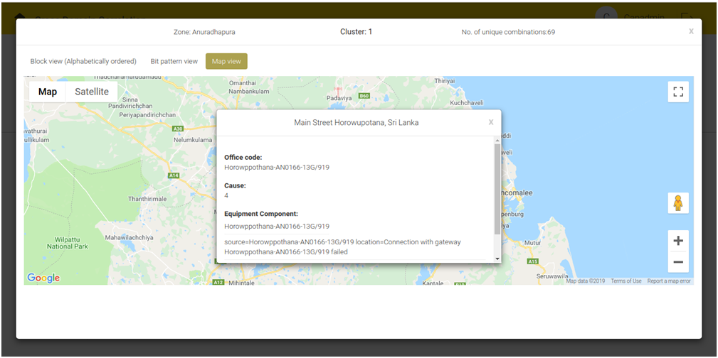
Figure 5.18 - Zone Detail, Cluster Id and No. of Combinations for Particular Cluster

To close this pop-up, click the close button available at the top right corner of each pop-up.
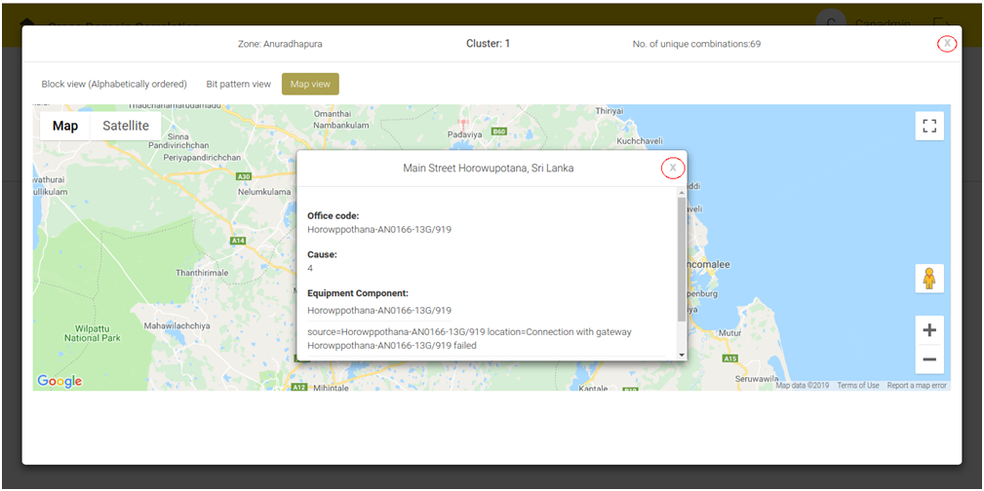
Figure 5.19 - Close Button

Note: Zone detail, Cluster Id and No. of combinations present for this particular cluster is shown above.

FAULT ANALYSIS
Fault Analysis allows the user to track the closed faults at any point in time. User can filter the closed faults based on different criteria and analysis. User can filter the Fault Analysis to show or not to show the Cause Categorization depending upon the Display Cause Categorization present in the Visual Preferences section. To select the Tabular or Map view, click the Tabular icon  or the Map icon respectively (the default view depends on the selection made in the Visual Preferences option on Adaptation tab).
- Faults are classified as per priority (Low, Medium, High) and legend of markers in this page are similar to that of Predictive Failure Analysis screen.
- To choose the faults, click the calendar button. It displays the closed alarm window.

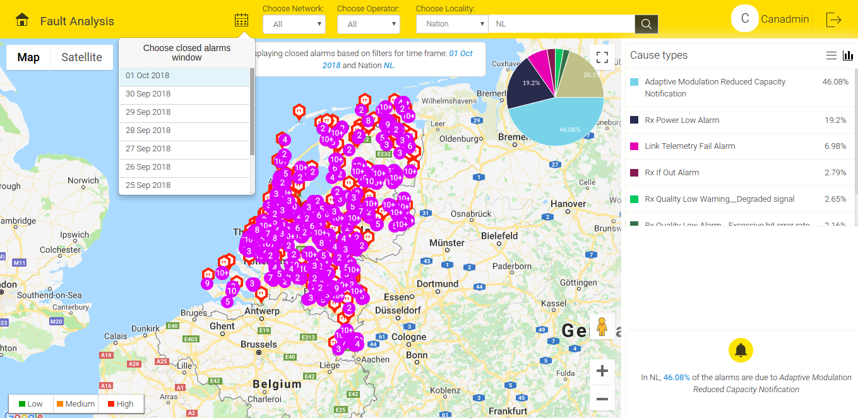
Figure 6.1 - Fault Analysis (Map View)

Location based search and representation of Cause types remain same as Predictive Failure Analysis screen.
Under Advanced Configuration tab, in the Visual Preferences section, select Yes on the Group tickets to group the Fault Analysis Alarms.

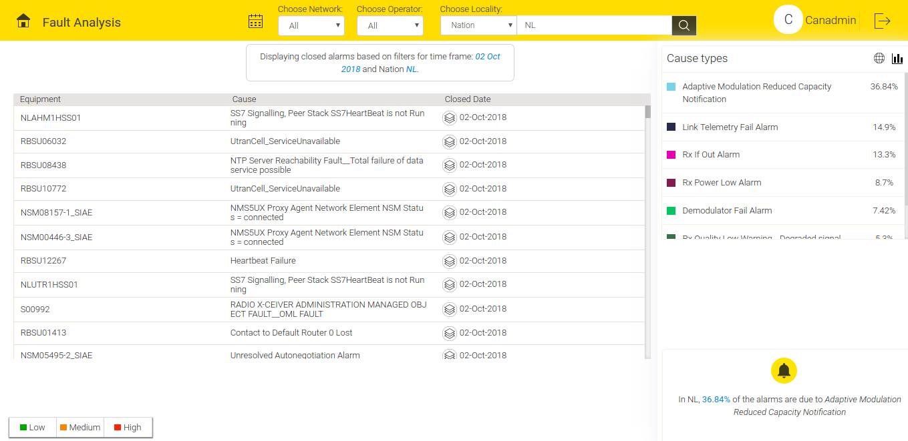
Figure 6.2 - Fault Analysis Grouped Alarms

Under Advanced Configuration tab, in the Visual Preferences section, select No on the Group tickets to ungroup the Fault Analysis Alarms.

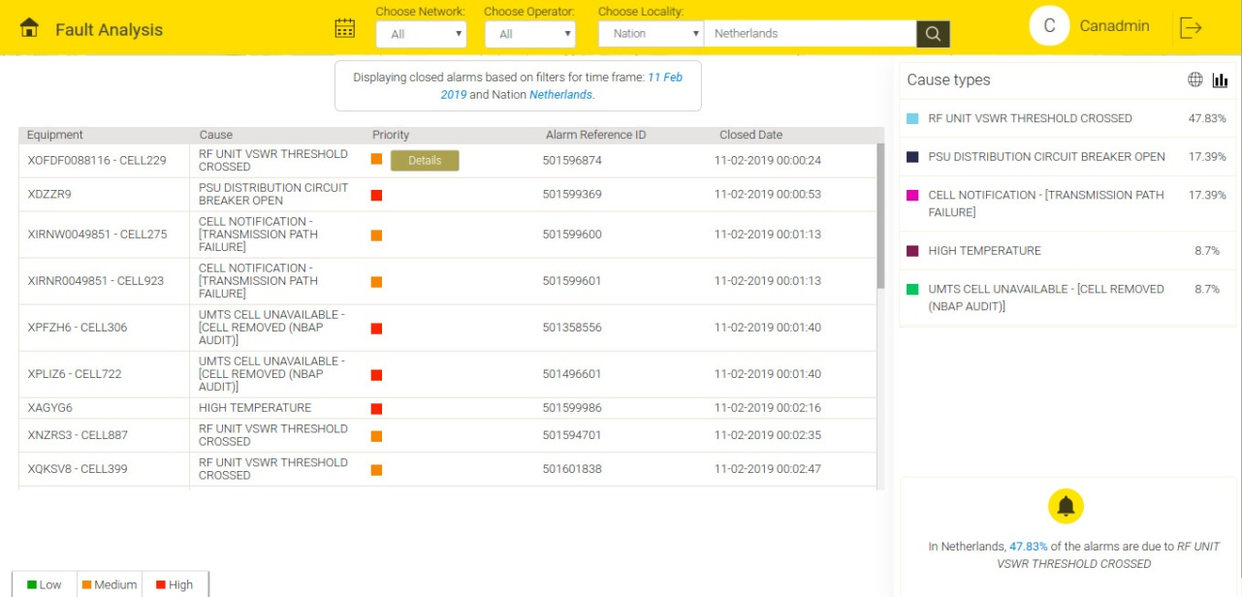
Figure 6.3 - Fault Analysis of Ungrouped Alarms (Tabular View)

Upon grouping, alarms with same equipment and cause occurred on the same day shows in tabular view as a single entry

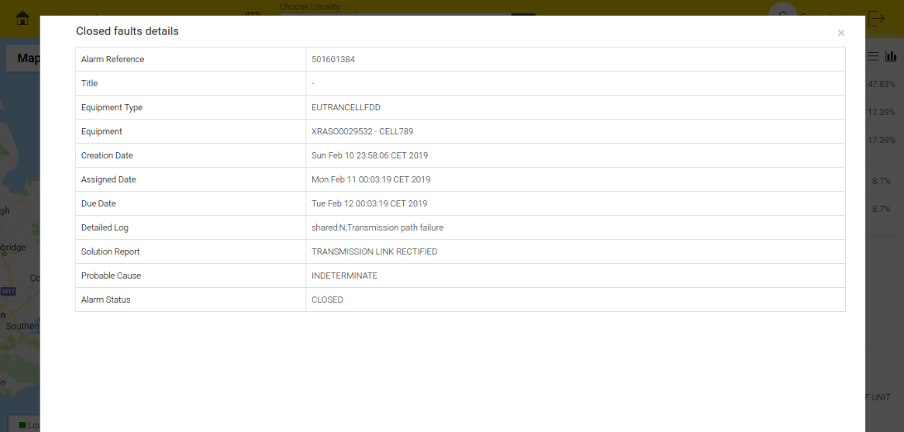
Figure 6.4 - Close Fault Details

To view the details of the multiple occurrences of alarms, click .

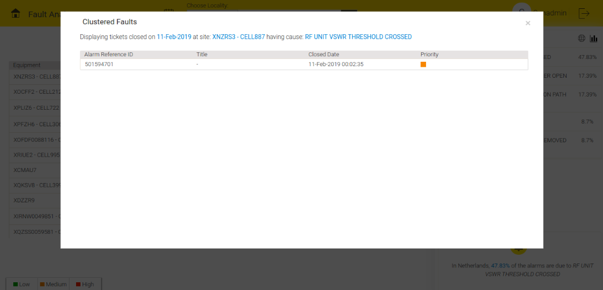
Figure 6.5 - Clustered Faults

Work Order Status
- Work order stats tracks and analyses alarms on a monthly basis over a period of year. This is shown in a bar chart view and tabular view. When the user click a particular bar on bar chart representation, corresponding tabular view gets generated for the selected month.
Equipment and cause category filters can be applied for the same.

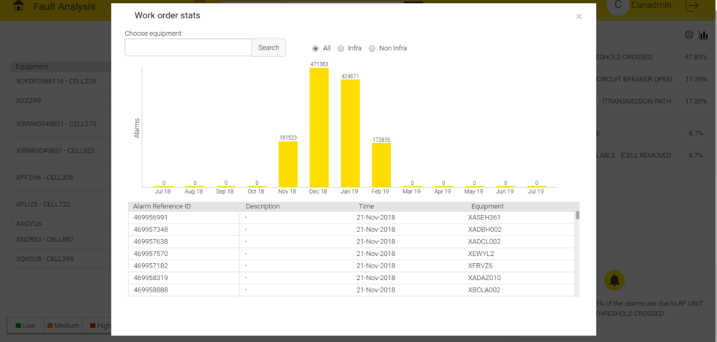
Figure 6.6 - Work Order Stats

TECHNICIAN WORK PLAN
User can access the screen from the dashboard home. The Technician Work Plan tab has two options: Recommendations and Resolved Tickets.

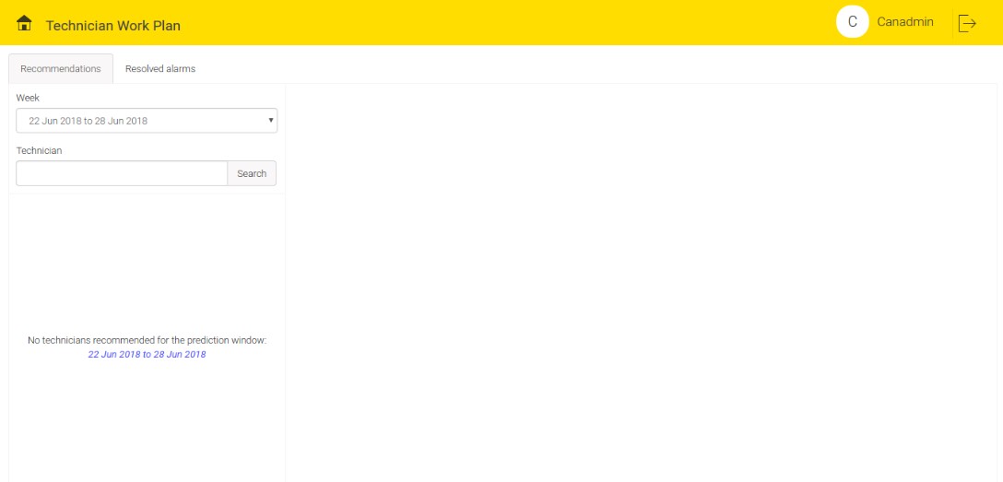
Figure 7.1 - Technician Work Plan

Click the ‘Recommendations’ tab and choose a week from the drop down menu. Screen displays the list of technicians most suitable to solve the related fault. The screen also displays the technician’s availability. If certain technician is not available, the work will be deployed to next most suitable technician available. When user select a technician, user can see his work plan for a week.

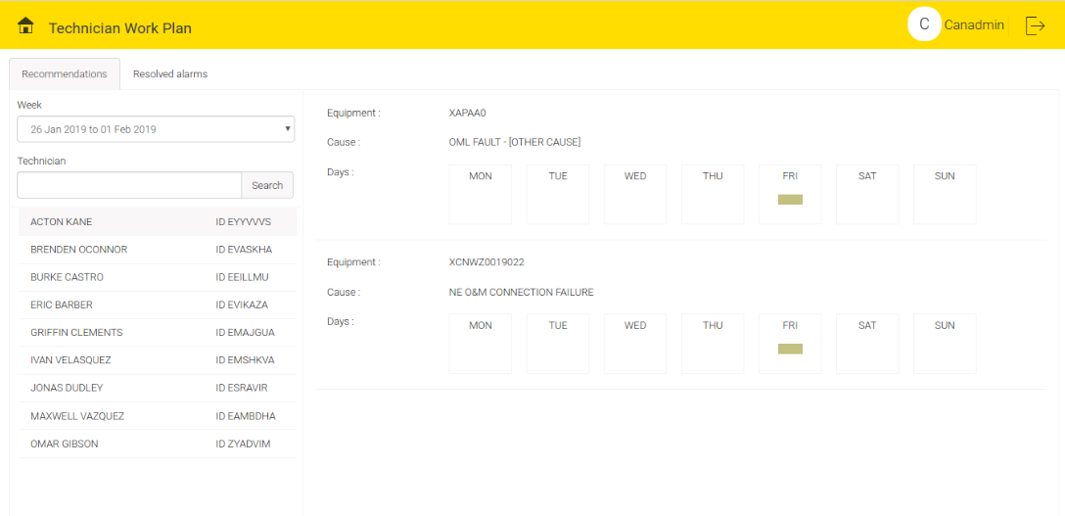
Figure 7.2 - Recommendations
Click ‘Resolved Tickets’ on the screen.
On the screen, in the Technician Search box, select the name of the technician from the drop down menu. The screen displays all the resolved tickets mapped with technician’s name.
To see the details of the Resolved Tickets, click the Particular Month Column button.
This screen displays the Resolved Tickets Information of last 13 months.

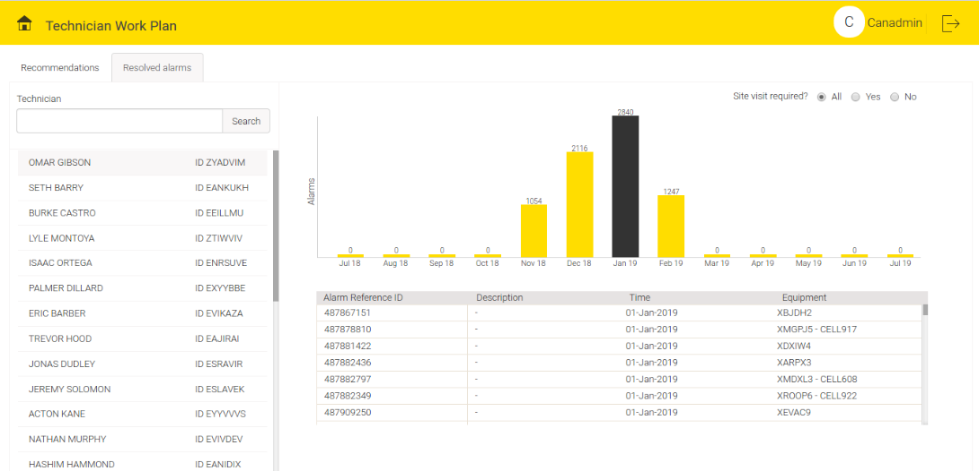
Figure 7.3 - Resolved Tickets

INVENTORY
This screen shows the required items for the site engineers to resolve the predicted faults in the equipment. This enables early procurement of the required inventory, results in faster issue resolution even before the actual ticket registration in the trouble ticket management system.

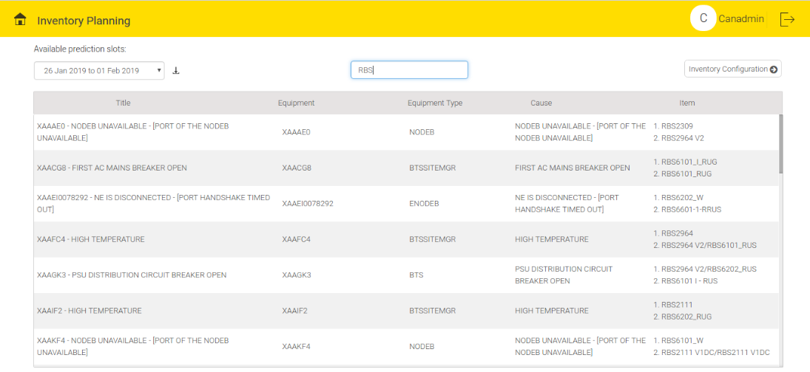
Figure 8.1 - Inventory Planning Home Page

This screen is used to map the inventory items with the Alarm attributes such as Equipment, Cause and Equipment Type. Scroll down to see the list.

Click the 'Inventory Configuration' button to see the list of equipment items.

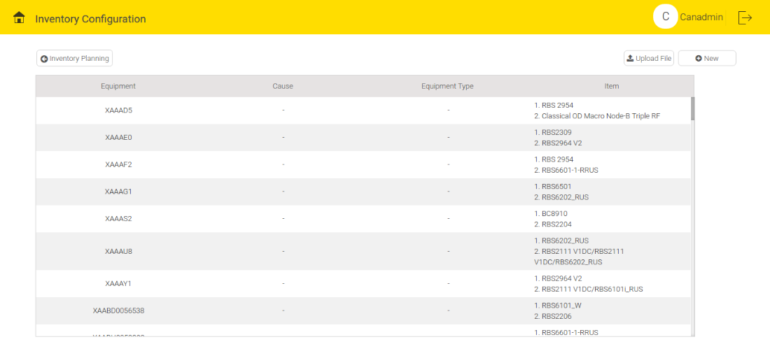
Figure 8.2 - Inventory Configuration Screen

To upload the file, click the ‘Upload File’ button on the screen and drag and drop the inventory file.

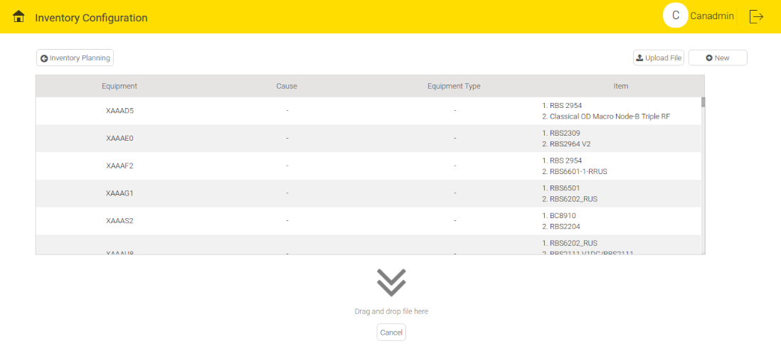
Figure 8.3 - Upload File Screen

To add a new equipment item, click the ‘New’ button on the screen. Add the categories manually or choose from the existing drop down menu.

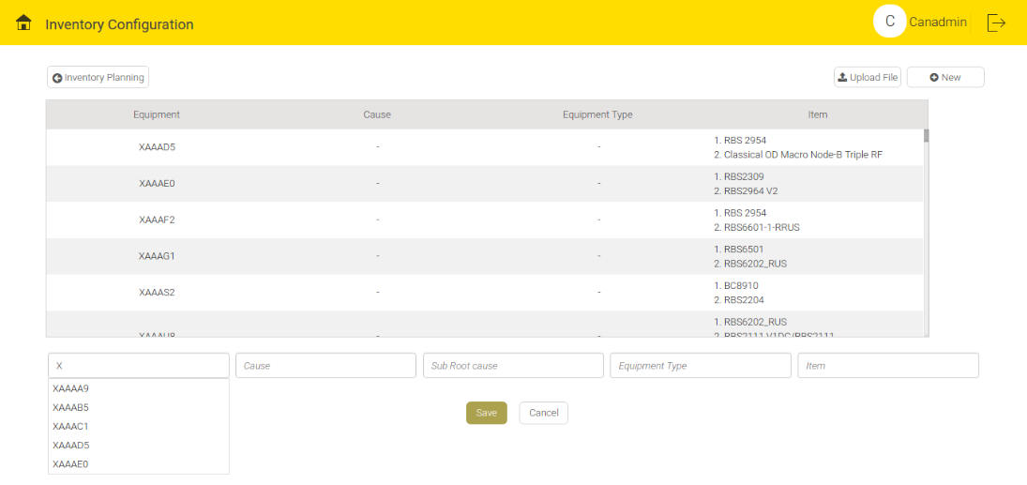
Figure 8.4 - New Equipment Item Addition Screen

To update one of the existing equipment items, click and select the equipment. Do the changes manually or choose from the existing options.
To save the changes, click the 'Update' button. Similarly, select and delete an equipment item.

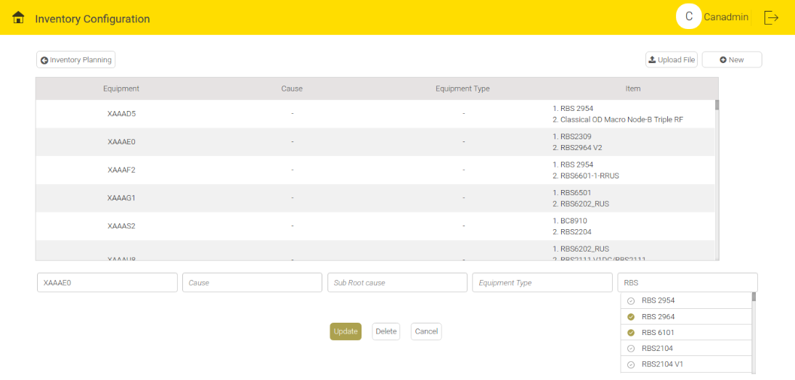
Figure 8.5 - Update or Delete Equipment Item Screen

ANNOUNCEMENT
This screen is useful for the administrators at the NOC. The Announcement tab generates a continuous stream of critical problems that can be eventually projected on big screen for the information and necessary actions of related teams

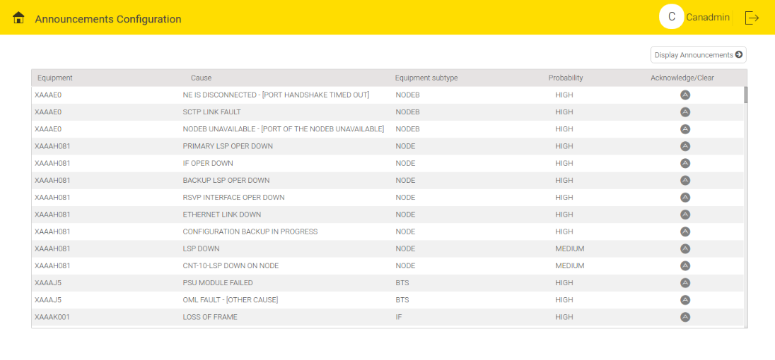
Figure 9.1 - Announcement Home Page

To view the announcements, click the 'Display Announcements' button .

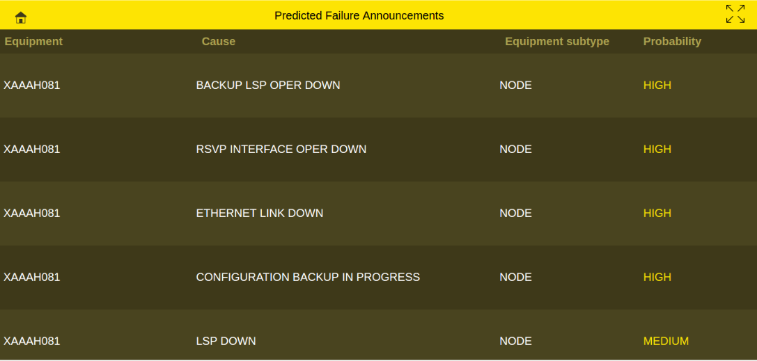
Figure 9.2 - Display Announcement Screen

USER MANAGEMENT
User management helps to control the user access.
Roles supported are Super User, Admin, Circle Manager and Zone Lead. Each role has following accesses:

Super User | Admin | Circle Manager | Zone Lead
Predictive Fault Analysis | Predictive Fault Analysis | Predictive Fault Analysis (related to concerned circle) | Predictive Fault Analysis (related to concerned zone)
Fault Analysis | Fault Analysis | Fault Analysis | Fault Analysis
Cross Domain Correlation | Cross Domain Correlation | Cross Domain Correlation | Cross Domain Correlation
Technician Work Plan | Technician Work Plan | Technician Work Plan | Technician Work Plan
Inventory Planning | Inventory Planning | Inventory Planning | Inventory Planning
Announcement | Announcement | Announcement | Announcement
Root cause analysis | Root cause analysis | Root cause analysis
User Management | User Management
Settings | Settings
Monitoring | Monitoring
Adaptation
Table 1 : User Roles

User Management screen comprises of three tabs:
Manage roles
Manage users
View logs

Manage roles
This tab allows to add, delete , search and modify the existing roles. On top portion of the screen, user can see the tabular view of existing roles. Below the tabular view, there is a slot to set new role. In the new slot user can add role name, circle and cities (Figure 10.1).

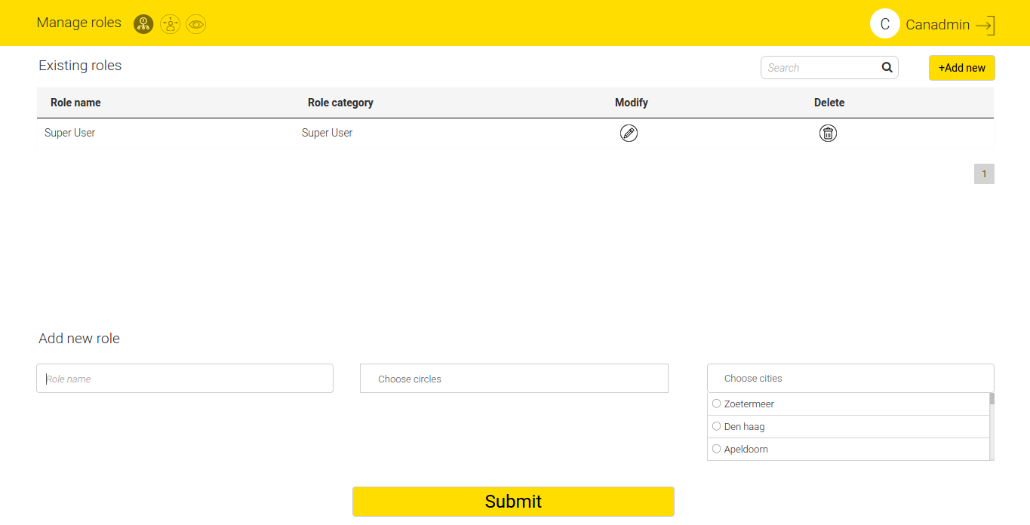
Figure 10.1 - Manage Roles

Manage users
The screen displays the details of existing users of CAN. The details include username, email id, role assigned to user, expiry date of a particular user, current status of the user. It also displays resume/suspend state of the user.The functionality of this screen allows to add a new user, modify the existing user details and delete the existing user .

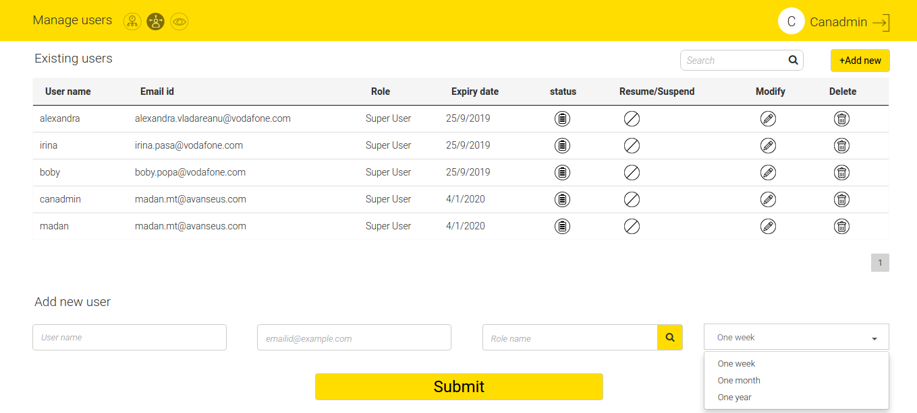
Figure 10.2 - Manage users

View logs
This screen displays up-to-date CAN log activity from various users. User can search for a particular activity based on the username, date period, activity type (all, log in, log out, password change) and location.

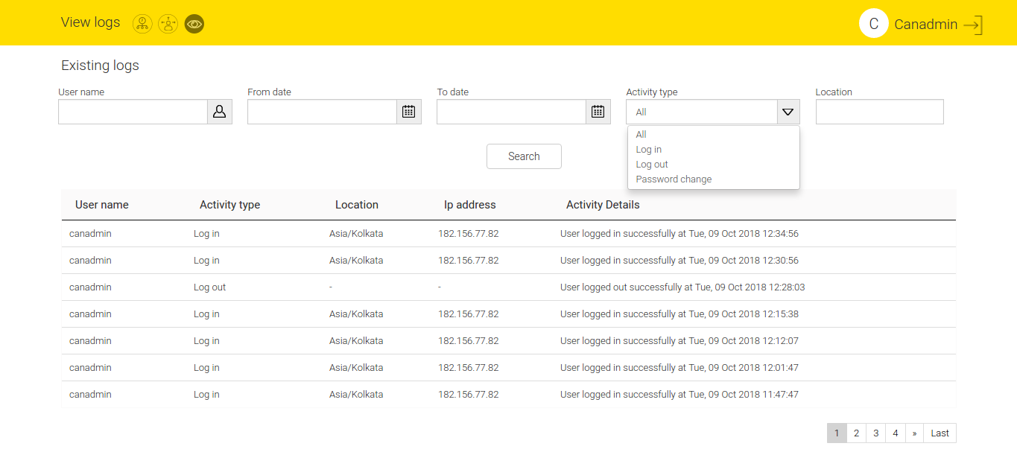
Figure 10.3 - View logs

SETTINGS
Executives can visit the settings page to modify the application level configuration.
To modify the application level configuration, click the settings tab .
Settings are classified under five tabs:
- Cause Management – Manage the Causes relevant Configurations by giving them an alias by setting in display name field, classify them as INFRA or NON-INFRA and provide a slot to totally remove them from prediction generation by toggling in Exclude column.
- Announcement Exclusion Rules – Useful at NOC for administrators and network fault resolution team to get real time notifications/announcements of the major and top priority predicted faults. This is a focal point for network troubleshooting, supervision, monitoring and management.
- Technician Availability – This helps to record the technician availability in real time for work assignment.
- Mailing List – The mailing list is used to configure the mail ids of the executives into groups to send them the prediction report and other important reports.
- Equipment Component Configuration – This screen is used to view and edit the latitude and longitude of the equipment. Validated the same against the geo coding API.

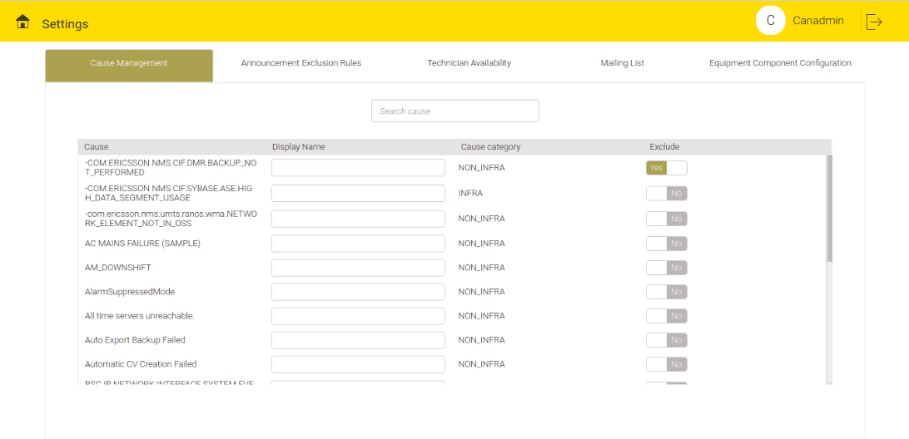
Figure 11.1 - Cause Management

Rule Configuration for Announcement Exclusion
This screen is maintained in order to create rules to exclude certain predicted faults for the announcements.
User can create and modify the rules in the same way as that of Alarm Exclusion Rules screen.

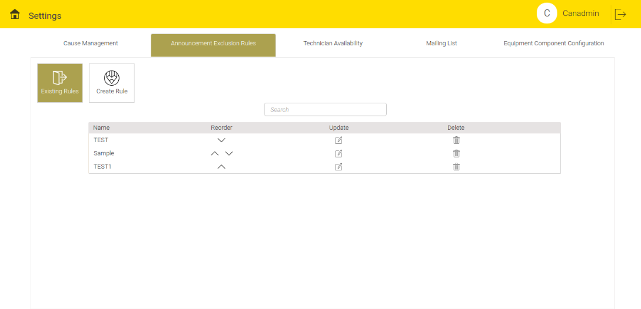
Figure 11.2 - Rule Configuration for Announcement Exclusion

Technician Availability
This screen helps to check the availability of technicians. A list of technicians is available here along with their type – either External or Internal – with their ids. User can search specific technicians in the Search bar.

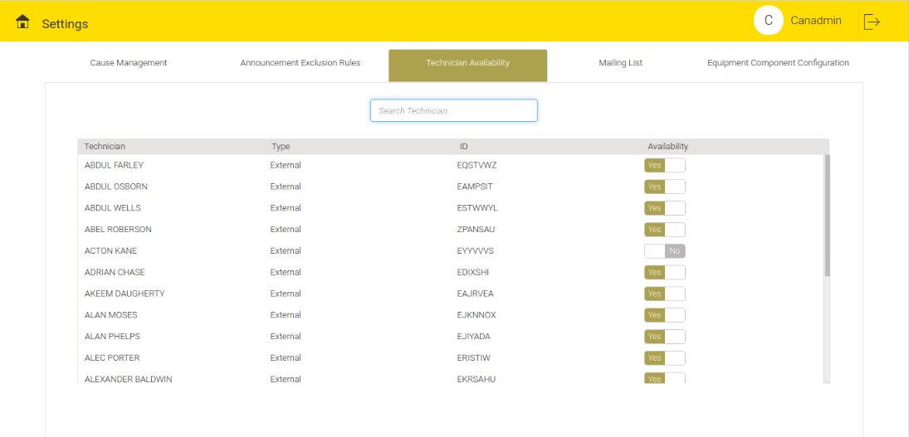
Figure 11.3 - Technician Availability Screen

Mailing List
Mailing list comprises of the groups with individual email ids of the end users, responsible to act on the Predicted Faults. Other important application related mails will also be sent to this mailing list.
To edit an existing mailing group, click the Edit menu. Add or delete the Email ids accordingly.
To create new mailing groups, click the 'Create Group' button.

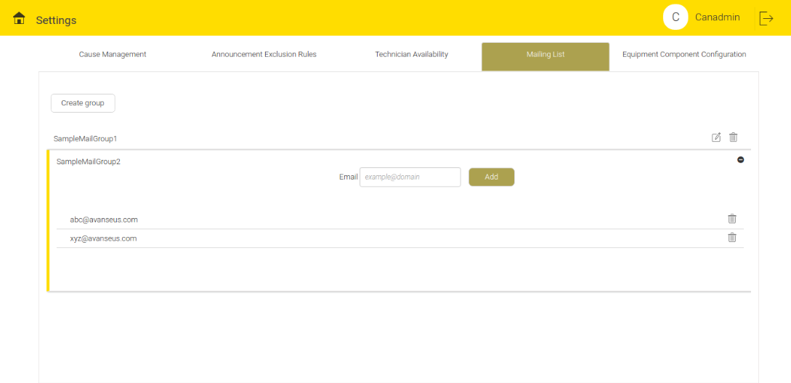
Figure 11.4 - Mailing List

Equipment Component Configuration
This screen helps to configure the equipment along with appropriate latitude and longitude. These (Latitude and Longitude) must be valid as per the geo-coding API. The first column displays the list of equipment and one can scroll down to access the entire list.

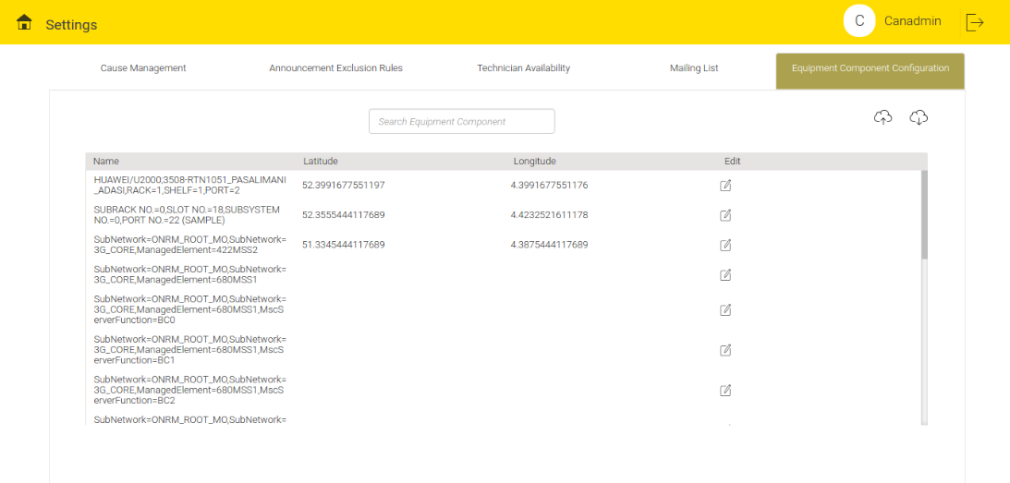
Figure 11.5 - Equipment Component Configuration

To edit any of the equipment details, click the Edit menu.
To download the equipment details, click the Download icon .
To upload or update equipment details, click the Upload icon . Either select the file from a location or drag and drop the file.
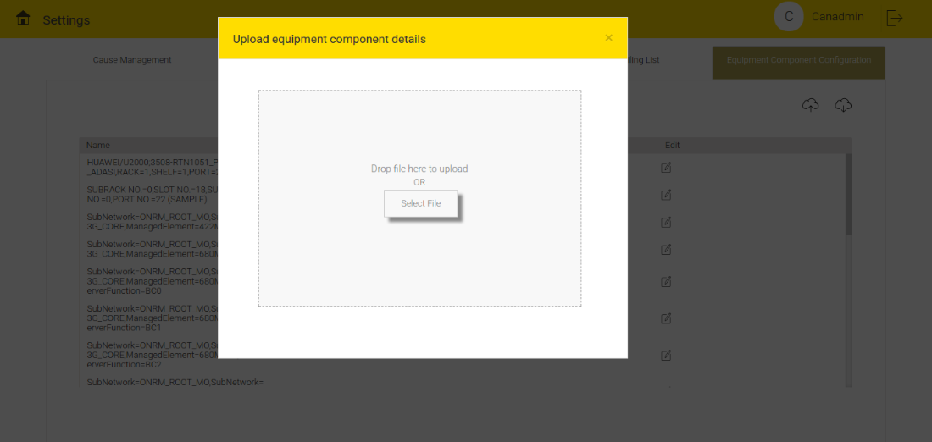
Figure 11.6 - Uploading/Updating Equipment Details

MONITORING
Monitoring allows the user to receive information on the system operation. This tab has two options: Data Collection Audit and Notification Handler.

Data Collection Audit
This screen displays the count of De-Duplicated Records, Relevant Records, Discarded Records, Net Records and Aggregated Records on a daily basis.
User can click each row to see the details of File Parsed Info, File Parsed Status, Start Time, End Time, Time Difference (in HH:MM:SS format) with previously mentioned count stats for file on a daily basis (Figure 12.1).
To view the information on Discarded Records Category, click the icon .
Discarded Category includes counts of Preprocessor Rejected, Postprocessor Rejected,No OfficeCode No Equipment, No EquipmentComponent, NoCause, No Creation Date, No Category, Others, No Ticket ID, No Ticket Creation Date, No Performance Counter Creation Date and Error.

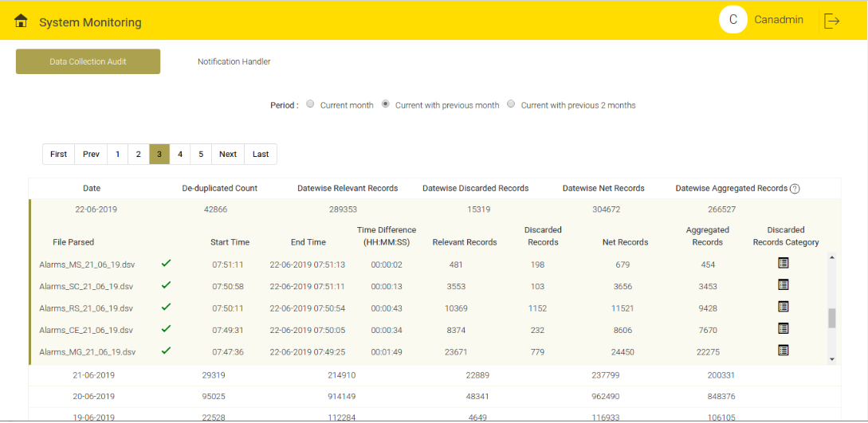
Figure 12.1 - Data Collection Audit

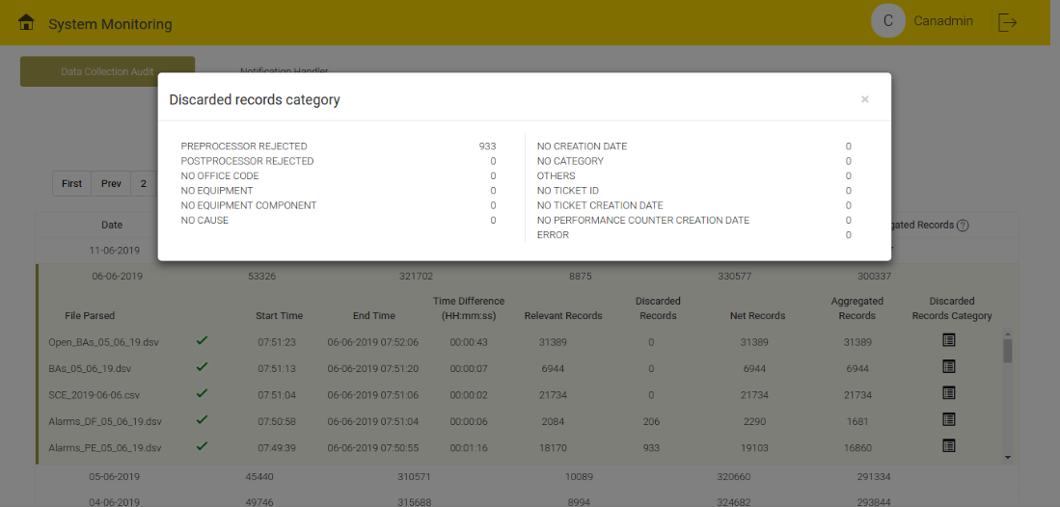
Figure 12.2 - Discarded Record Category

Notification Handler
This screen is used to configure success (Figure 12.4) and failure (Figure 12.5) emails for various email groups. When enabled, notification about various processes such as Data Collection, File Availability, Alarm archival etc. will be sent to mail ids listed in mail group (Figure 12.3).

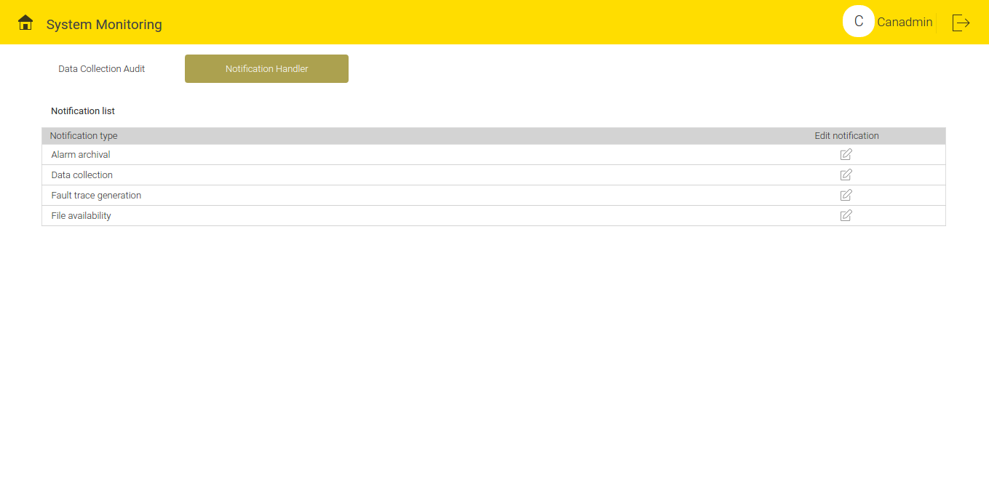
Figure 12.3 - Notification Handler

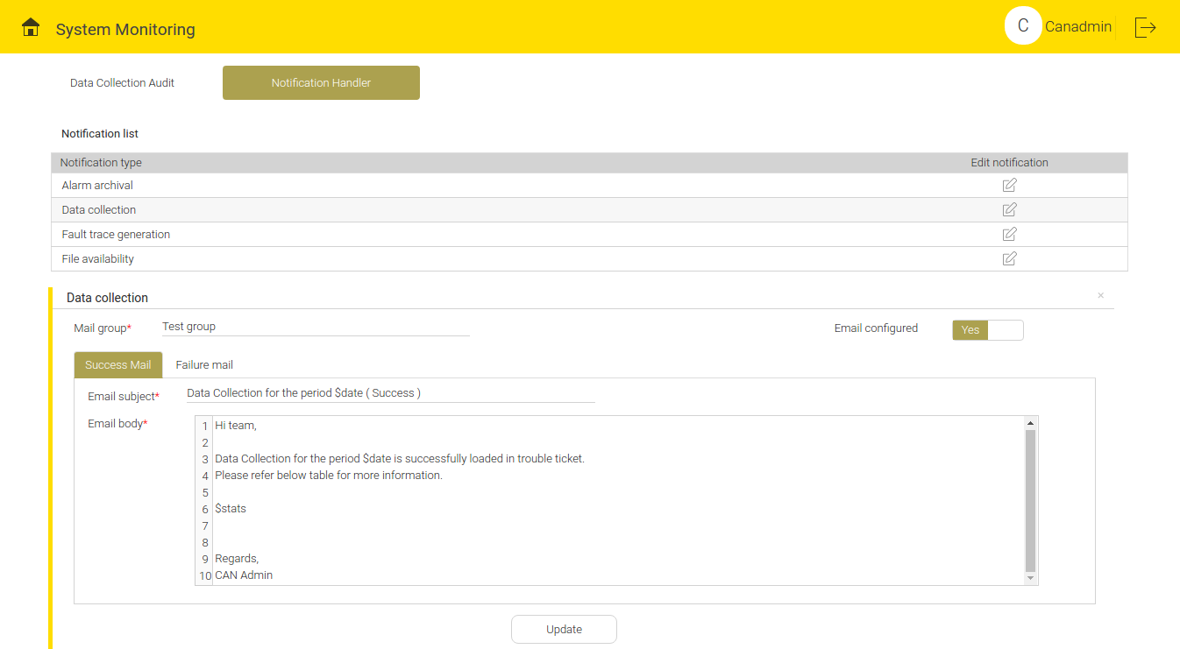
Figure 12.4 - Success Mail Template

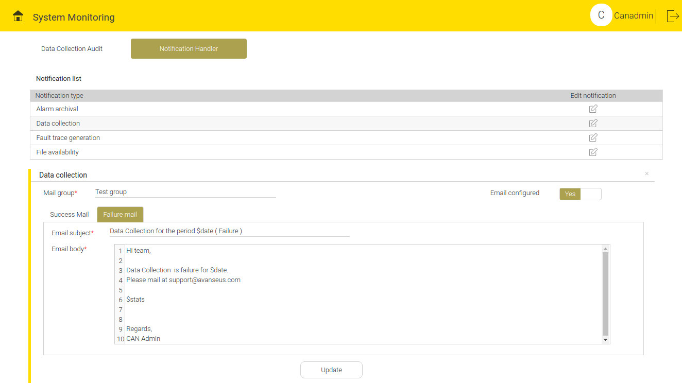
Figure 12.5 - Failure Mail Template

ADAPTATION
Adaptation helps to integrate new data sources and refine prediction output based on expert knowledge.

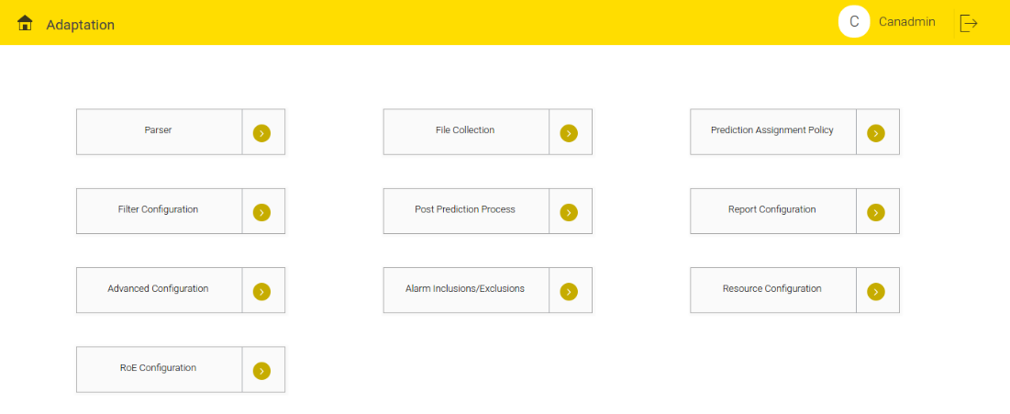
Figure 13.1 - Adaptation Screen

It consists of following 10 tabs:
- Parser –User can set the Configurations related to loading client data files here. 3 options fall under this category.
- Pre-processor
- Parser
- Post-processor
- File Collection – User can set the Configurations required to pull files from remote sources.
- Prediction Assignment Policy – It is used for prediction load distribution.
- Filter Configuration – User can configure the rules to filter and optimize predictions here.
- Post prediction Process – User can upload the customizable code to be executed post prediction.
- Report Configuration – The result of Prediction in Excel format is made configurable.
- Advanced configuration – Developer related Configurations.
- Alarm Inclusions/Exclusions – Allows user to configure alarm filters.
- Resource Configuration – Allows user to upload master data files which can be later used to fetch some information.
- ROE Configuration – Helps to identify the root cause of a prediction based on multiple alarm parameters.

Parser (Input Mapper)
This is found under the Adaptation on the main home screen. Its function is to map the client input data with the CAN model. These two data structures need to be in sync to generate results. A client input data file should be synced with the CAN fields.
- To add New parser Configuration, click the 'Add New' button .
- To delete the names of existing parser configuration within Saved Mappings section, click the delete button .
- File Level info contains fields that includes Name, Description of parser, File type, Page size, Pre-processor, Post-processor, Presence of header, and few file type specific details.
- The usual format of file type is XLSX, DELIMTED, CUSTOMDELIMTER, CUSTOM.
- In XLSX file type, Sheet Names should be specified. Add multiple sheet names and separate them with colon (:).Empty Sheet names field will consider all the sheets in the file.
- In DELIMITED file type, Delimiter (single character that separates 2 columns) and Escape Character fields needs to be recognized from input file and set accordingly. Row delimiter in this case is by default new line character (\n).
- In CUSTOM file type, a popup provides an option to upload java file. This java file must contain code for parsing custom files formats. This code implements ICustomFileParser interface.
- In CUSTOMDELIMITER file type, column delimiter (multiple character that separates 2 columns), row delimiter (multiple character that separates 2 rows) and escape character needs to be set.
- Page size defines batch size of records to be parsed at once while parsing input data.
- Pre-processor and post-processor is auto completed that already have existing pre and post processor Configurations.
- Select Yes on the toggle switch 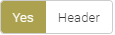 to select the Header in the file.
- Beneath File level info, a tabular view is present which helps in mapping client data with CAN conventions. This contains Mapping Name and CAN Fields. Mapping Names are the header names found in input files (In case there is no header name, its convention starts with 0 as 1st column,1 as second column and so on). CAN Fields are standard conventions maintained in CAN. These configurations are customizable and can be added or deleted as per client requirements.
User can add additional CAN fields in the table. To add the additional CAN field in the table, click the 'Add' button . The screen displays a pop-up of standard CAN fields for selected data source, user can select the appropriate field. If input parsing requires a new field that is not part of standard CAN fields, user can add new field i.e. custom fields. To add custom field, Click and select the Custom option in CAN field popup.
On the Mapping column, when user click the Edit menu , a pop up opens up on the screen. User can write a valid class name and corresponding java mapping code in the text area. To compile the code, click the 'Compile' button and to save the code, click the 'Save' button To edit the saved code, click the Edit menuat the right top corner of text area and recompile if needed.
Click the 'Update' button to update the edited Parsers and click the 'Save' button  to save the newly created ones. If user will not save the changes, parser screen will not reflect the changes.

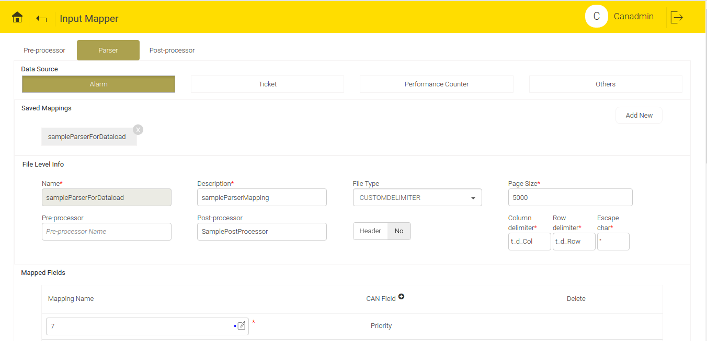
Figure 13.2 - Parser Screen

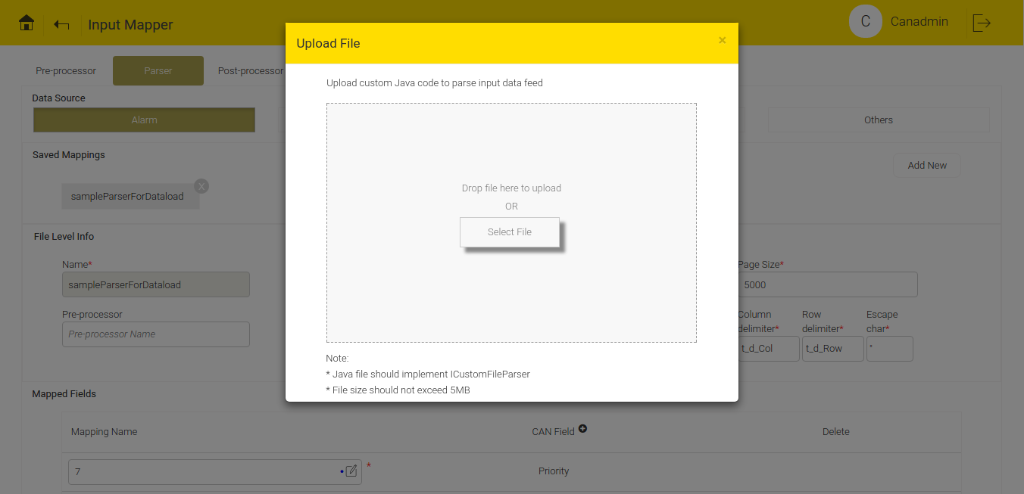
Figure 13.3 - Custom File Upload

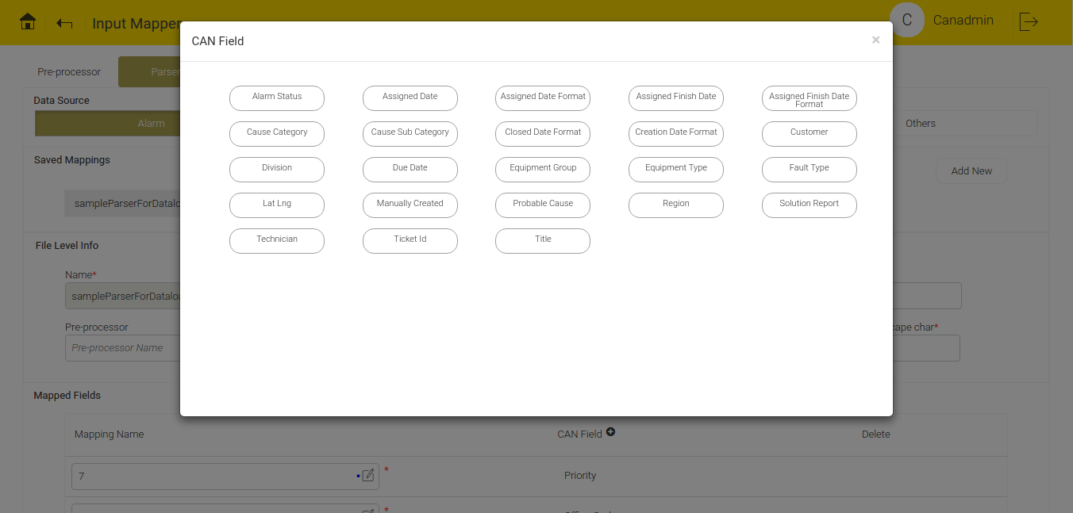
Figure 13.4 - CAN Fields

Sample Java Code for Parser Screen
if(row.get("MO_IDENTIFIER") != null && !row.get("MO_IDENTIFIER").isEmpty()) {
equipment = row.get("MO_IDENTIFIER");
if (equipment.contains(".")) {
equipment = equipment.substring(0,equipment.toLowerCase().lastIndexOf(".nl"));
}
}
return equipment;
Figure 13.5 - Java Code before Compilation
Java code is written if any modification is required in mapped column while parsing.
The above java code will actually implement IParserUserField interface which provides row object as parameter. Row object is a key value pair of header name (In case there is no header name, its convention starts with 0 as 1st column,1 as second column and so on) and header value. In the above example, code is written to eliminate “.nl” from equipment name. Likewise, code can be written to concatenate two columns, modify column values and so on.
This implementation doesn’t require class definitions, only code snippet is sufficient. But return statement is mandatory.
package com.avanseus.generated.parserCode;
import com.avanseus.helper.Record;
import com.avanseus.eventFileFormat.IParserUserField;
import java.util.Map;
import com.avanseus.database.mongo.MongoPersistenceManager;
import java.util.List;
import com.mongodb.BasicDBObject;
import com.avanseus.model.can.Priority;
import com.mongodb.DBCursor;
import com.mongodb.BasicDBObject;
import java.util.List;
import java.util.regex.Matcher;
import java.util.regex.Pattern;
import com.mongodb.DBObject;
import java.util.Date;
import java.util.*;
import java.text.SimpleDateFormat;
import java.util.Calendar;
public class SiteNlimplements IParserUserField {
@Override
public Object getRow(Record row) {
String equipment = null;
if (row.get("MO_IDENTIFIER") != null &&!row.get("MO_IDENTIFIER").isEmpty()){
equipment = row.get("MO_IDENTIFIER");
if(equipment.contains(".")){
equipment=equipment.substring(0,equipment.toLowerCase().lastIndexOf(".nl"));
}
}
returnequipment;
}
}
Figure 13.6 - Java Code after Compilation

After compilation, add the necessary packages and import statements. Add the code snippet written within text area inside override method of Equipment class that implements IParserUserField interface.
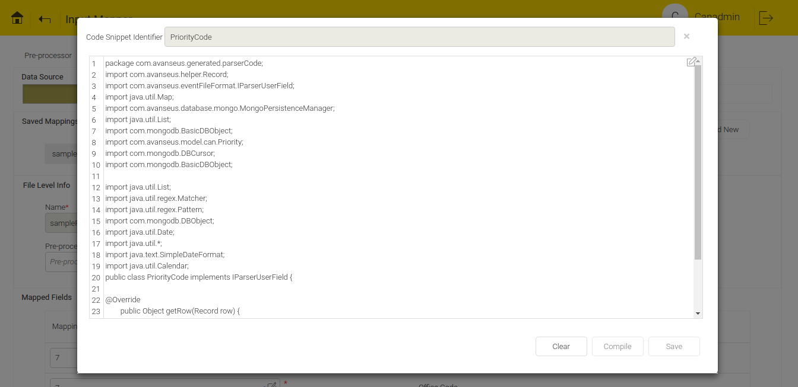
Figure 13.7 - Java Code compilation

Pre - Processor
Pre-Processor screen is used to process the data before mapping it to CAN field. This is helpful when some data needs to be excluded from data load or some input data value needs to be modified before mapping it to CAN field.
To save a pre-processor user has to give name and description and write a java code (similar to that of writing Parser Java code) inside text area.
This code will implement IPreprocessor interface which provides record object as parameter. Record object is a key value pair of header name(In case there is no header name, its convention starts with 0 as 1st column,1 as second column and so on) and header value.
Click the 'Compile' button to compile the code snippet. After compilation, click the 'View generated code' button 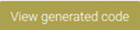 to view the fully-generated code. After the successfully compilation of the code, click the 'Save' button to save the pre-processor.
User can see a list of saved pre-processor Configurations at the right top corner.

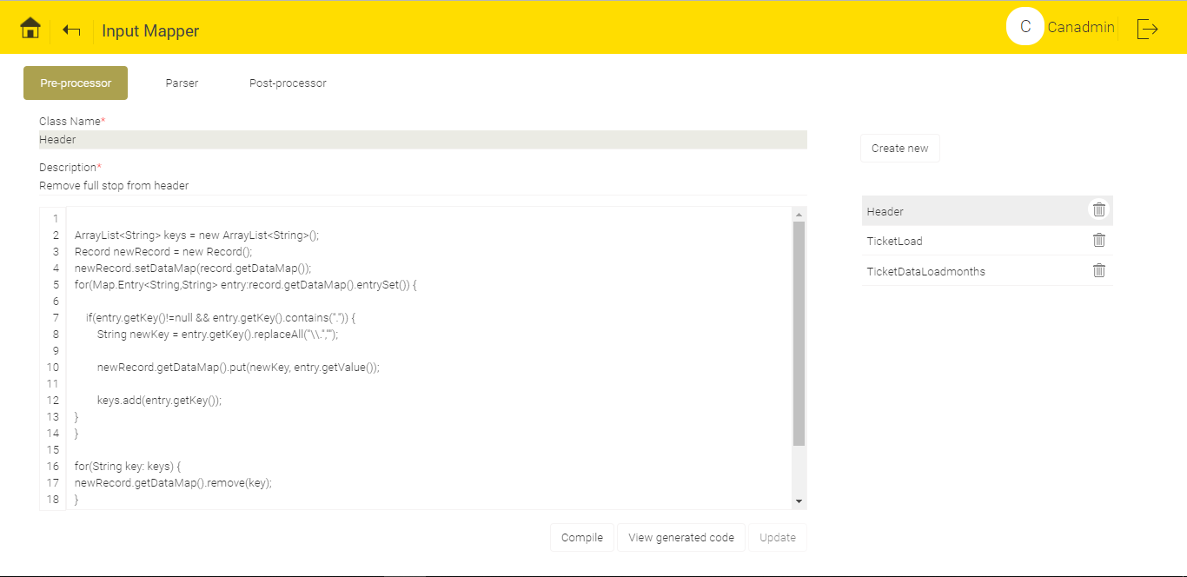
Figure 13.8 - Pre Processor Screen
To edit the saved configurations, click any of the entry.
To delete the saved configurations, click the delete button.
To create a new Pre – Processor configuration, click the 'Create new' button .

Post – Processor
Post-processor is used to modify or discard the data after parsing and just before loading of data.
Post Processor screen look and functionality is almost similar to Pre Processor screen.
But code snippet written here will implement IPostprocessor interface which provides a map of troubleTicket object as parameter.

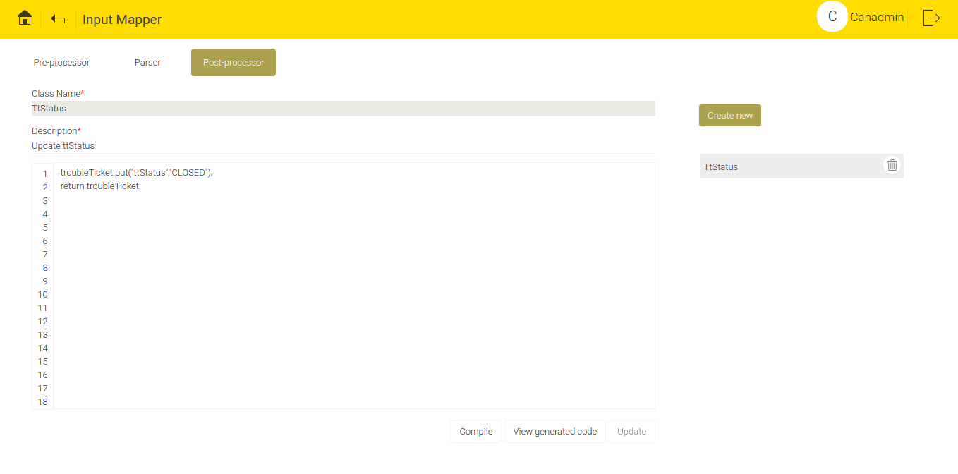
Figure 13.9 - Post Processor Screen

File Collection
File Collection screen include configurations that are applicable to collect the data files from the remote source. Remote sources include following interfaces:
SFTP
FTP
GITHUB
EMAIL
CUSTOM
User can add, edit and delete a new File Collection Configuration.
To add a new File Collection Configuration, click the 'Add new' button .
To edit the new File Collection Configuration, click the Edit button .
To delete the new File Collection Configuration, click the Delete button.
To activate or de-activate the File Collection Configuration,use the 'ON/OFF' toggle button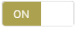.
File Collection Configuration fields that are common to all interface type are as follows:
User can set the Specific Name and description for every File Collection Configuration.
All of these pre mentioned interface types require authentication information such as Username and Password.
File name pattern can be regex pattern that will match with multiple files.
Each configuration is provided with various compression formats such as ZIP, GZ, TAR, TARGUNZIP, TARZIP and NONE. Compressed files will be decompressed before parsing.
This configuration also requires mapper information to be set that will be autocompleted from the saved parser configurations.

User can edit and save the newly created File Collection Configuration. To save the newly created File Collection Configuration, click the 'Save' button .If user will not save the changes, File Collection Configuration screen will not reflect the changes.

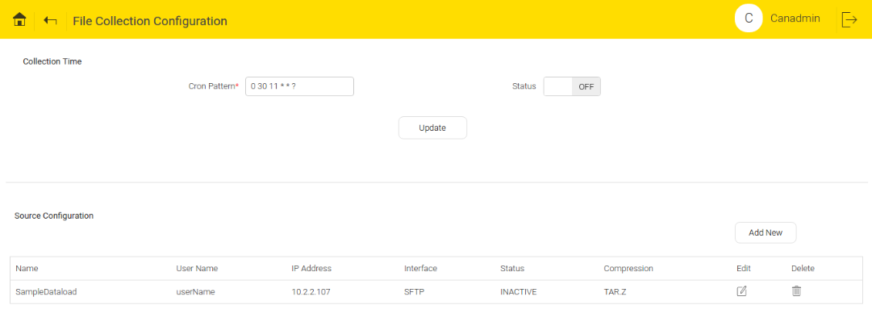
Figure 13.10 - File Collection Configuration Screen

SFTP and FTP
In SFTP/FTP interface, apart from above mentioned fields user must specify IP address of SFTP/FTP location, source root path (relative path of file location on SFTP/FTP) and source archive folder path (relative path of archive folder on SFTP/FTP).

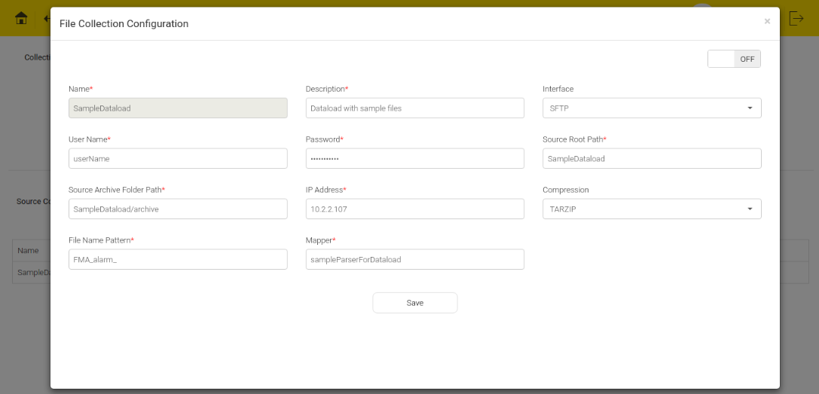
Figure 13.11 - SFTP/FTP Interface Configuration

GITHUB
In GITHUB interface, apart from the above mentioned fields user must specify URL of GITHUB location, source root path (absolute path of file location on GITHUB), source archive folder path (absolute path of archive folder on GITHUB) and source directory (location where git is cloned).

Steps for Cloning GITHUB
- https://github.com/avanseus/customer with one repository called customer data.
- Create dir in local.
  - mkdir gitHub
  - git init (Initiative git)
  - git remote add origin https://github.com/avanseus/customer.git
- Generate ssh key:
Assuming you are connecting GitHub over SSH, you can run below command to confirm this.
$git config --get remote.origin.url
If you get a result has following format git@github.com:xxx/xxx.github.com.git, then you should do the following.
Generate a SSH key (or use existing one). if you had one, you just need to add your key to the
ssh-agent (step 2) and to your GitHub account (step 3).
Below steps are for those who don't have SSH key.
    - Step 1 Generating public/private rsa key pair.
$ssh-keygen -t rsa -b 4096 -C "your_email@example.com"
You'll be asked to confirm where to save the SSH key and what passphrase you want to use.
    - Step 2 Add your key to the ssh-agent
Ensure ssh-agent is enabled
$eval "$(ssh-agent -s)"
Add your SSH key to the ssh-agent:
$ssh-add ~/.ssh/id_rsa
    - Step 3 Add your SSH key to your account
$sudo apt-get install xclip
$xclip -sel clip < ~/.ssh/id_rsa.pub
Then add the copied key to GitHub
Go to Settings->SSH keys(Personal settings side bar)->Add SSH key->fill out form(key is on your clipboard, just use ctrl+v)->Add key
After going through above steps, you should solve the permission problem.
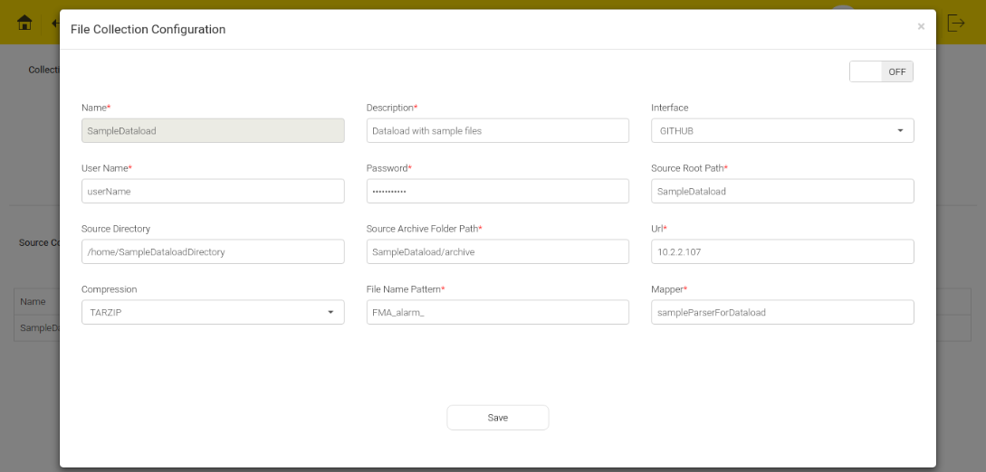
Figure 13.12 - GITHUB Interface Configuration

EMAIL
In EMAIL interface, apart from above mentioned fields user must specify protocol (IMAP /POP3S), mail server name, port number, source archival folder path (relative path of archive folder). Instead of file name pattern, user must specify mail attachment (file) name pattern and search string for both email subject and body.

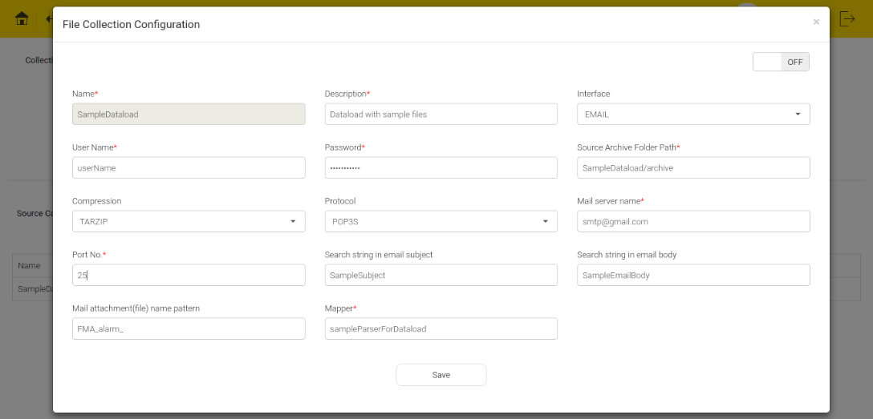
Figure 13.13 - EMAIL Interface Configuration

Prediction Assignment Policy
Configurations required to run predictions across distributed environment are set using this screen. Distribution can be done by considering any one of the fields among the master list that include Equipment, Cause, Zone, Equipment Type etc.
This screen expects an input parameter which specifies the number of distributions. Press arrow keys to set or reset it. Depending on the number of distributions being set, as many number of Node tables gets generated. Each node table consists of mongo dB query formulated using the master data entries.

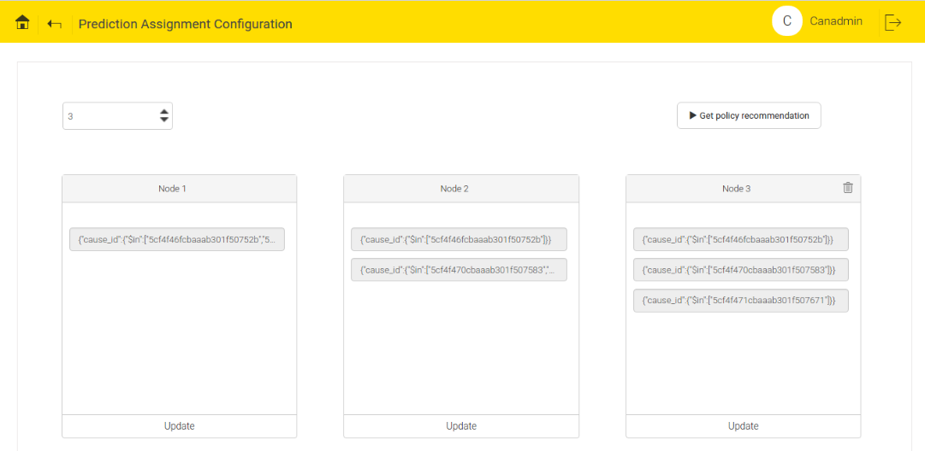
Figure 13.14 - Prediction Assignment Configuration

If number of nodes is set to 1, predictions will run on single instance based on the query. If number of nodes is set to 2, predictions will run on two instances by based on queries set for each of those nodes and so on.
To modify the query inside the node table, click the query entry. This will create a popup with name Distribution Criteria. Do the changes and save the changes. To save the changes, click the 'Update' button .

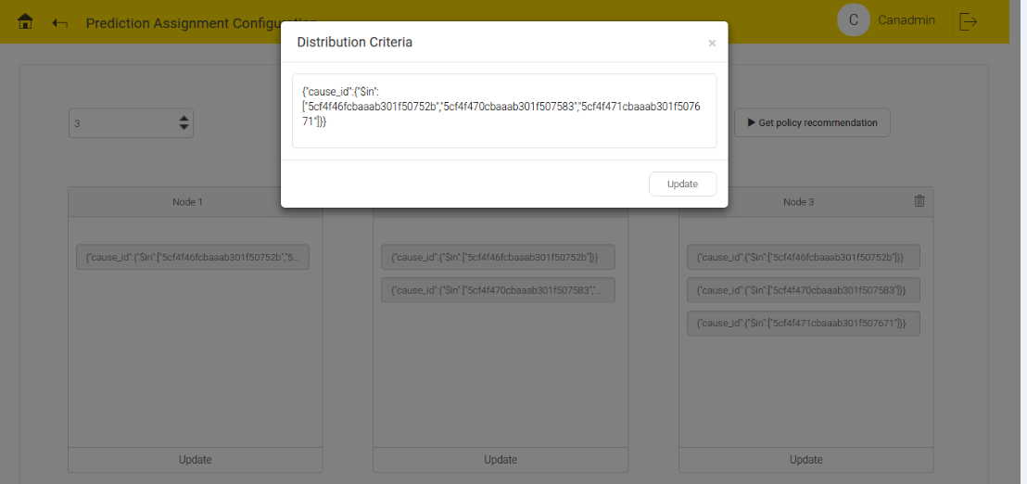
Figure 13.15 - Distribution Criteria

To generate new load distribution, user can click the 'Get policy recommendation' button. If load distribution already exists, a message "Previous Assignment Policy will be replaced. Are you sure you want to continue?" will appear on the screen.

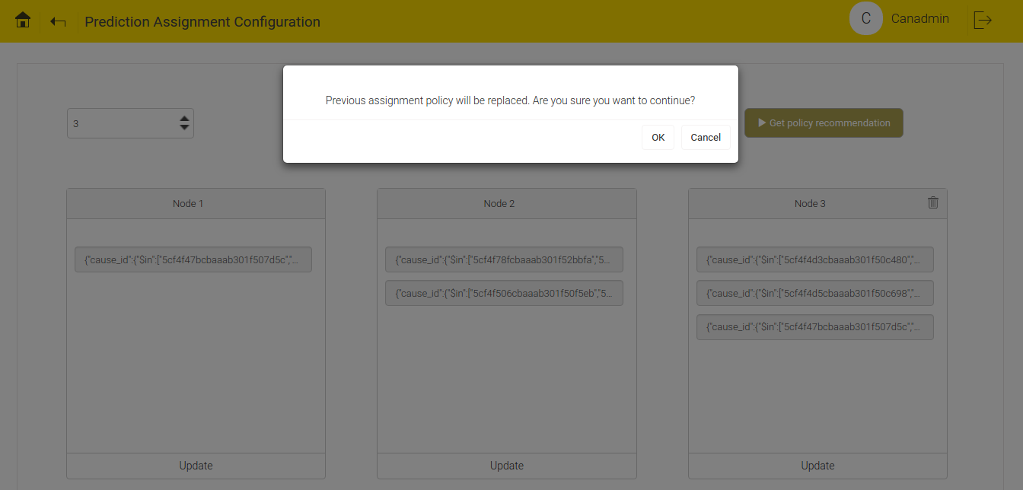
Figure 13.16 - Load Distribution Criteria

If user selects OK, the new load distribution in the nodes will replace the existing load distribution.
If user selects Cancel, the existing load distribution will retain.

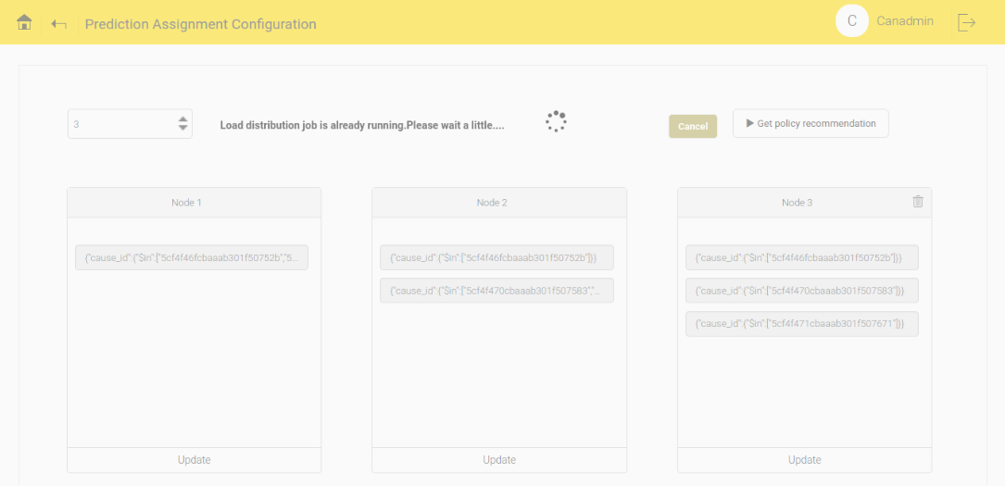
Figure 13.17 - Load Distribution

Filter Configuration
This screen can be accessed under the Adaptation tab. It provides features to manage predicted fault filtration rules. The predicted fault generation is widely split into two phases, namely:
(a) Generation of initial set of predicted faults
(b) Generation of final set of predicted faults.
The filtration rules created in this screen is basically applied on the initial set of predicted faults to derive at the final set. The filtration rules are based on the rules discovered from past history of alarms and its patterns as well as manually entered ones which collectively provide an appropriate set of predicted faults to act upon. These rules also help in improving the overall accuracy of prediction and mainly to optimize the prediction results.

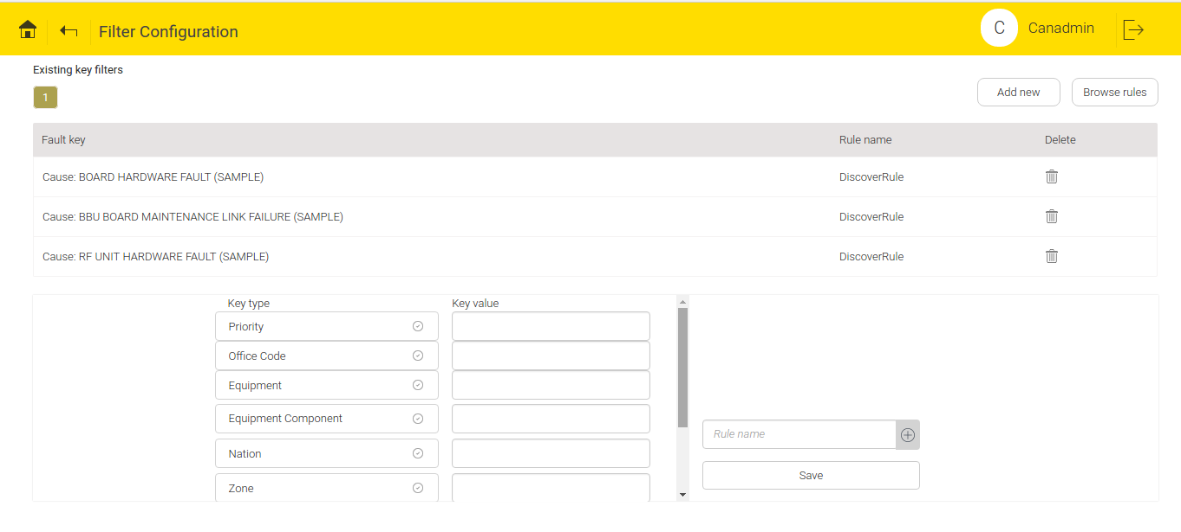
Figure 13.18 - Filter Configuration Home Page

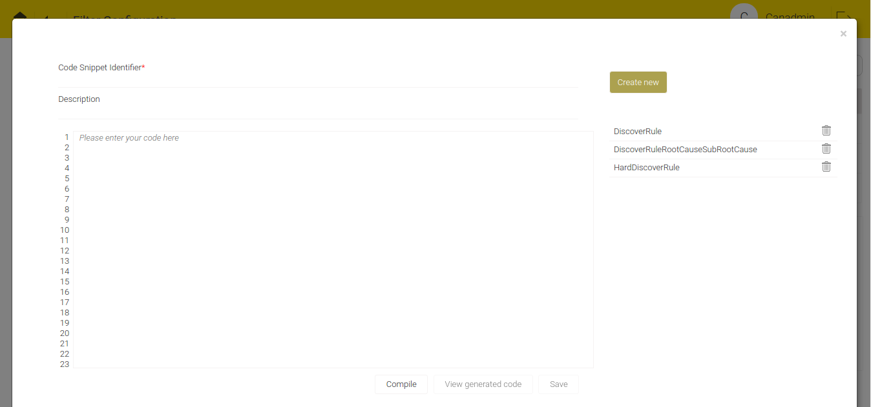
Figure 13.19 - Create Predicted Fault Filtration Rules

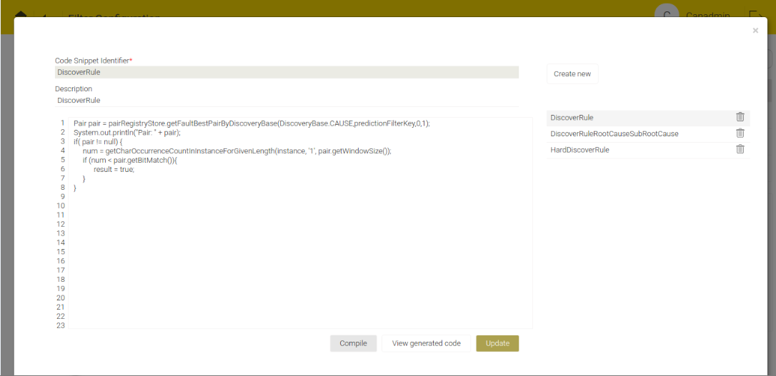
Figure 13.20 - Update Predicted Fault Filtration Rules

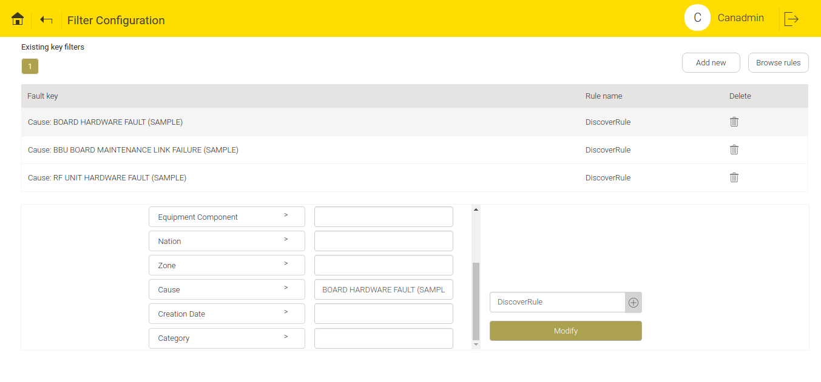
Figure 13.21 - Modifying Predicted Fault Filtration Rules

Post Prediction Process
A file needs to be uploaded that contains java code to enrich predicted information with customized data. This java file should implement IPostPredictionProcess.

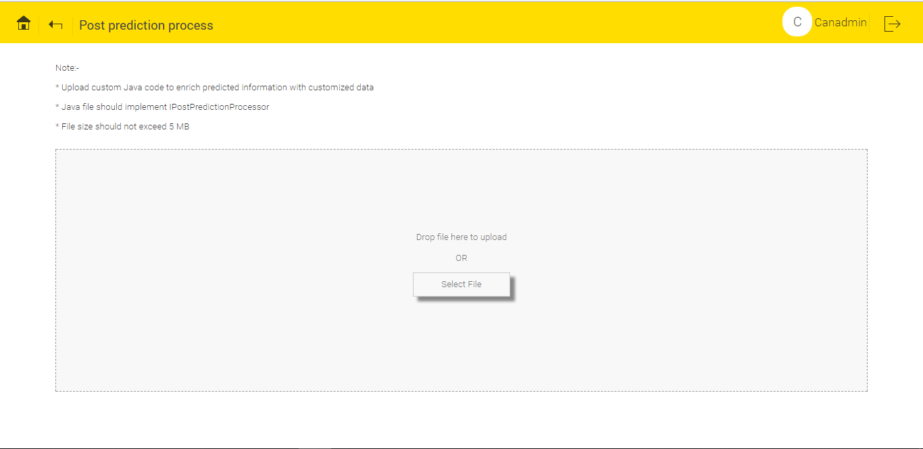
Figure 13.22 - Post Prediction Process

Report Configuration
Prediction results are generated as an excel report. This screen allows user to configure fields which they wish to see in the excel report.
There are 2 configurations under this:

Page Configuration
Columns those are required to appear in every sheet of a prediction report are customizable and are configured in this tab. Allows user to set excel sheet formats and excel sheet styles accordingly.
On top portion of this tab, a 'Create New Configuration' button is available to create new configuration. There is a list of pre-existing configuration names. User can click any of the existing configurations, the screen will display the saved contents of corresponding configuration. User can modify the existing configuration, if required. If any of the pre-existing configuration isn’t required, click the delete button .
To create a new configuration, give a new name to the configuration. User is allowed to set excel styling features like Font Color, Header Background Color, Font Size. User is also allowed to set the Header Name that appears as first row in excel report.
There is a toggle button called master format 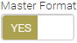. If enabled, this configuration generates the matching report.
To add the New column configuration, click the Add New button .User can also modify or delete the existing column configuration.
This screen also requires few other parameters to be set to configure each column of the prediction report The parameters are as follows:
- Field name - Name of the field as it is in prediction result table i.e. Predicted Fault table as per CAN convention.
- Column Name - Name of the column which user wishes to see in report.
- Sort - Column values can be sorted as Ascending, Descending and None.
- Data Type - Select the Data formats like String, Number, Percent, Complex and Dropdown. If user selects the complex data type, Edit icon appears next to that. On click of this icon a popup which is similar in functionality with respect to parser screen comes up (Figure 13.25).
- Header BG Color – User can decide background color for column header.
- Font Color - User can decide font color for column values.
- Column Width – Sets width of column, here value 0 indicates auto resizing of column.
- Wrap Text – If checked, text contents of each cell in that column will be wrapped.
- Merge – Allows multiple adjacent cells to be combined into a single larger cell when values are similar.
- Sequence - User can change the column sequence to Top, Up, Down and Bottom.
Click the 'Update' button to update the edited configuration and click the 'Save' button to save the newly created configurations. If the user will not save the changes Page Configuration will not reflect the changes.

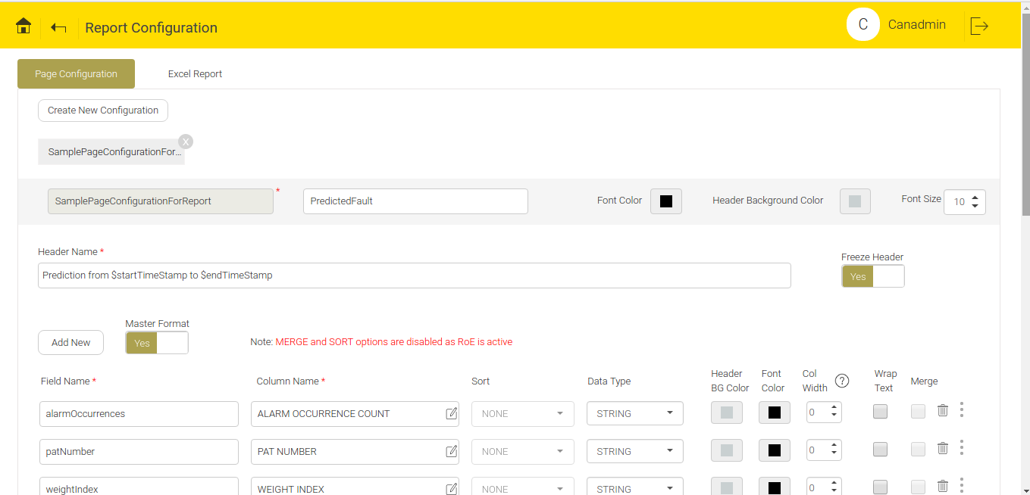
Figure 13.23 - Existing Page Configuration

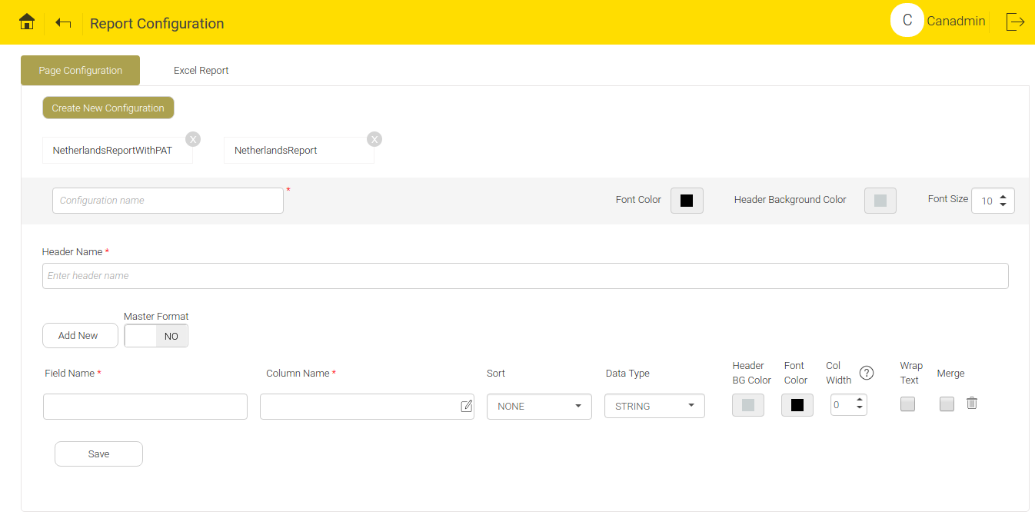
Figure 13.24 - Create New Page Configuration

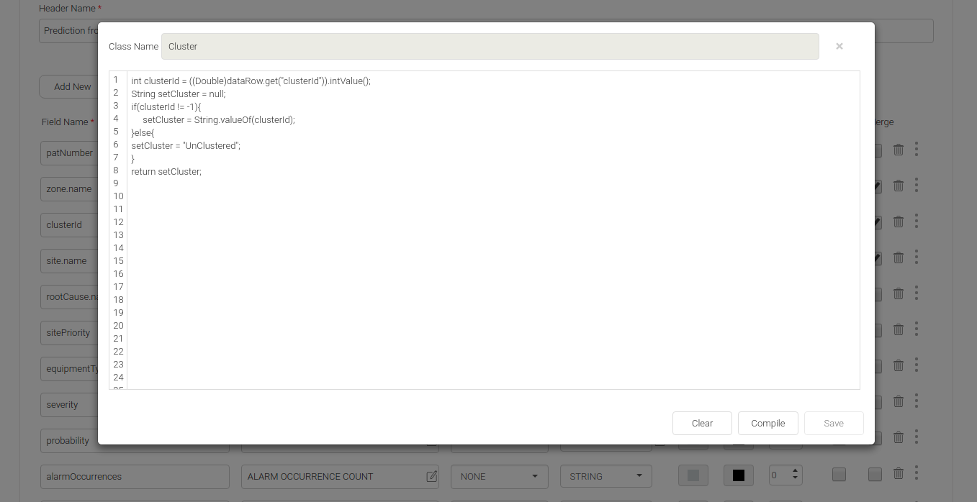
Figure 13.25 - Code Snippet Text Area

By default, “Freeze Header” will be ON. If it is ON, then the first two rows of report will freeze when the report will be generated.
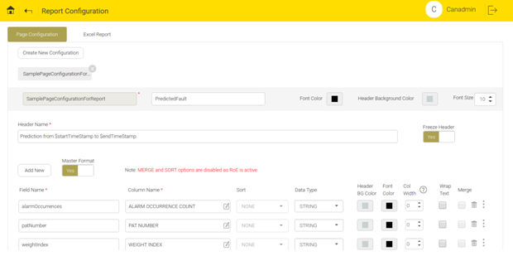
Figure 13.26 - Freeze Header Button

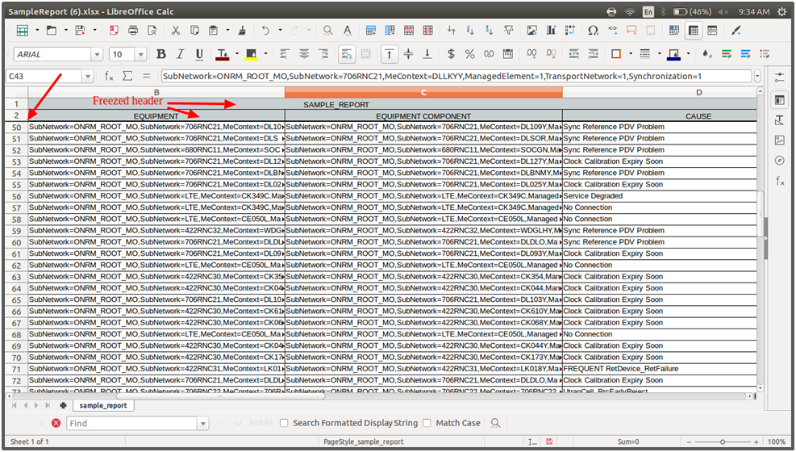
Figure 13.27 - First Two Rows Freeze

Excel Report Configuration
Page Configuration tab is specific to column configurations of every single excel sheet whereas Excel Report tab helps to create the sheet configurations.
On top portion of this tab, a 'Create New Configuration' button to create new configuration is available. There is a list of pre-existing configuration names. Click any of the existing configurations to display the saved contents of that corresponding configuration. User can modify the existing configuration, if required. If any of the pre-existing configuration isn’t required, user can delete the existing configuration. To delete the existing configuration, click the delete button .
To create a new configuration give the Configuration name, Percentage format, Date format, Font name, Excel Report name. A switch to activate and deactivate excel report configuration is also available. User can generate the Prediction report in accordance with active configuration. User can also write success and failure mail templates. Success mail will be attached with Prediction report.
To add New sheet, click the 'Add New' button . User can also modify or delete the existing sheet configuration.
Sheet configuration contains the following fields:
- Sheet Name – Name of the sheet to appear in Prediction report.
- Page configuration type –It can be Basic or File Upload type.
- Page configuration – Allows to choose saved Page Configuration from auto completion.
- Query – User can write a MongoDB query to filter prediction results appearing in various sheets. Query can be written within a popup and it will be validated before saving or updating the configuration. Refer the link https://docs.mongodb.com/manual/ for Mongo DB user manual.
- Sequence - User can change the column sequence to Top, Up, Down and Bottom.
Click the 'Update' button to update the edited configuration and click the 'Save' button to save the newly created configurations. If the user will not save the changes, Page Configuration will not reflect the changes.

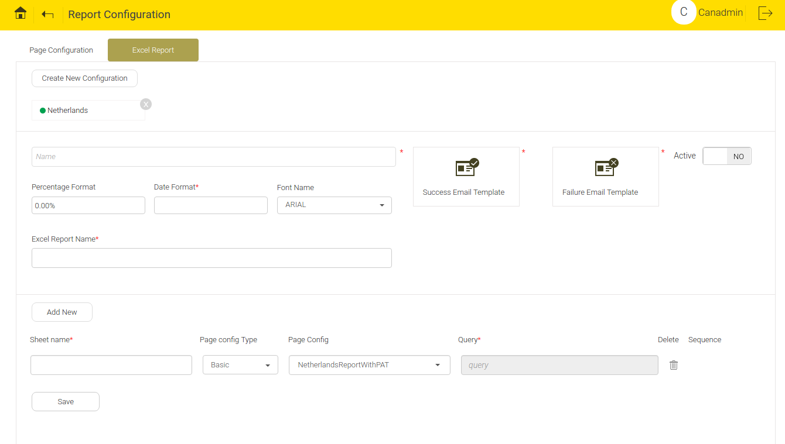
Figure 13.28 - Create New Excel Report Configuration

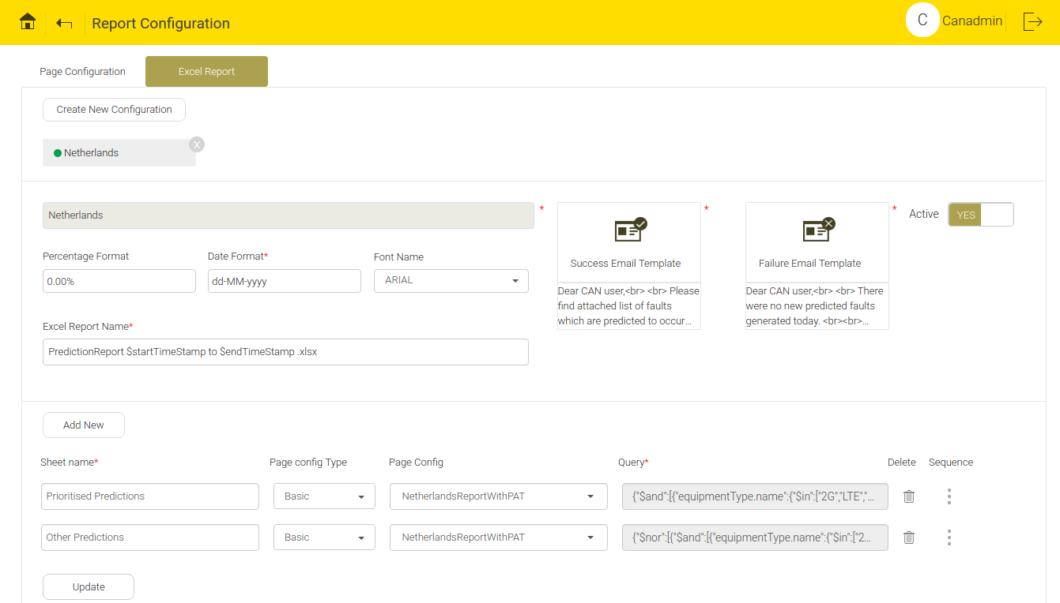
Figure 13.29 - Existing Excel Report Configuration

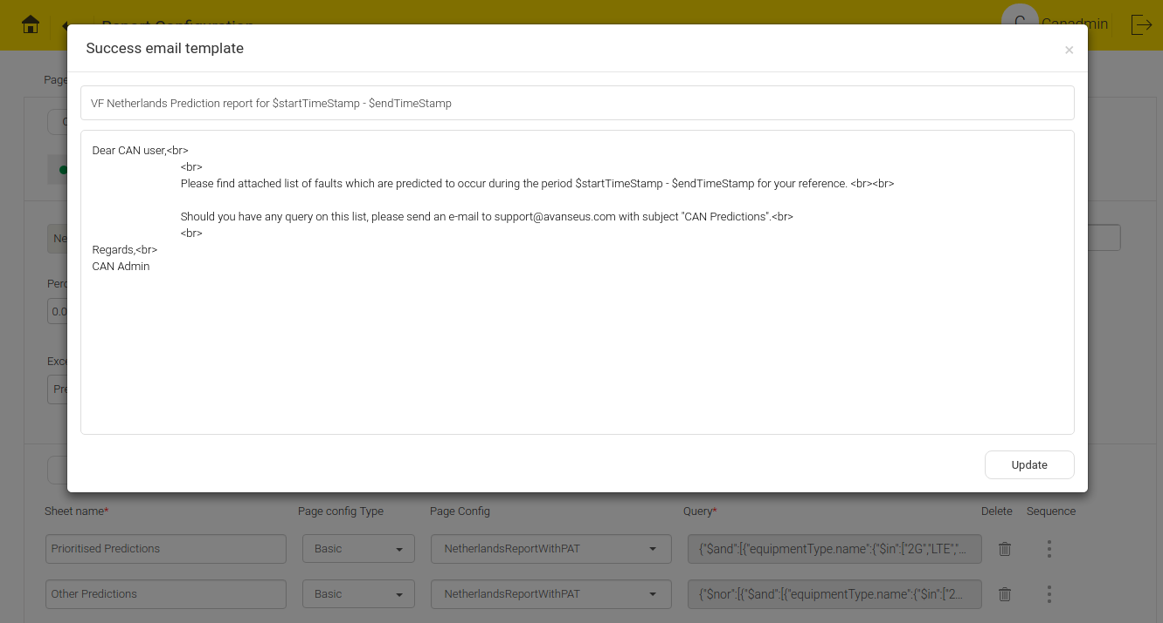
Figure 13.30 - Email Template

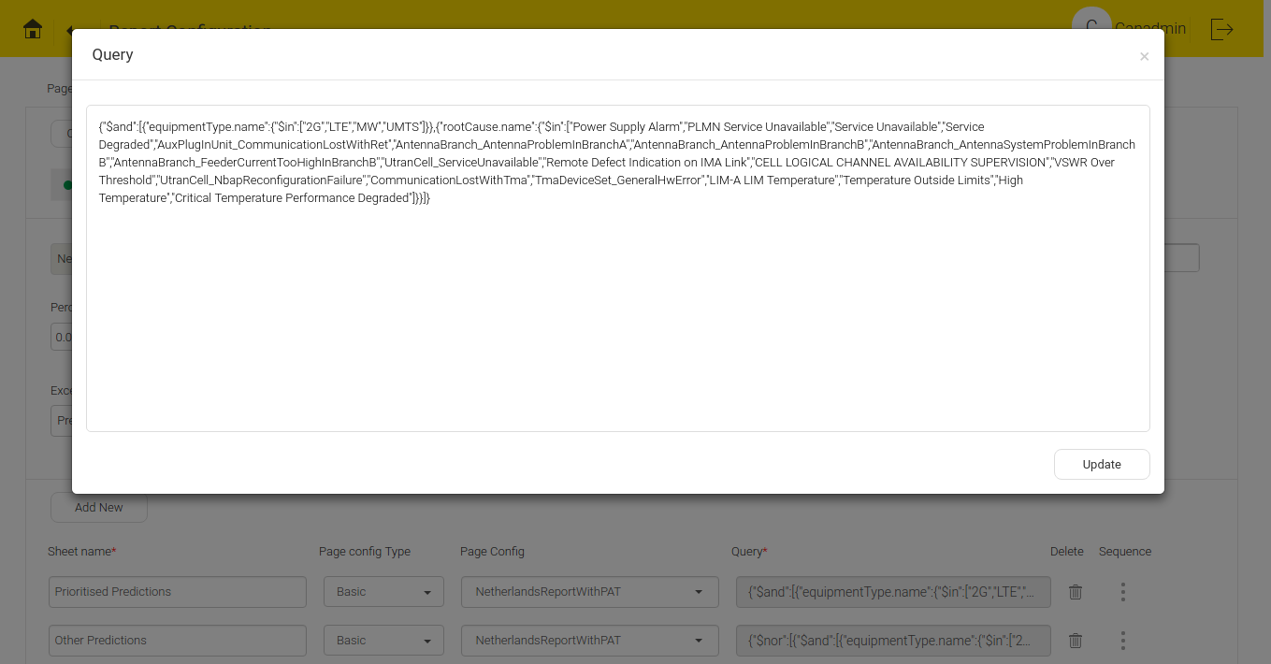
Figure 13.31 - Query Snippet

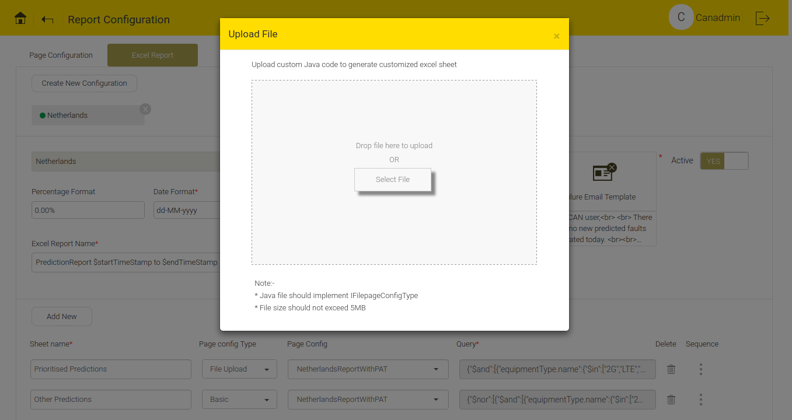
Figure 13.32 - File Upload

Resource Configuration
This screen is found under the Adaptation on the main home screen. Its function is to upload and parse the customer specific data which cannot be mapped with the CAN model. A client input data file should be synced with the mapper present in parser screen.This resource data can be used as an add-on during data load or after prediction (Eg:In post Prediction process to attach some information to prediction).
To add New resource Configuration, click the 'Create new' button .
To delete Names of existing resource configuration, click the delete button .
Resource information contains fields which includes Name (Name of resource), Mapper (Allows to choose saved Parser Configuration from auto completion).
There is an option to upload resource file. User can select a file or drag and drop to upload. This file should be of specified format in selected Parser Mapping and should not exceed 100 MB. User can upload multiple files and the progress bar displays the percentage of the file upload and it disappears once upload is complete.
A list of Saved Resource Files for selected resource configuration displays at the right top corner, consists of the following information:
- Uploaded Time: Specifies the file upload time.
- Parsing Status: Specifies the file parsing status. Not yet started (Immediately after file upload), In Progress (When parsing begins), Completed (When file is successfully), File rejected due to format problem.
- Total Records: Total number of parser records.
To download the Uploaded resource, click the download buttton and to delete, click the delete button .

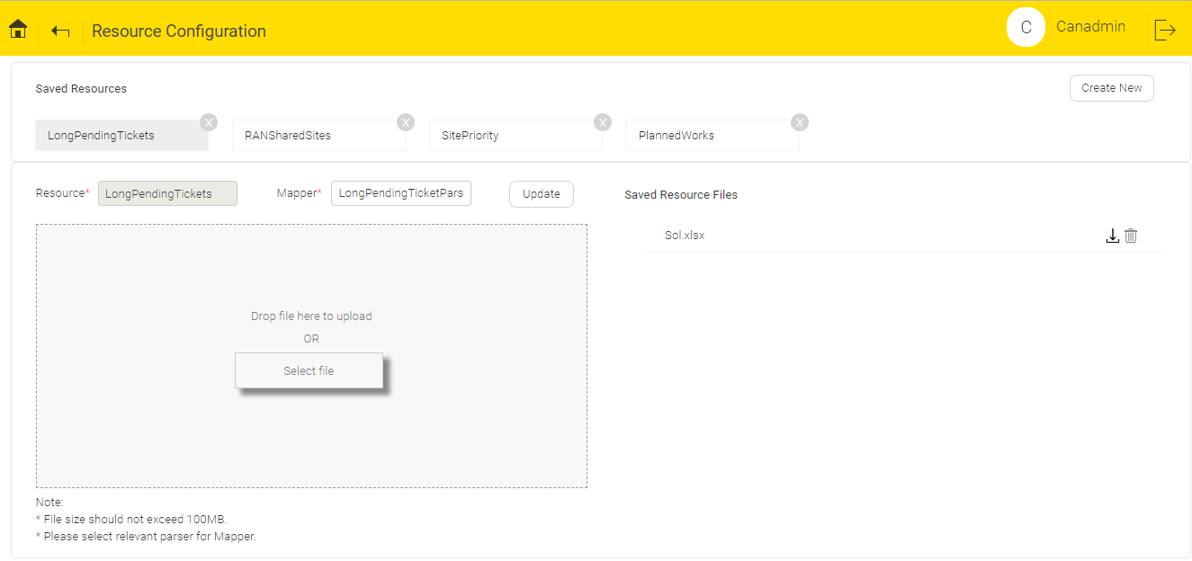
Figure 13.33 - Resource Configuration Screen

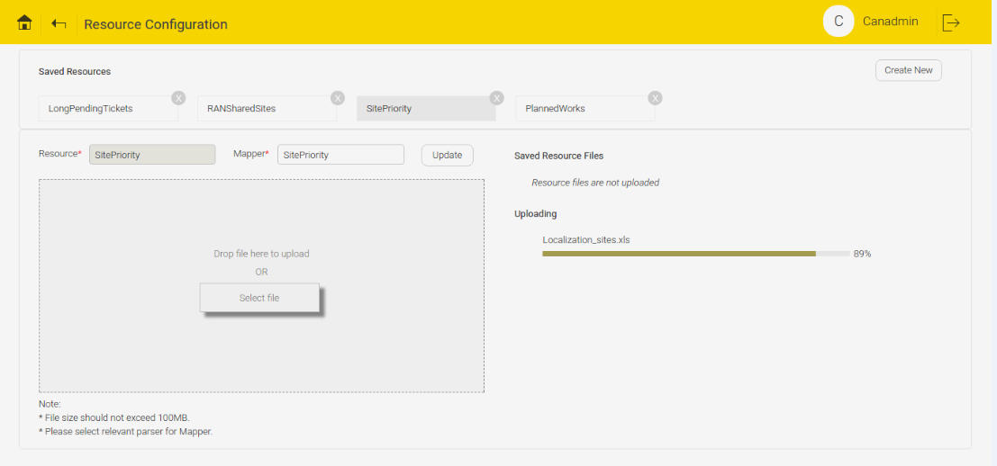
Figure 13.34 - Resource Configuration Screen during file upload

Advanced Configuration
Developers use this screen to configure prediction algorithm settings, General settings and a few UI view related settings.
This includes the following:

SFTP Data
- Cron - Cron pattern needs to be set for scheduling the time of input file pickup from remote source.

User Management
- User expiry Cron - This Cron checks the validity date of the user.

Archive Data
- Cron - Cron pattern to schedule the archival process.
- Threshold in days - Set a slider with name Threshold in days to maintain the number of days of data in Trouble Ticket Table required to run the predictions. Older data that doesn’t fall under this set threshold will be moved to Archival table.

Matching Configuration
- Prediction match slots – Decides the number of slots to be matched.
- Prediction matching (Days) –Number of history days to be considered for matching from current day. It is mainly used for cross validation that will be performed for history dates.

Advance Prediction
- Prediction in advance - Toggle switch to enable or disable advanced prediction.
- Prediction skip days - Slider that specifies number of days to be skipped for running predictions. This provides clients some buffer time to take action by sending future prediction reports.
- Performance KPI Level - Level at which the prediction for performance counter will happen.

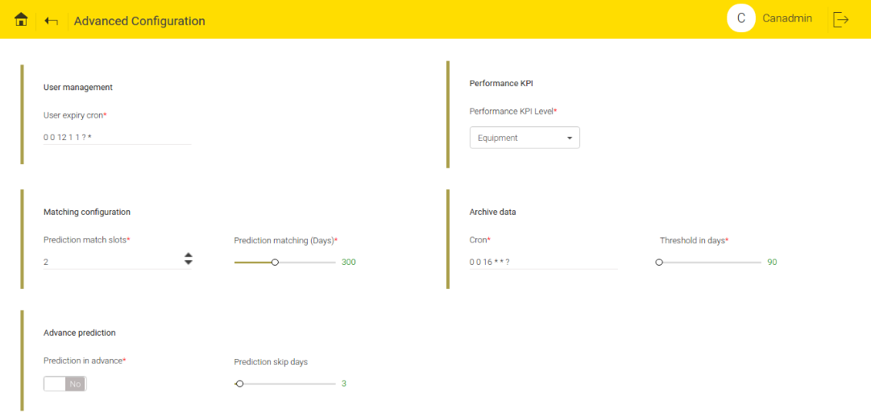
Figure 13.35 - Advanced Configuration

Visual Preferences
- Displayable causes – Predictive Fault Analysis screen displays the filter causes as top causes.
- Feedback configuration – User can choose to display the Technician feedbackin fault details popup.
- Historical Faults (Days) – Fault Analysis screen displays the maximum number of closed alarm days.
- Default representation – Select the Map view or Tabular view for the Default representations of faults.
- Display cause categorization – If any categorization exists, top faults can be categorized by enabling or disabling this toggle button.
- Group tickets – When it is toggled to YES, alarms in Failure Analysis are grouped.

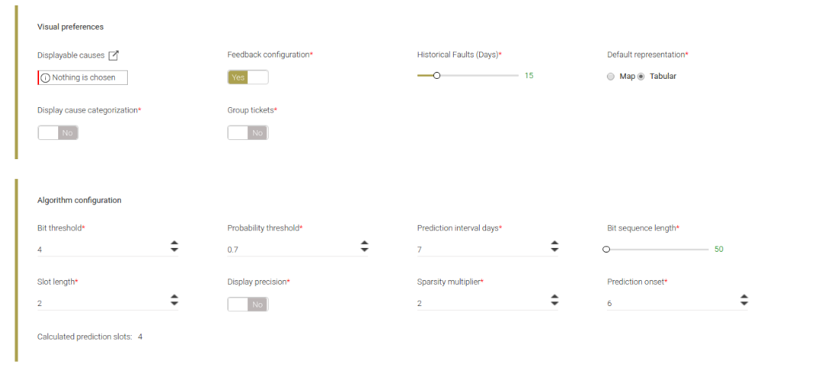
Figure 13.36 - Visual Preference and Algorithm Configurations

Algorithm Configuration
- Bit threshold - Minimum threshold number of faults in input data in order for a fault sequence to be eligible for prediction. Please note that fault sequence is smoothened before being considered for prediction.
- Prediction Interval days- The period for which prediction is being made e.g. 7 days
- Bit sequence length - Number of history days to be covered for prediction input.
- Slot length - Number of days a single unit represents in the prediction input.
- Prediction slots - Number of units to be considered as prediction output.
- Sparsity multiplier - Multiplier to go back more in history as part of variable horizon.
- Prediction onset - Start day of the prediction in a week. 1 represents Sunday & 7 represents Saturday.

Cross-Domain Correlation
- Enable clusterization – Enable clusterization switch decides whether to display the configuration part or do the clustering.

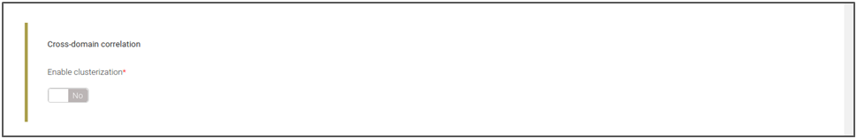
Figure 13.37 - Cross Domain Correlation Screen

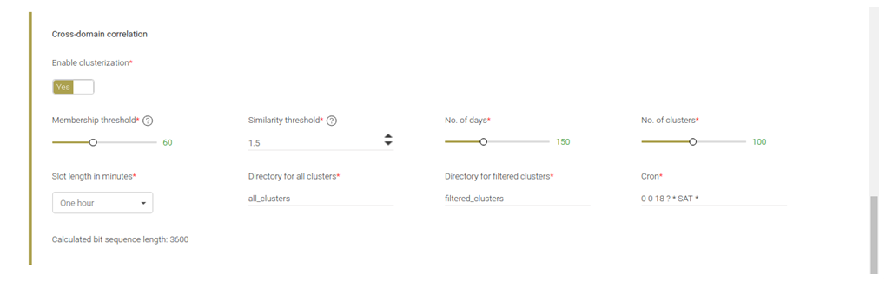
Figure 13.38 - Enable Clusterization Switch

- Membership threshold – displays the percentage of faults where “Similarity threshold” are within the specified limits. User can select the value moving the slider between the min value and max value i.e. (40% to 90% respectively).
- Similarity threshold – displays the percentage of interrelated faults occurring together across the same or different sites. User can select the value using arrow keys. (Min value is 0.5% and max. value 3%).
- No. of days – User can select the No. of days to run the cluster. User can select the values using slider between the min value and max value i.e. (120 to 200 respectively).
- No. of clusters – It allows the user to select maximum No. of clusters for each zone. User can select the values using slider between the min value and max value i.e. (50 to 150 respectively).
- Slot length in minutes – It allows the user to select the number of hours from the drop down menu. User can select a slot from the drop down menu. The slot divides the day into different hours.
- Directory for all clusters – Relative path of the folder in which cluster details will be saved as a file.
- Directory for filtered clusters – Relative path of the folder in which filtered cluster details will be saved as a file.
- Cron – It runs the “Cross-domain correlation” automatically at specific time.
- Calculated bit sequence length– Length of bit sequence which will be generated after checking whether faults have occurred or not in each slots for total no. of days.
- [Calculated bit sequence length = 1440*(No of days)/ ((Slot Length in minutes)*60)].

General Configuration
- Network IP pattern – IP pattern prefix where the prediction process needs to bind.
- Support email id– Mail id of CAN support team.
- Fault data type – Input data (Alarm, Ticket, etc.)
- Customer – Customer name for whom the reports would be generated.
- Alarm collection – Cron to initiate UI table population on a daily basis.
- Alarm collection days – Number of days of data to be maintained for rendering UI.
- Recommend technical query execution – Decides whether or not to run Technician related queries.
- Cause based precision coverage – It displays the Number of top faults in Predictive Fault Analysis and Fault Analysis screen.
- Deduplicated count – Cron to calculate Deduplicated count for alarms and tickets on a daily basis.
- Recommendations – Number of recommendations needs to be shown during report generation.
- Fault key separator – Key separator or delimiter in prediction input data.
- Display inventory – Switch that decides whether to display Inventory table or not in Inventory Planning screen.
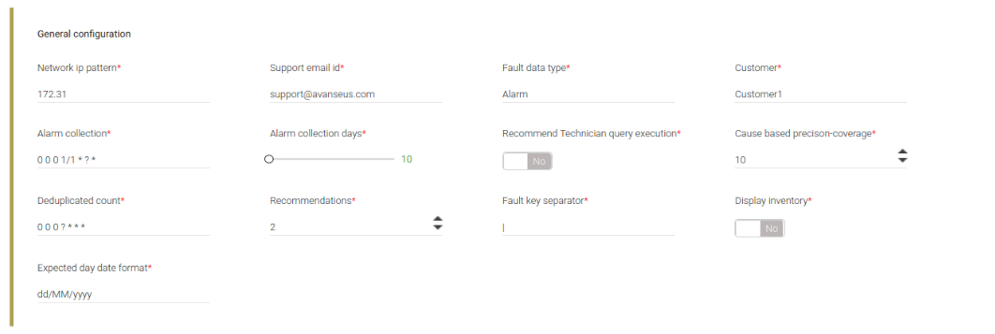
Figure 13.39 - General Configuration

RoE
Return on Effort (RoE) index based prediction shortlisting is a way of selecting a particular subset of predicted faults which are more impactful or likely to happen and highlighting them in the prediction report. This impact or likelihood of faults are determined by taking cumulative effects as measured by weight indices of different parameters like fault history, ticket history, alarm occurrences etc.
By default RoE is active and configured with parameters like Ticket count, Average alarm duration (ms), Priority and Alarm de-duplicated count.
RoE configuration consist of 2 tabs :
Weightage Configuration: User can configure different prediction parameter with their respective limits and weightages.
Sheet Configuration: Different sheets from prediction report where RoE needs to be applied are configured.
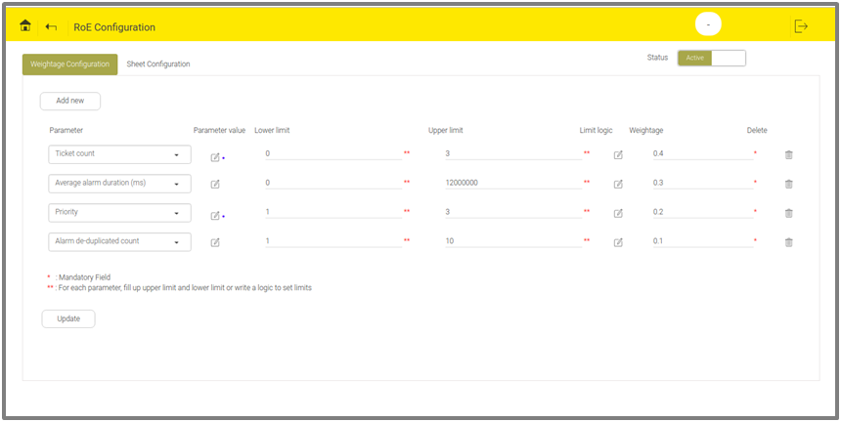
Figure 13.40 - Default RoE Weightage Configuration

On top portion of Weightage Configuration tab, 'Add new' button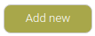is available. To add new row to configure parameter weightage, click the 'Add new' button.
Six different columns can be configured inside Weightage configuration tab are :
- Parameter: User can select the name of parameter from the drop down menu.
- Parameter value: User need to write a logic to fetch the value of a parameter. This is not a mandatory field. User can directly access the value using parameter name from Predicted fault, then code is not required. User need to write logic to fetch the value when the value cannot be fetched directly by the parameter name. A default code for an alarm count, ticket count and priority is already present.
Click the Edit menu in parameter value column, a popup will open. User can write a valid class name and corresponding code in text area to fetch the parameter value. To compile the code, click the 'Compile' button and to save, click 'Save' the button . User can edit the saved code. To edit the saved code, click the Edit menu available at the right top corner of text area. User can recompile, if needed.

Sample java code to fetch parameter value
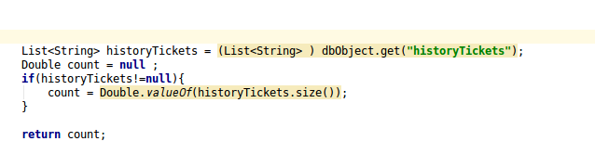
Figure 13.41 - Logic to Fetch Number of Tickets
The above java code will implement IRoeParameterValue interface which provides “dbObject” as parameter.

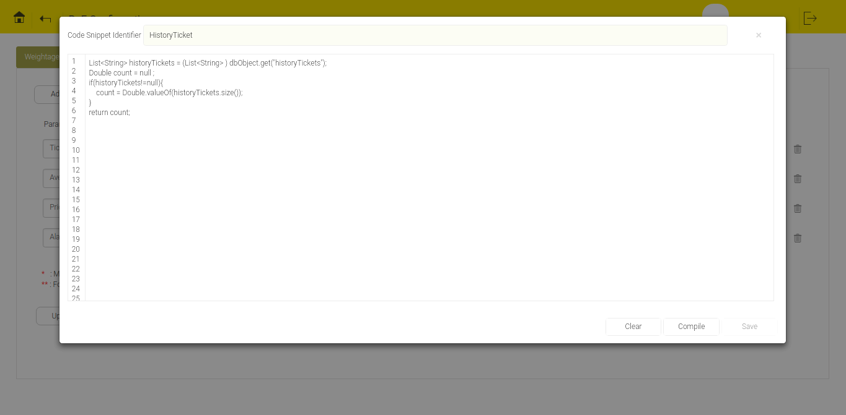
Figure 13.42 - Code Snippet for Parameter Value

This implementation needs code snippet. It doesn’t require class definitions. In the implementation return statement is mandatory which expects user to return a “Double” value.

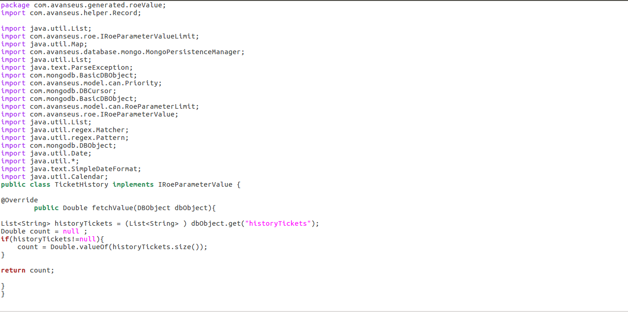
Figure 13.43 - Java Code for parameter value after Compilation

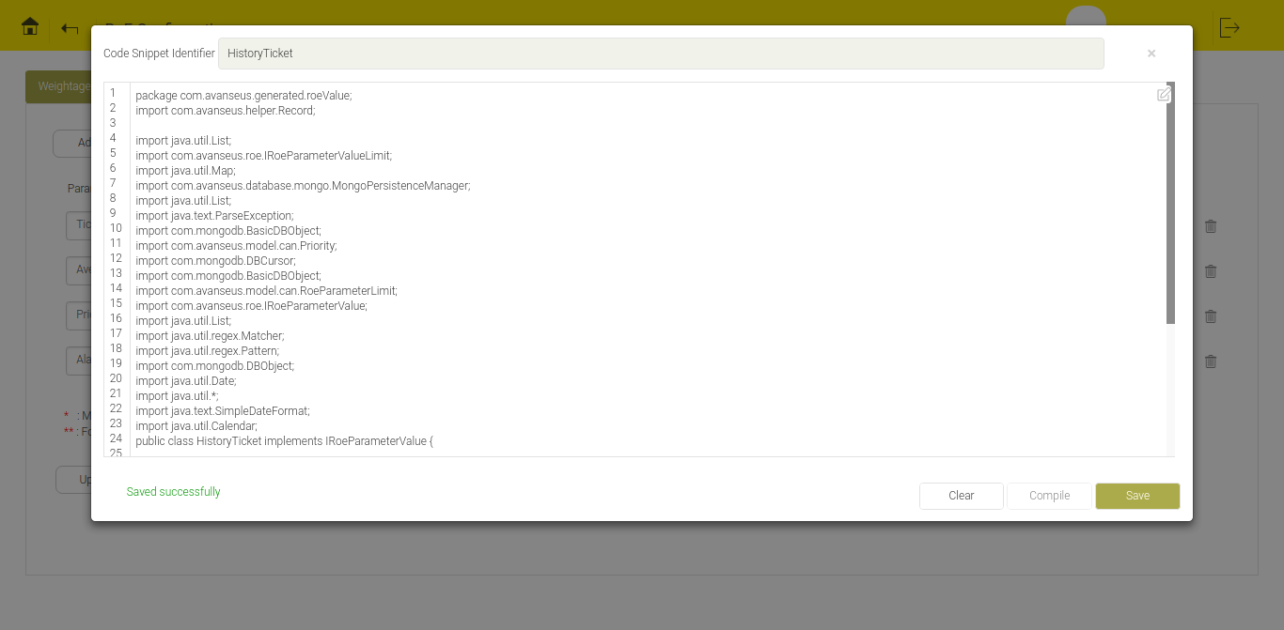
Figure 13.44 - Parameter Value Code
After compilation, necessary packages and import statements are added. Code snippet written within text area overrides the fetch Value method.
- Lower limit: The lower limit of parameter value.
- Upper limit: The upper limit of parameter value.
- Limit logic: User can write any complex logic to set the lower and upper limit of the parameter. For example, user can set the average of last ten highest value as the upper limit or can write a logic to ignore outliers etc.
Click the Edit menu in Limit logic column, a popup opens. To set the limits (both upper and lower limit), user can write a valid class name and corresponding code in the text area. User must compile and save this code. To compile the code, Click the 'Compile' button and to save, click the 'Save' button .User can edit the saved code. To edit the saved code, click the Edit menu available at the right top corner of text area and recompile it.. Once the code is saved the upper and lower limit fields are disabled and the values set in the code is taken into consideration for weight index calculation.
Sample java code to set limit logic
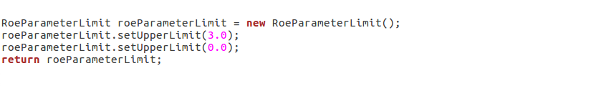
Figure 13.45 - Java Code before Compilation

The above java code will actually implement IRoeParameterValueLimit interface which provides predictedFaultCursor as parameter and expects RoeParameterLimit as return type.

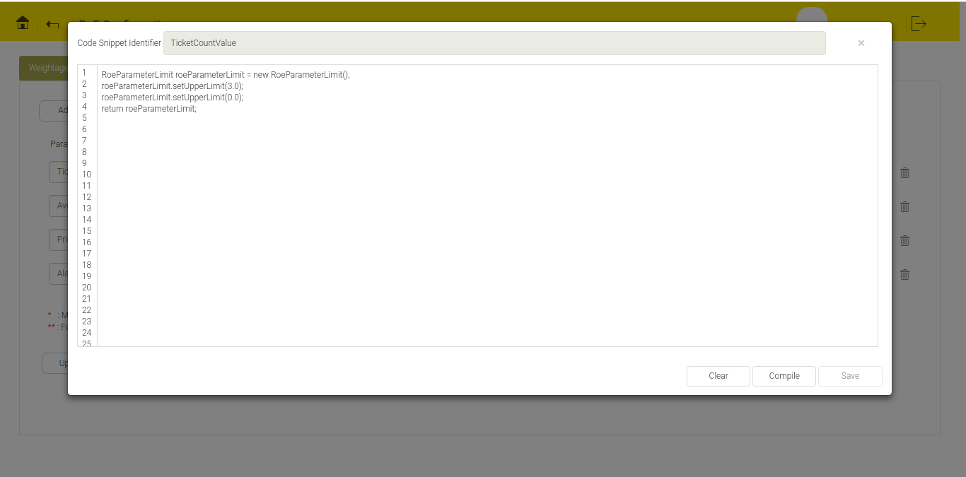
Figure 13.46 - Code Snippet for Parameter Limit
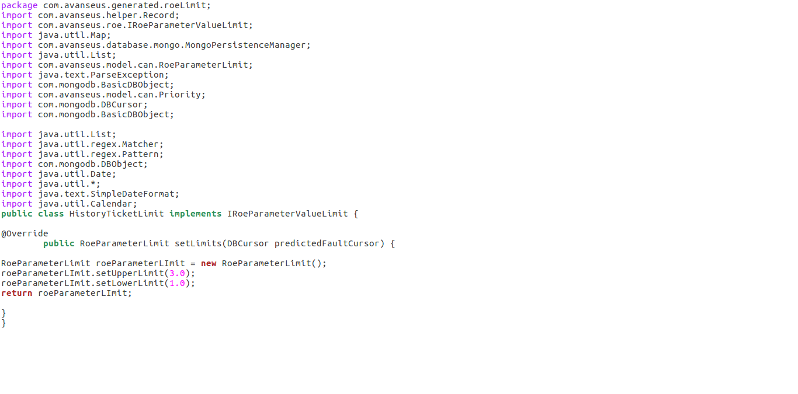
Figure 13.47 - Java Code for Parameter Limit after Compilation

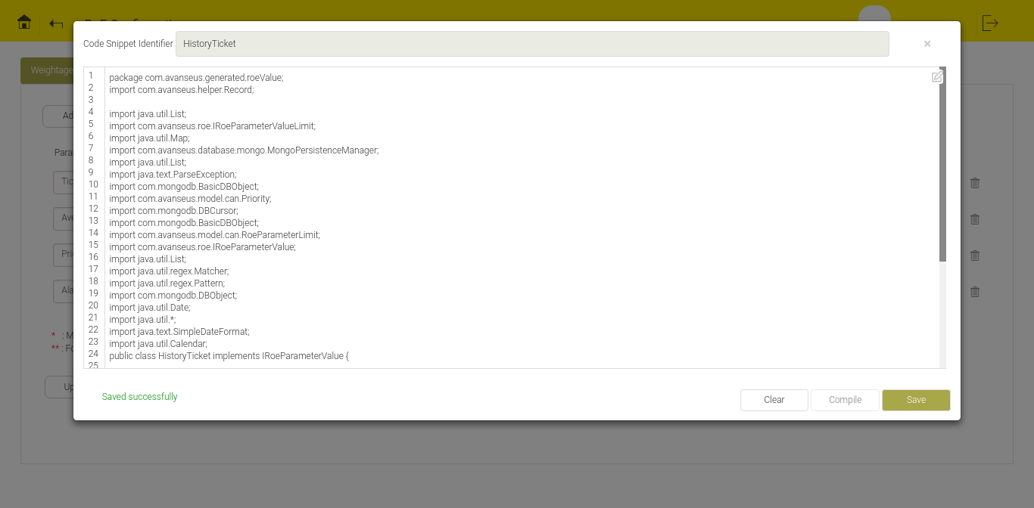
Figure 13.48 - Pop up to after Saving Parameter Limit
- Weightage: Assign weightage to each parameter such that sum of them equals 1.0.
User can use the delete icon to delete the particular parameter row and the Update icon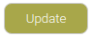 to save/update the changes.

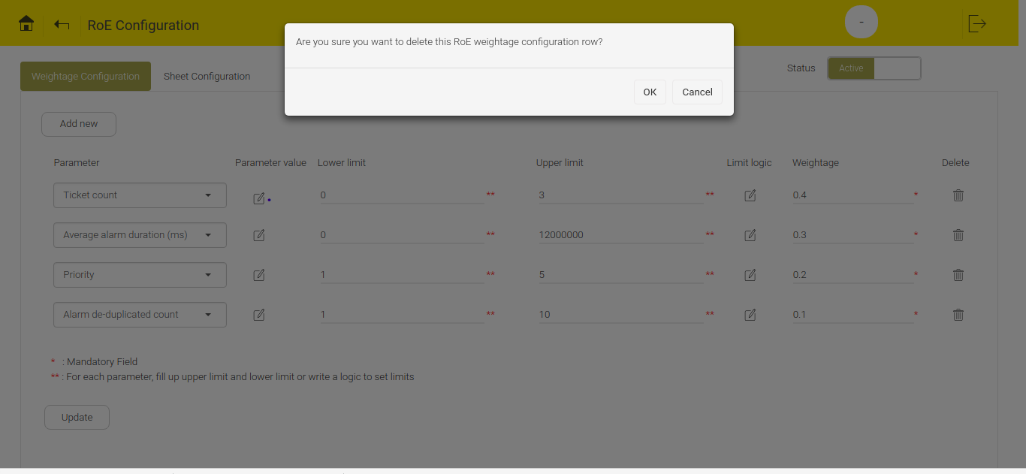
Figure 13.49 - Delete Confirmation Message

To enable/disable RoE, use the toggle switch 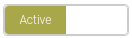.
Note: RoE becomes disabled if any SORT or MERGE option in the Page Configuration is active.

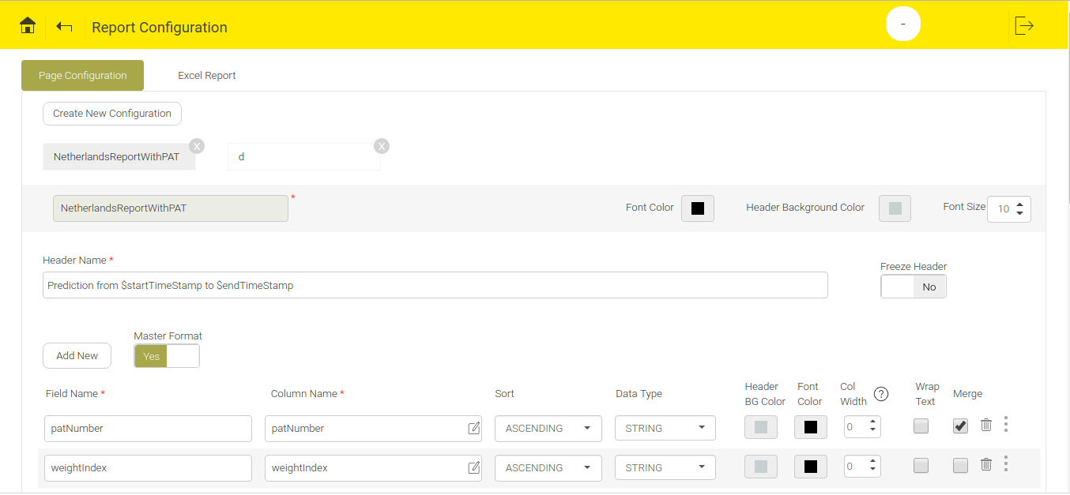
Figure 13.50 - Sample Page Configuration where Sort and Merge is enabled in few columns
If Sort and Merge options are enabled in Page Configuration, a message appears at the bottom of the ROE screen which allows users to navigate to Page Configuration and disable the Sort and Merge options to enable RoE.

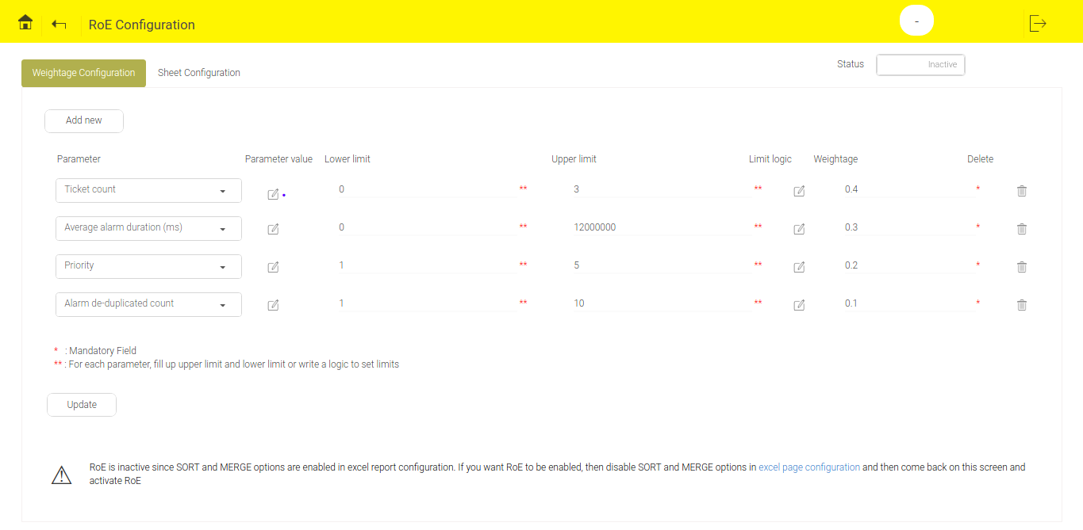
Figure 13.51- RoE is disabled and message appears at bottom

Sheet Configuration
By default, no sheets are configured in Sheet Configuration tab.

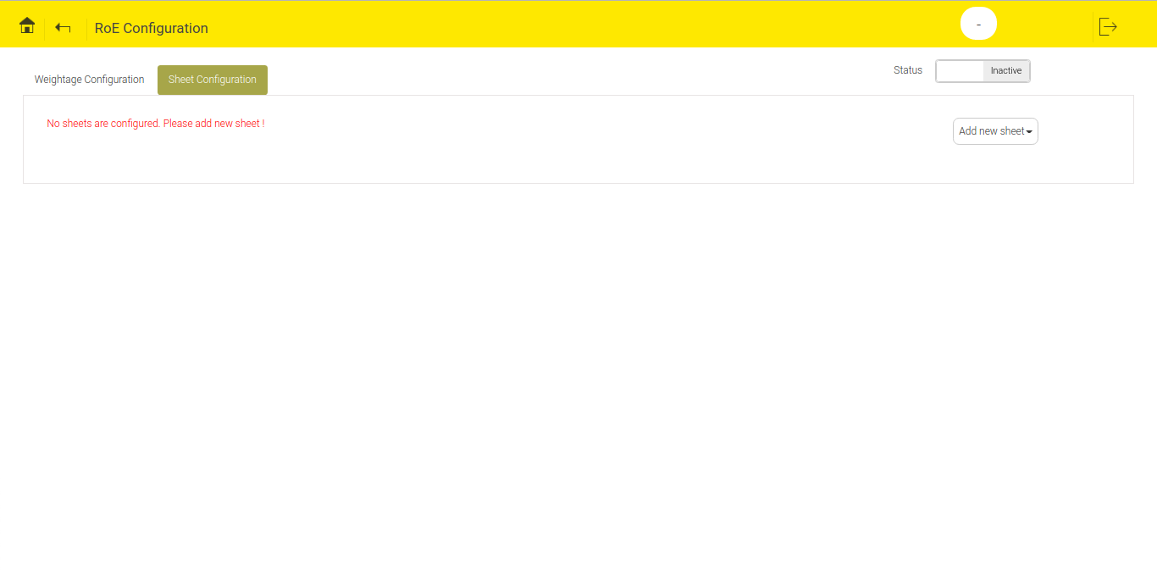
Figure 13.52 - Default view of Sheet Configuration Tab
To configure new sheet, click the 'Add new sheet' button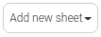, to see all the sheets configured in excel report . Click any of the sheet to save a default configuration.
To delete the configuration of the sheet, click the delete icon.

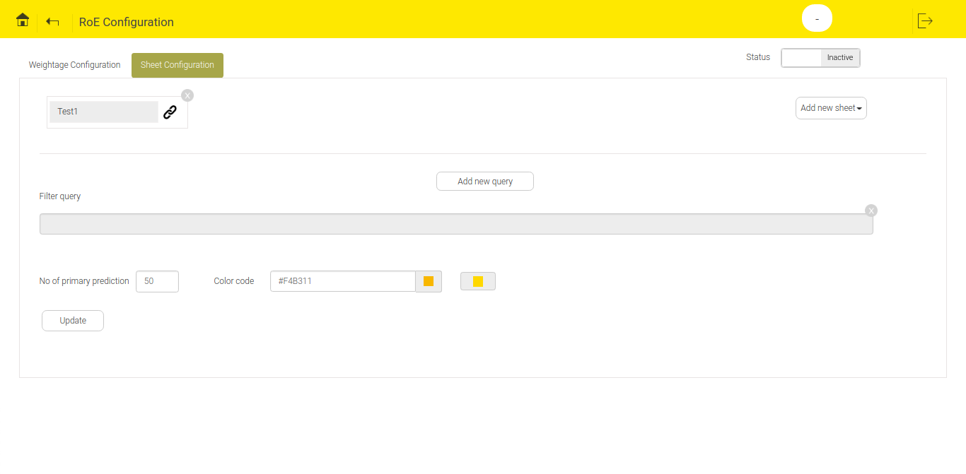
Figure 13.53 - Default Configuration for Sheet Test1
Configurations provided in this tab are:
- Filter query: User can add single or multiple queries.
When multiple queries are added then predictions in the prediction report appear based on the sequence of added queries. To change the sequence of query, use the sequencing icon .

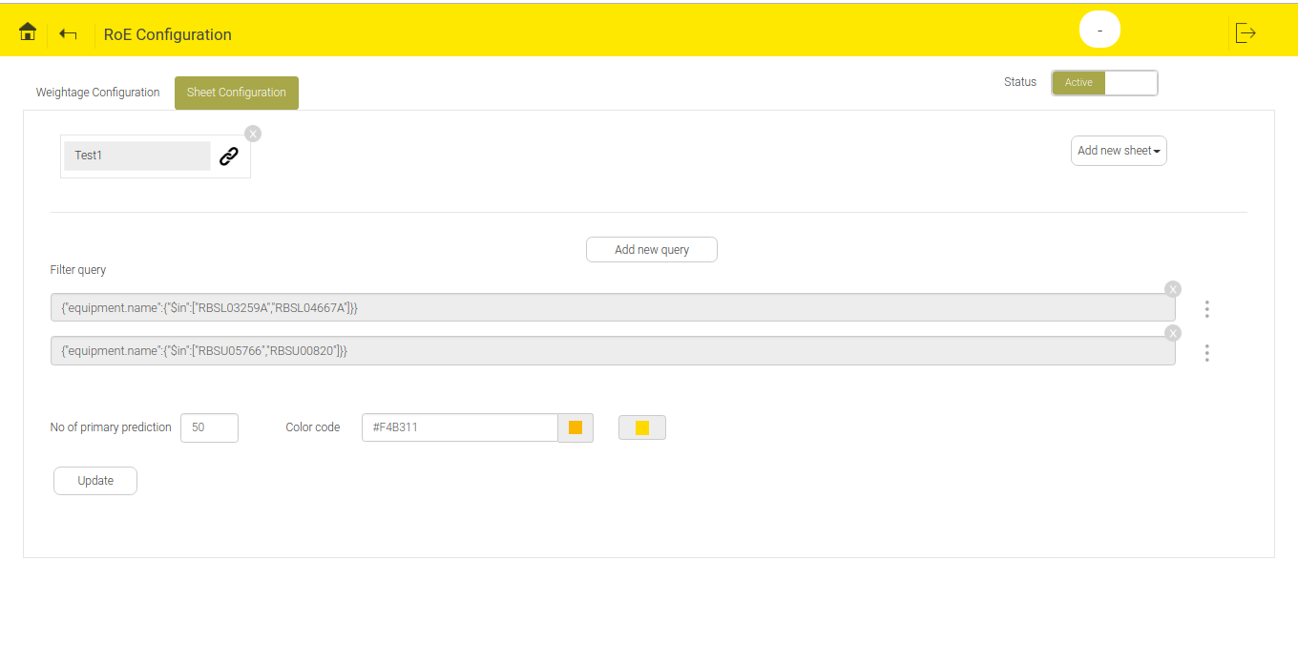
Figure 13.54 - Multiple Filter Query Configured

The above figure displays two filter query. Predictions in report will first appear based on the first query and then the second query.
- No. of primary prediction: Total number of primary predictions required to be colored in the prediction report.
- Color code: Color of primary prediction rows of prediction report.
Note: The second color box’s color changes automatically with lesser intensity as that of first color box to indicate the color of secondary predictions.

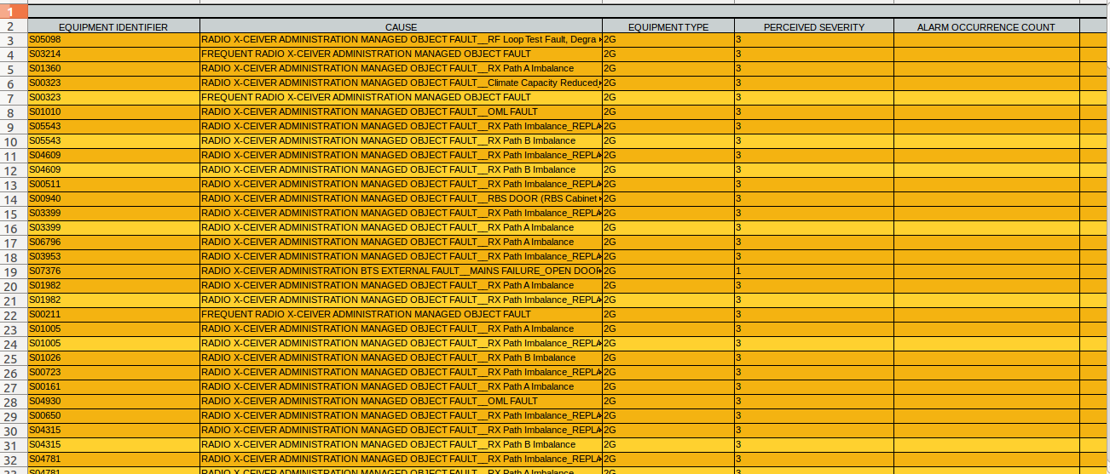
Figure 13.55- A Sample Report to show Primary And Secondary Predictions in Two Different Color Shades

User can add multiple queries. To add multiple queries, click the Add new query button 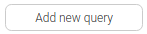. Once a new text box appears, click the text box to open a pop up. User can write json query in the text box. All the keys of json query must be enclosed within double quotes.

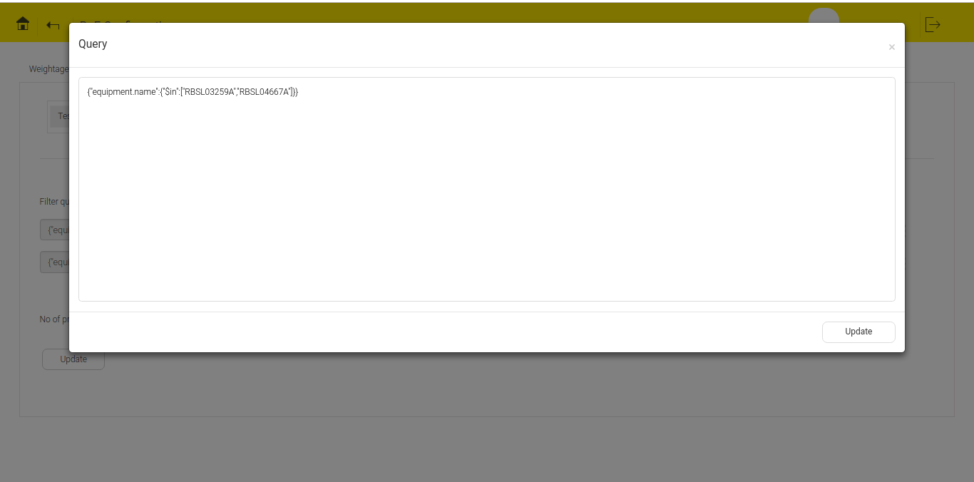
Figure 13.56- Pop up to Write Query in json Format

Linking
RoE can also be extended from a parent sheet to another sheet of prediction report if the total number of primary predictions appearing in the parent sheet is lesser than the number specified in the configuration.
Linking feature is available for all the sheets in excel report. To link multiple sheets to a parent sheet, use the linking icon . When the user click the link icon, the screen displays all sheets available for linking on the left hand side and the list of all sheets already linked on right hand side.

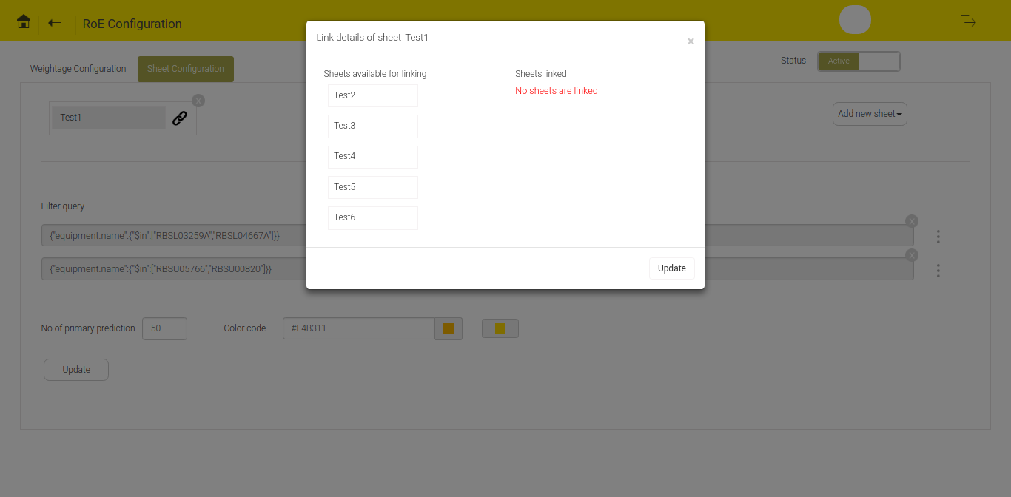
Figure 13.57 - Pop up showing Sheets Available for Linking and Sheets already Linked

When no sheets are available the screen displays a message “No sheets linked”. A sheet can link only those sheets which are appearing later in prediction report. For example: if Test1, Test2, Test3, Test4, Test5, Test6 is the sequence of the sheets in excel report then Test1 can be linked to Test2, Test3, Test4, Test5, Test6. Test2 cannot be linked to Test1 but can be linked to Test3, Test4, Test5 and Test6.
To link sheets from the pool of available sheets, click the sheet name.The sheet moves to linked sheet names from available sheet name list.

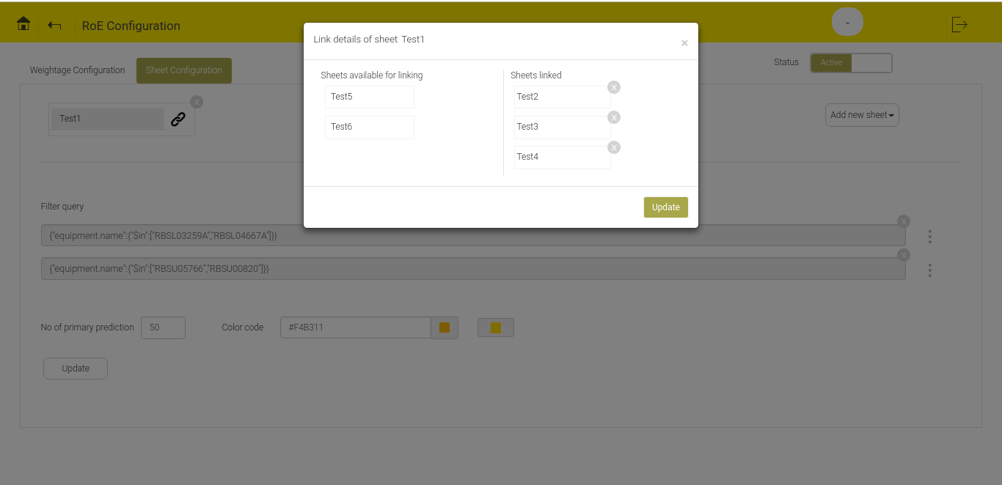
Figure 13.58 - Linked and available sheets
Select the sheets to be linked, click the 'Update' button  to update the changes. If user will not update the changes it will not reflect on the screen. The linked sheets will appear at the bottom of parent sheet after update.

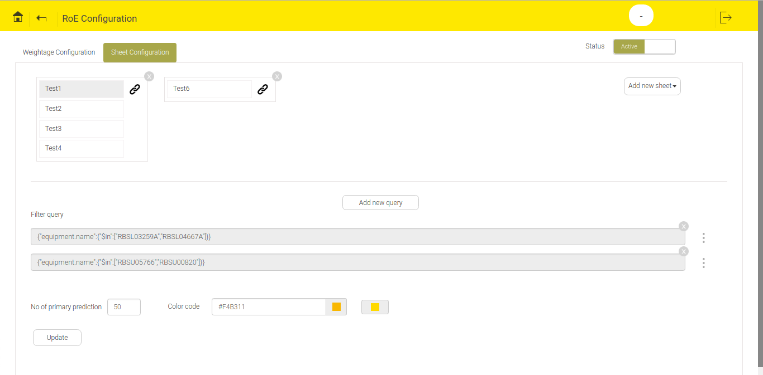
Figure 13.59 - Sheet Configuration

